Work Order User Guide

Introduction
Reference guide for Crow Canyon Work Order Tracking Applications

Permissions:
1. Permissions – SharePoint has sites and lists. Our program is installed in one Site. If you use our Portal, that is installed in another Site. You need to determine who (what users or groups) is going to have access to which Site and the lists that are in it.
For end users: If you are using the Portal, they will need access only to that Portal site. The Portal administration has a Security Settings section. You can read more about it here: https://www.crowcanyon.info/nitro/appmanual_v2/securitysettings.html
If you are not using the Portal, the end users will need to have permission to the main program Site. They will need the permission to create an item in the main Ticket list and read permissions on the other lists. You can give them the Read permission on the Site and the Create permission on the Ticket list. If you want them to Edit tickets after they are submitted, they will need the Edit permission on the Ticket list.
(Note: the IT Help Desk has a Tickets list as the main list, but other programs may have a different name for this main list, such as “Work Orders”, “Requests”, or “Purchase Requests”, as appropriate for that program.)
For technicians and managers: they need access to the main program Site. You can use standard SharePoint permissions for these individuals or groups. That is, you would give some Full Control and others Design, Edit, or Contribute, as appropriate. You can also create custom Site Permissions and use those.
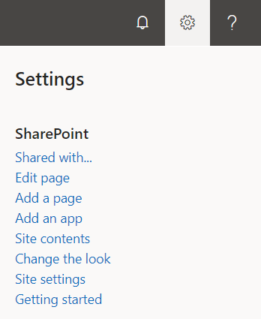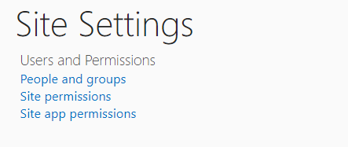
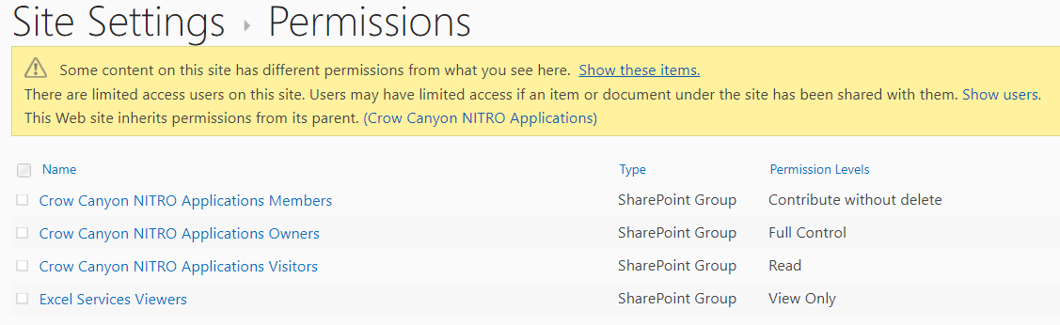

Working with Work Orders
There are several activities that will be performed on each Work Order over the course of its life, from creation to close.

Creating a Work Order
A Ticket can be created in one of three ways as shown below:
- From Quick Launch ‘New Ticket’ link
- From Employee Portal
- From Email (Incoming Email)

Creating Ticket from Quick Launch
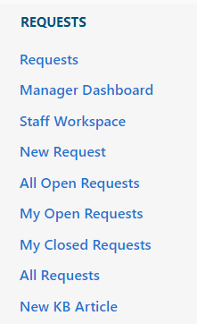
Click on ‘New Ticket’ link and fill required information:
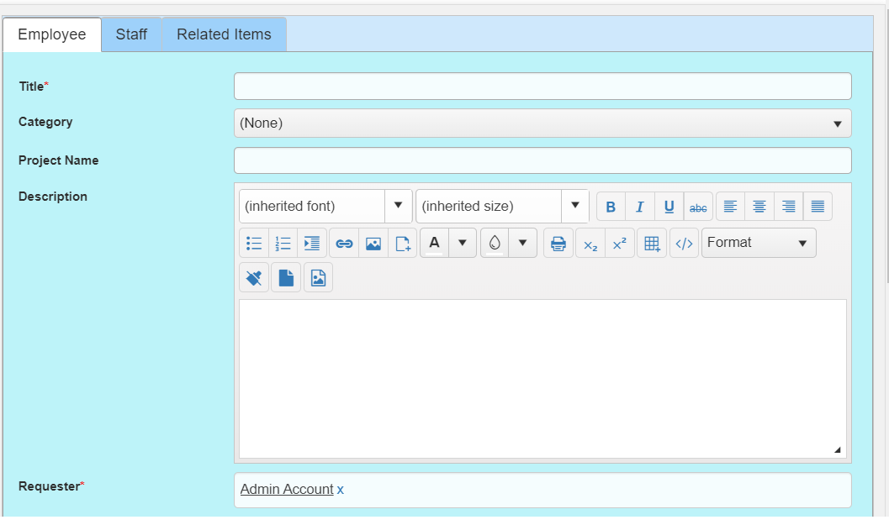

Creating Work Order from Employee Portal
Work Orders can also be created from the Employee Portal. End-Users can be direct to the Employee Portal automatically by configuring the portal settings. Reference this section in the NITRO manual (https://www.crowcanyon.info/nitro/appmanual_v2/power-portal.html) to set this up.
In ‘Employee Portal’ Home Page click on ‘Submit New Work Order’ as shown below
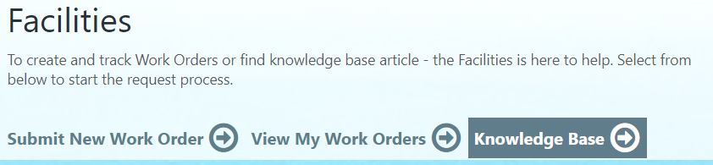
Create New Work Order with all the required information along with attachments (if any) as shown below:
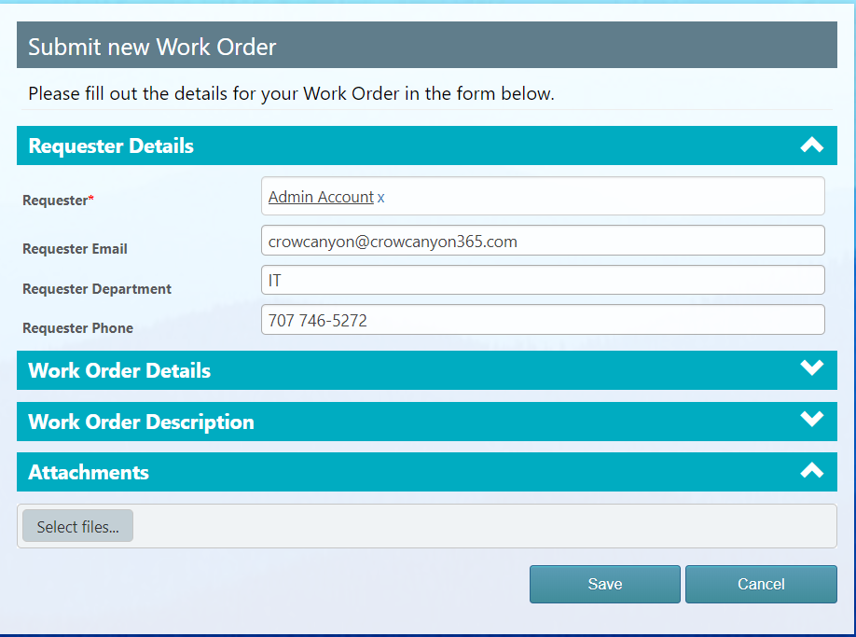
The logged in user will be able to see all their Work Orders in the View My Work Order link.
To read more details about the Employee Portal, Click on this link: https://www.crowcanyon.info/nitro/appmanual_v2/power-portal.html

Creating Work Order from Email
A Work Order can also be created from an email. The Crow Canyon solution includes an Email Sync App which allows you to sync an email to a SharePoint list. In our Service Request program, you will want to set this up to sync emails to the Email Tickets list within the Service Request site. Our program will either create a new Work Order in the Work Orders list or associate the email with an existing Work Order. To set up the Email Sync App, refer to the Email Sync App: https://www.crowcanyon.info/nitro/appmanual_v2/email-sync.html
For example, there is an email with subject ‘User solution Resources Exhausted’ added in ‘Email Work Orders’ list which creates a new work order in ‘Work Order’ list using email subject as title as shown below:
Item in Email Work Orders list
Work Orders created in the Work Order List
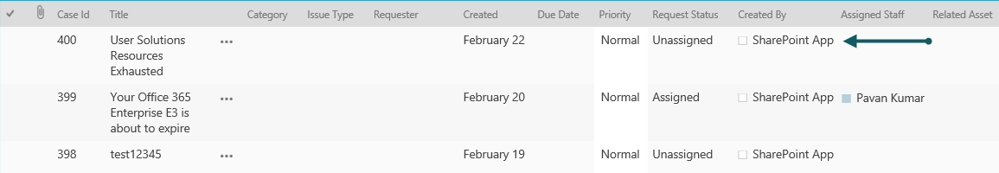

Assigning a Work Order
To assign a Work Order manually to a staff member, open the Work Order in edit mode. A Work Order can be assigned to staff members using ‘Assigned Staff’ and ‘Assigned Team’ fields in Ticket list.
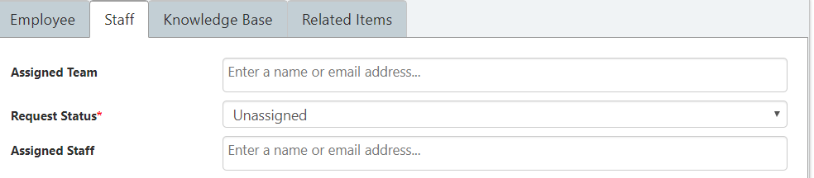
As ‘Assigned Staff’ allows multiple selections, Ticket can be assigned to multiple staff members.

Auto- Assignment of Work Orders
Work Orders can be auto assigned to staff members by configuring Assigned Staff and Enabling Round Robin functionality in ‘Issue Type’ and ‘Category’ list in the application admin home screen.
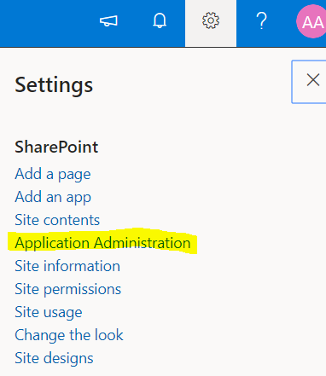
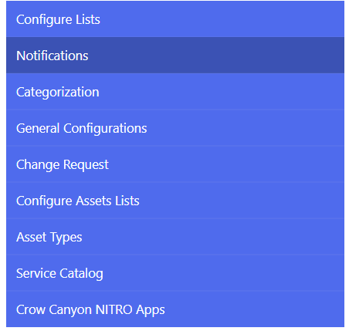
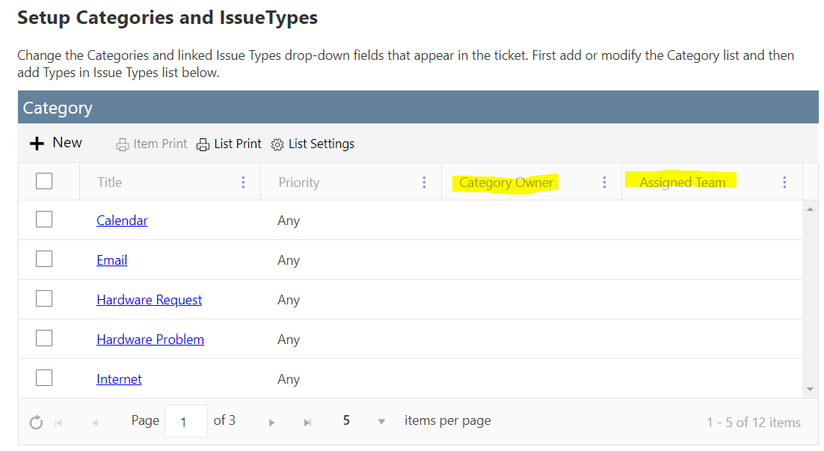
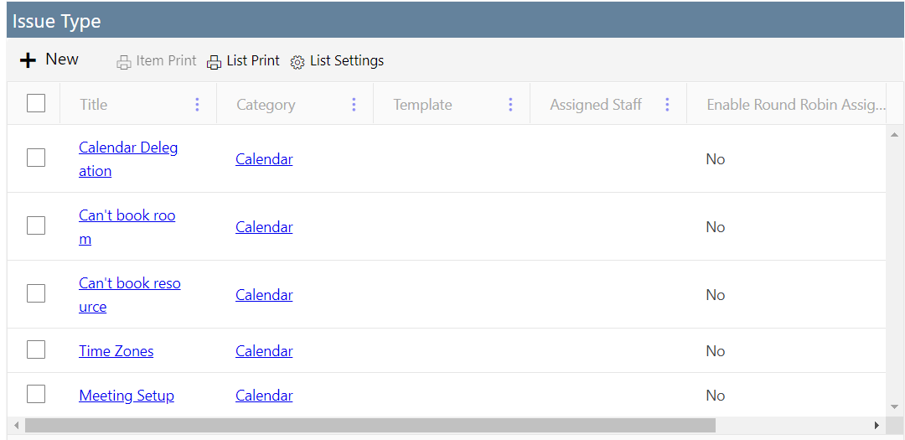

Create a new Category by clicking on the plus sign in the upper left of the Category list (see above screen shot).

Title -- Category name
Category Owner – A Person or Group who will be notified when a new work order matches both the Category and Priority settings on this Category form. This field can be left blank so that new ticket notification is not based on Category. This works in conjunction with the New Work Order Notification utility described in Notifications below. That utility is used to set up the new ticket notification for every new ticket. The Category Owner is used to set notifications by Category.
Assigned Team – A group who will be notified of the new work order. Populates the Assigned Team field on the Work Order. The Assigned Team will get updates on the Work Order, such as the Notification on Work Order Assignment, and Notification on Work Order completion. The ticket remains unassigned until the Assigned Staff field is populated.
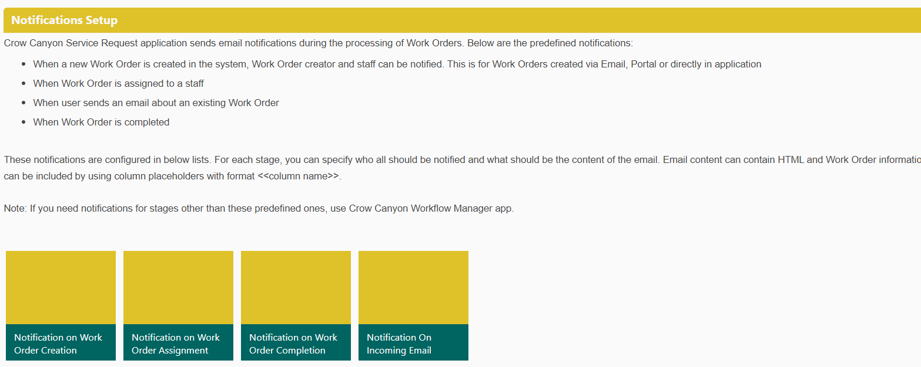

Modify Work Orders
Work Orders can be modified by using one of these following options:
- Open Work Order (Display mode)
- Work Order list view ‘Items’ ribbon bar
- Drop-down menu accessed from Work Order title
Open Work Orders (Display mode):
You can edit Work Orders by opening it in display mode and select ‘Edit Item’ on the top left corner as shown below
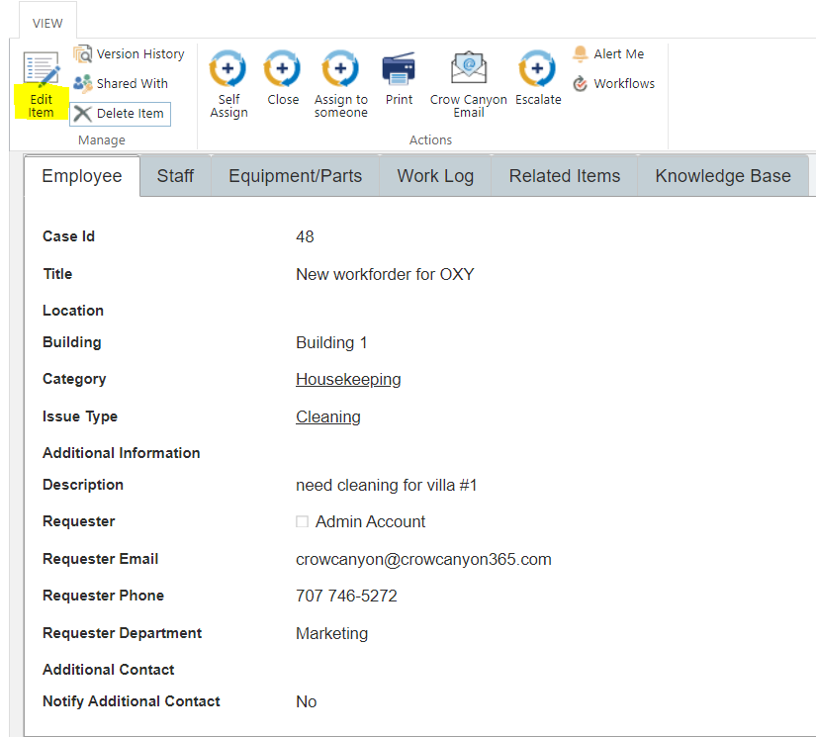
Work Orders can be edited from the list view ‘Items’ ribbon bar on selecting a Work Order as shown below:
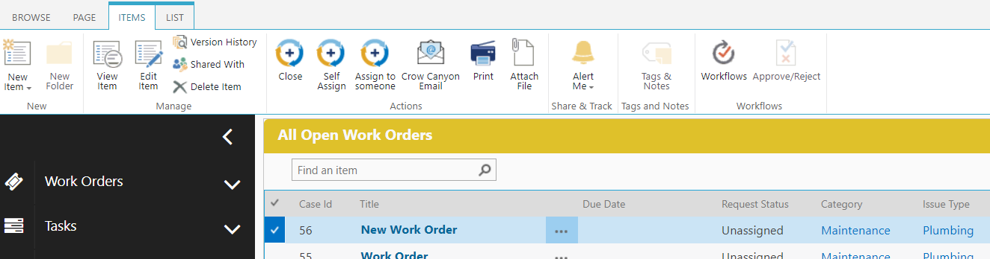

Drop-down menu accessed from Work Order title:
Work Orders can be edited from the drop down accessed from ticket list item title as shown below

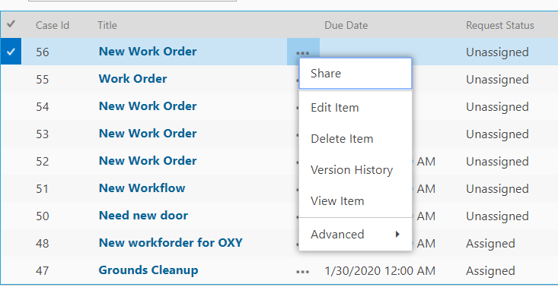

Custom Action Work Order Assignment

- Custom actions allow you to quickly assign and close Work Orders.
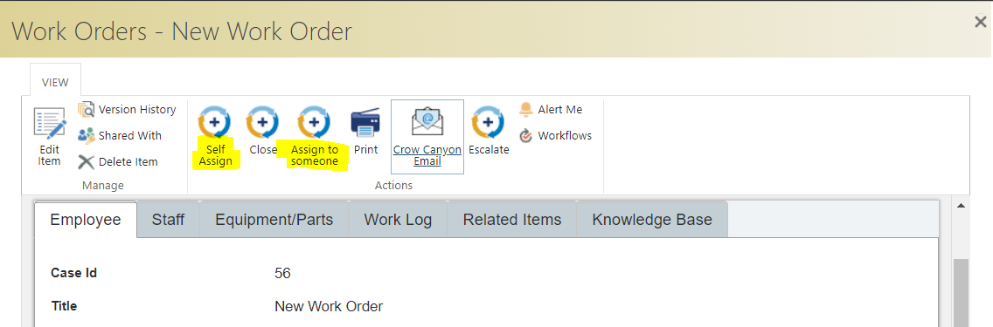

Close Work Order
You can close a Work Order by using one of the following options:
- Custom Action
- Work Order Actions
- Request Status

- Request Status:
Work Orders can also be closed by setting ‘Request Status’ field to ‘Closed’ as shown below
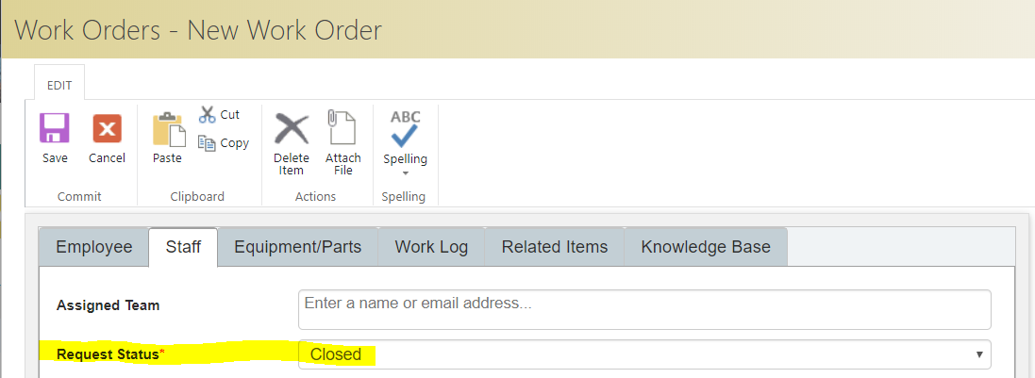

Emailing Work Order
You can email a Work Order to anyone who may want to see it. You can use this feature as ‘For Your information’ for someone who does not want to have continuous notifications about the Work Order, or for someone who misplaced a notification email.
You can send email from one of these following options:
- Open Work Order in Display mode
- ‘Items’ ribbon bar from within the list view of Work Order
Open Work Order in Display Mode:
You can send email from the ‘Email’ option in ribbon of a ticket opened in display mode as shown using Crow Canyon’s Email Manager: https://www.crowcanyon.info/nitro/appmanual_v2/advanced-email.html
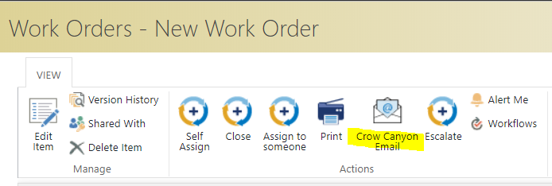

Manager Workspace
The Manager Workspace is a quick way for Managers to monitor staff work across the whole department.
- All overdue work orders
- My Assigned work orders
- Unassigned work orders
- User tasks
- Staff load
- Open work orders by category and priority
- Incoming work orders by month
- Closed work orders by month
All these elements are customizable web parts.
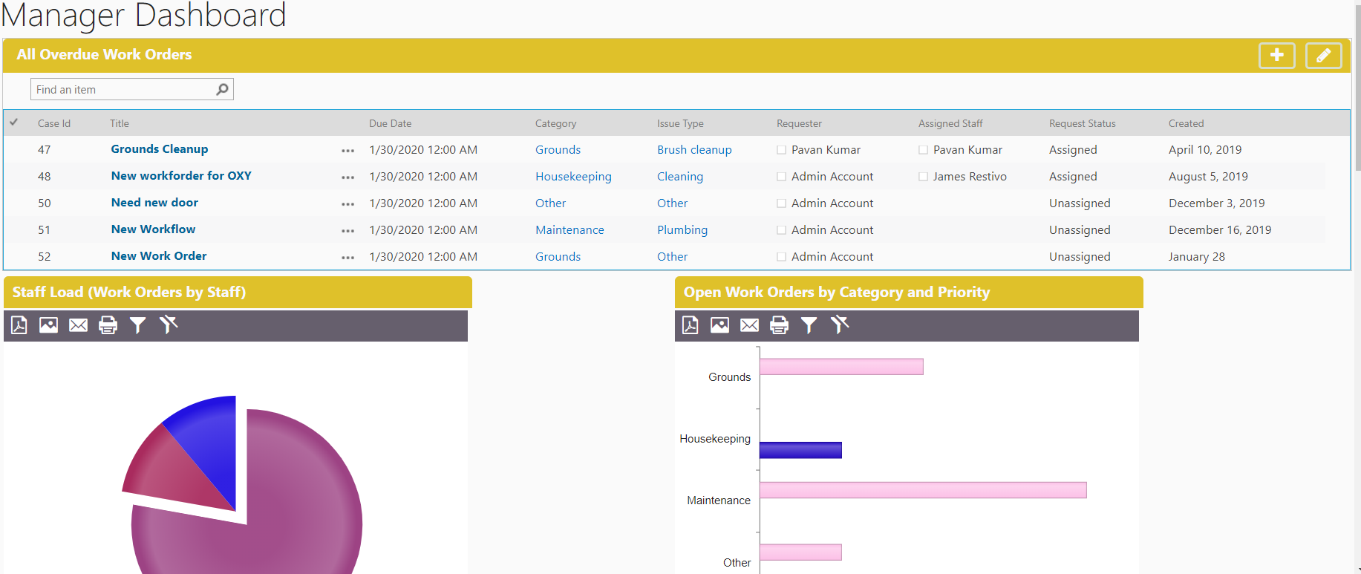
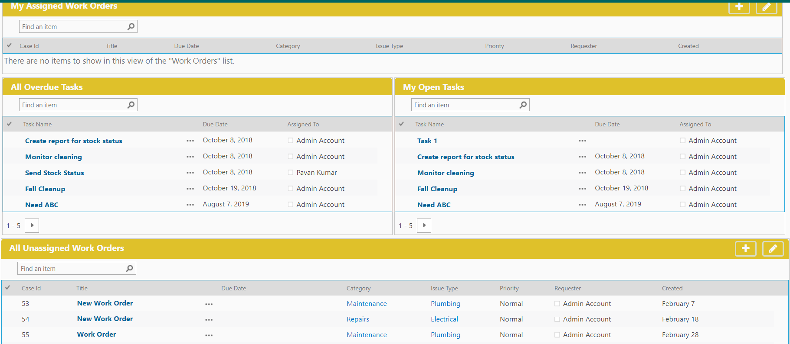

Staff Workspace
The Staff Workspace is a quick way for a staff member to see data assigned to him, including assigned tickets, unassigned work orders, assigned work orders, and open work orders by category, etc. All these elements are customizable web parts.
Note: From here staff can Work on tickets and tasks which are assigned to them
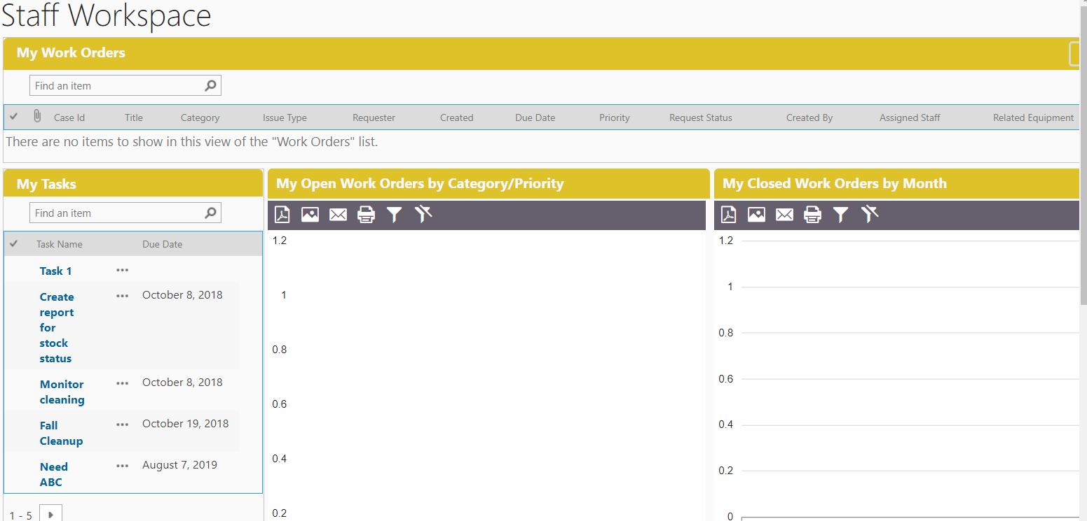

Knowledge Base

‘Knowledge Base’ is a quick way to search KB Articles which is configured as a top navigation link in the site as shown below
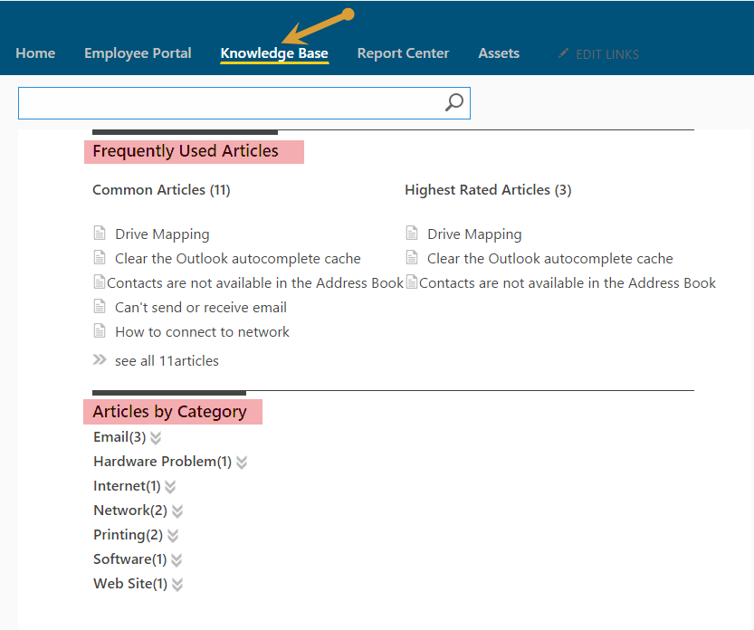
- You can search Articles directly by entering a Keyword, category, issue type or Title in the Search Box
- Frequently Used Articles
    - This Section is very useful for which are more popular
    - In this section we find two types
- Common type Articles
- Highest rated Articles
- Articles by Category
    - In this Section we find count of Articles under each category

Report Center

- Report Center is configured as a top navigation link which is to show all the reports configured in the site as shown below.
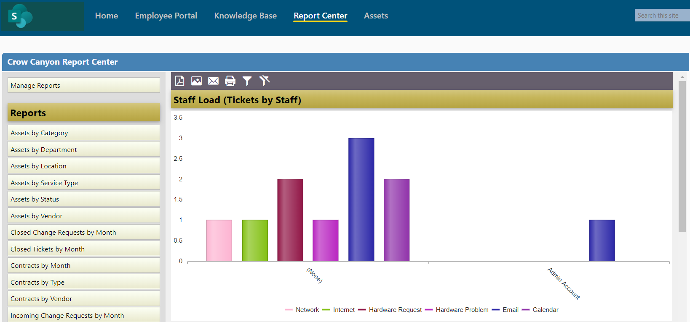
- Reports are configured in Dashboards to show progress of list items in the form of charts and Tables.
- To configure reports please refer to the NITRO manual: https://www.crowcanyon.info/nitro/appmanual_v2/report-center.html

Create KB Article
Quick Launch Link:
New KB Article can be created directly from Quick launch link under ‘Work Order’ heading ‘New KB Article’ as shown below.
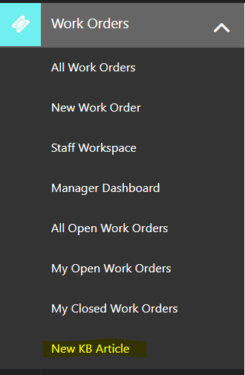
Work Order List:
In Work Order list under ‘Knowledge Base’ tab there is an option ‘Create KB Article’ check that option to create KB article for the ticket when the Work Order gets closed
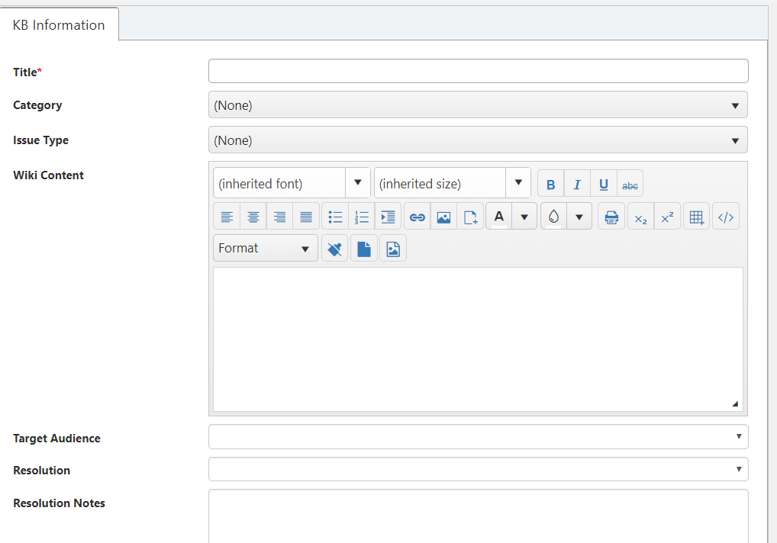
Note: KB article gets created as a list item in ‘Knowledge Base’ list based on the mappings specified in ‘Configuration’ list. To know more details about KB mappings refer: General Configuration link in Application Administration workspace
Create Ticket using KB Article:
Work Order can be created by using KB Articles by specifying ‘Related KB Articles’ while creating Work Order as shown below
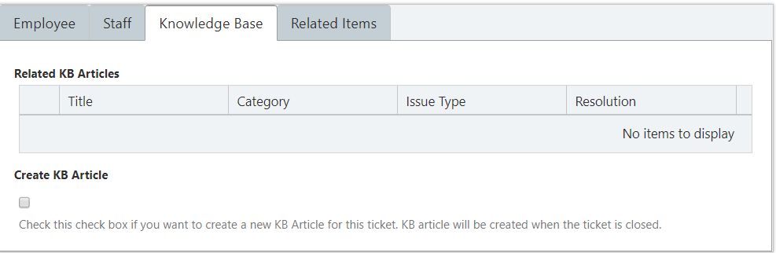

Create SLA’s
1. For overdue work orders https://www.crowcanyon.help/article/288/
2. For work order Creation, Due Date https://www.crowcanyon.help/article/287/
3. Based on the Priority of The Work Order to Update Due Date and Configure Alerts https://www.crowcanyon.help/article/286/
4. Auto close work orders - https://www.crowcanyon.help/article/151

