Request Manager User Guide

Contents
Introduction 2
Permissions 2
Working with Tickets 3
Creating a Ticket 3
Creating Ticket from Quick Launch 3
Creating Ticket from Employee Portal 4
Creating Ticket from Email 5
Assigning a Ticket 6
Auto- Assignment of Tickets 6
Categories 7
Issue Type 8
Notifications 10
Notification on Ticket Creation 10
Notification on Ticket Assignment 11
Notification on Ticket Completion 11
Notification on Incoming Email 11
Modify Tickets 11
Open Ticket (Display mode) 11
Tickets list view ‘Items’ ribbon bar 12
Drop-down menu accessed from Ticket title 12
Custom Action Ticket Assignment 13
Close Ticket 13
Custom Action 13
Request Status 15
Emailing Tickets 16
Open Ticket in Display Mode 16
Items Ribbon Bar 17
Workspaces 17
Manager Workspace 17
Staff Workspace 19
Knowledge Base 19
Create KB Article 20
Report Center 21
Create SLA’s 22

Introduction

Reference guide for Crow Canyon Request Manager for SharePoint.

Permissions
1. Permissions – SharePoint has sites and lists. Our program is installed in one Site. If you use our Portal, that is installed in another Site. You need to determine who (what users or groups) is going to have access to which Site and the lists that are in it.
For end users: End Users will need the permission to create an item in the main Ticket list and read permissions on the other lists. You can give them the Read permission on the Site and the Create permission on the Ticket list. If you want them to Edit tickets after they are submitted, they will need the Edit permission on the Ticket list. Please note that this is true even if using the portal.
If you are using the portal, the portal settings area has a Security Settings section to block end user access to the back-end site. You can read more about portal security settings here: https://www.crowcanyon.info/nitro/appmanual_v2/security-settings.html
(Note: the IT Help Desk has a Tickets list as the main list, but other programs may have a different name for this main list, such as “Work Orders”, “Requests”, or “Purchase Requests”, as appropriate for that program.)
For technicians and managers: they need access to the main program Site. You can use standard SharePoint permissions for these individuals or groups. That is, you would give some Full Control and others Design, Edit, or Contribute, as appropriate. You can also create custom Site Permissions and use those.
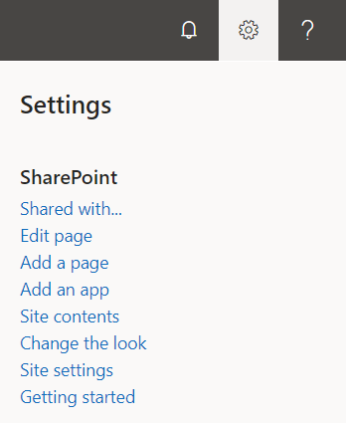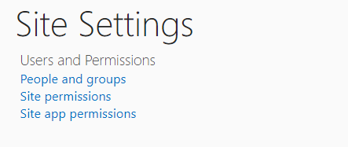
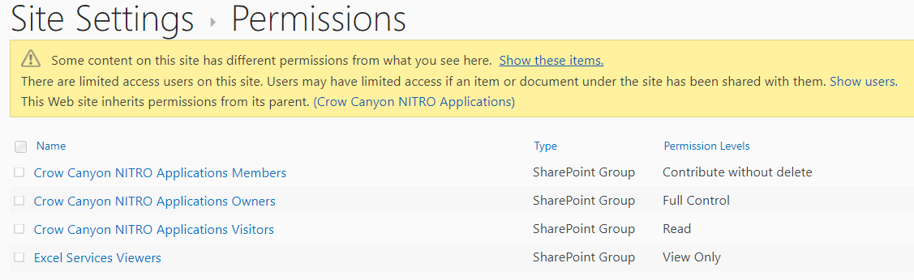

Working with Tickets
There are several activities that will be performed on each Ticket over the course of its life, from creation to close.

Creating a Ticket
A Ticket can be created in one of three ways as shown below:
- From Quick Launch ‘New Ticket’ link
- From Employee Portal
- From Email (Incoming Email)

Creating Ticket from Quick Launch
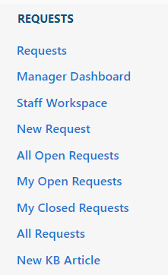
Click on ‘New Ticket’ link and fill required information:
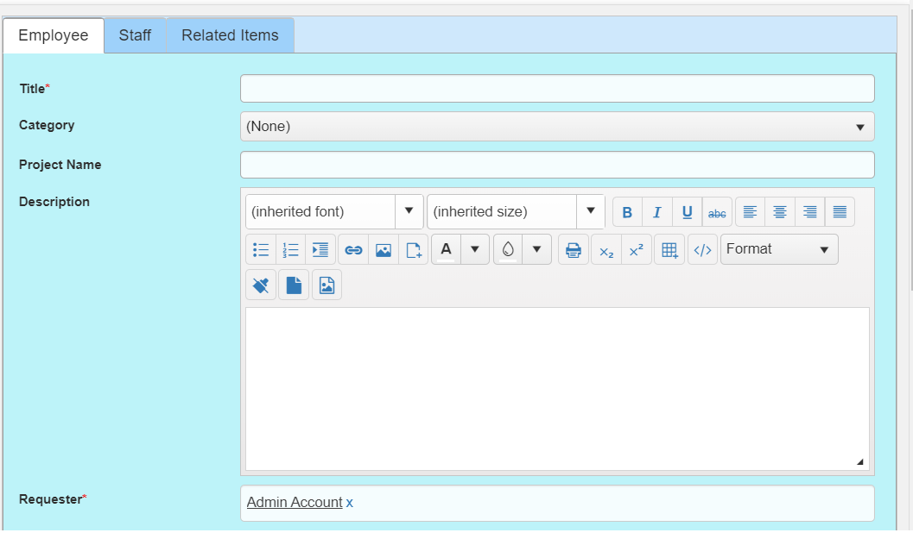

Creating Ticket from Employee Portal
Tickets can also be created from Employee Portal. End-Users can be directed to the Employee Portal automatically by configuring the portal settings. Refer to this section in the NITRO manual (https://www.crowcanyon.info/nitro/appmanual_v2/power-portal.html) to set this up.
In ‘Employee Portal’ Home Page click on ‘Submit New Ticket’ as shown below
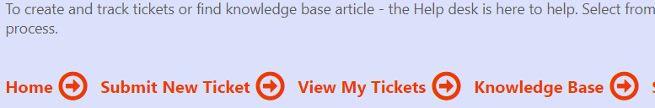

Create New Ticket with all the required information along with attachments (if any) as shown below
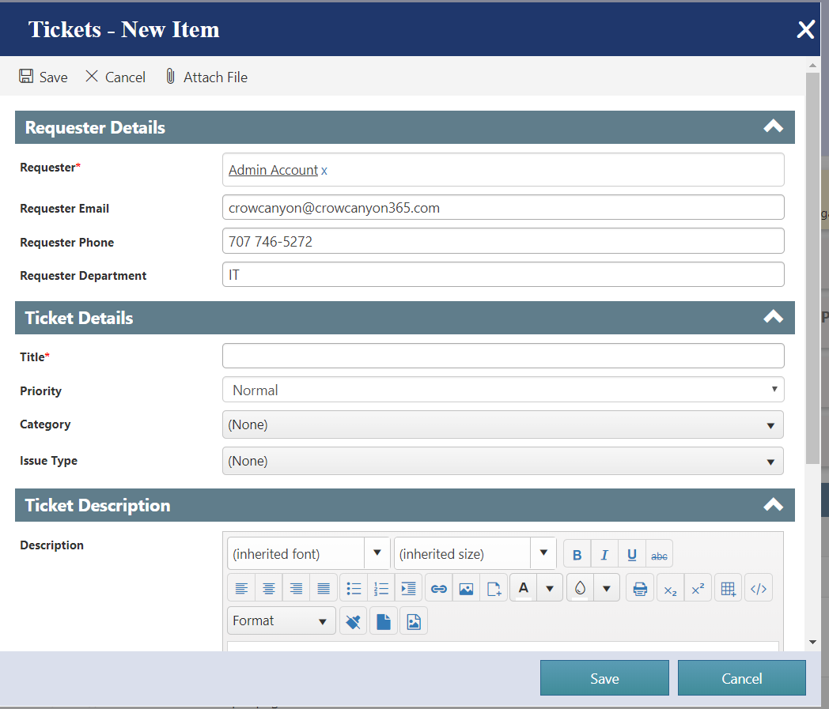
The logged in user will be able to see all of their tickets in the View My Tickets link.
To read more details about the Employee Portal, Click on this link: https://www.crowcanyon.info/nitro/appmanual_v2/power-portal.html

Creating Ticket from Email
A Ticket can also be created from an email. The Crow Canyon solution includes an Email Sync App which allows you to sync an email to a SharePoint list. In our Service Request program, you will want to set this up to sync emails to the Email Tickets list within the Service Request site. Our program will either create a new Ticket in the Tickets list or associate the email with an existing Ticket. To set up the Email Sync App, refer to the Email Sync App: https://www.crowcanyon.info/nitro/appmanual_v2/email-sync.html
For example, there is an email with subject ‘User solution Resources Exhausted’ added in ‘Email Tickets’ list which creates a new ticket in ‘Tickets’ list using email subject as title as shown below
Item in Email Tickets list
Ticket created in Tickets List
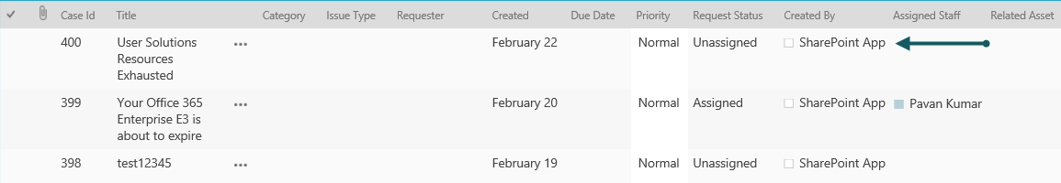

Assigning a Ticket
To assign a Ticket manually to a staff member, open the Ticket in edit mode. A Ticket can be assigned to staff members using ‘Assigned Staff’ and ‘Assigned Team’ fields in Ticket list.
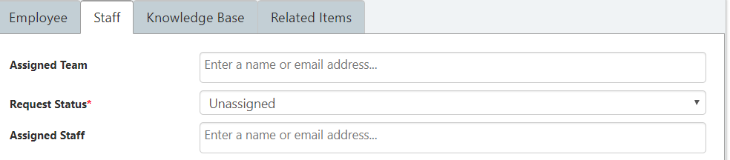
As ‘Assigned Staff’ allows multiple selections, Ticket can be assigned to multiple staff members.

Auto- Assignment of Tickets
Tickets can be auto assigned to staff members by configuring Assigned Staff and Enabling Round Robin functionality (optional) in ‘Issue Type’ and ‘Category’ list in the application admin home screen.
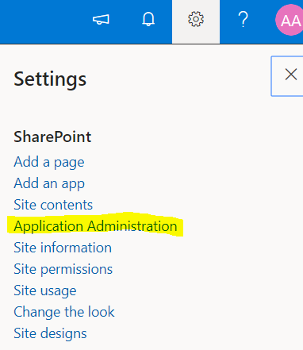
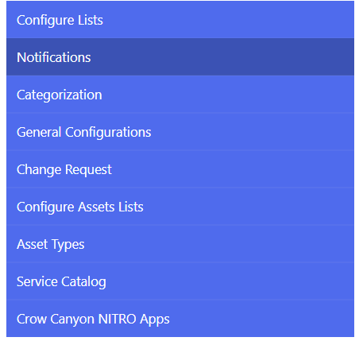

Categories
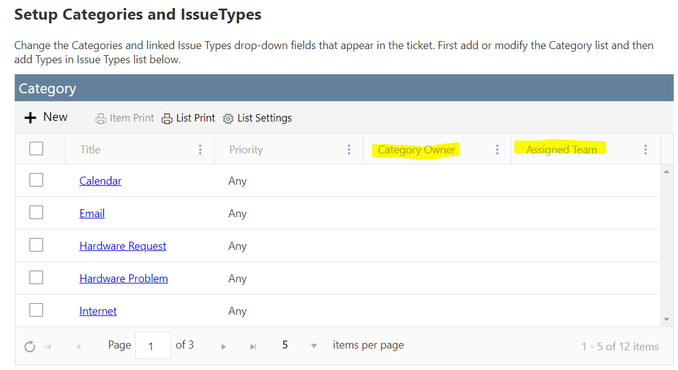

Create a new Category by clicking on the plus sign in the upper left of the Category list (see above screen shot).

Title -- Category name
Category Owner – A Person or Group who will be notified when a new ticket matches both the Category and Priority settings on this Category form. This field can be left blank so that new ticket notification is not based on Category. This works in conjunction with the New Ticket Notification utility described in Notifications below. That utility is used to set up the new ticket notification for every new ticket. The Category Owner is used to set notifications by Category.
Assigned Team – A group who will be notified of the new ticket. Populates the Assigned Team field on the ticket. The Assigned Team will get updates on the ticket, such as the Notification on Ticket Assignment, and Notification on Ticket completion. The ticket remains unassigned until the Assigned Staff field is populated.

Issue Type
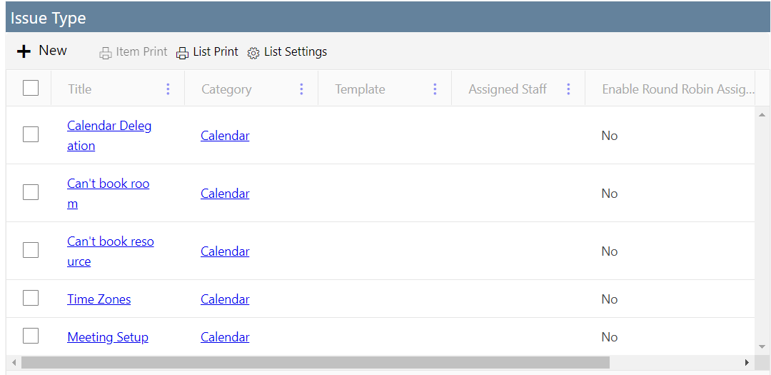
Create a new Issue Type by clicking on the plus sign in the upper left of the Issue Type list (see above screen shot).
Title – Issue Type name
Category – Links back to the Category. If you need to have the Issue Type refer to more than one Category, you’ll need to create multiple Issue Types and link each one to its respective Category.
Template – In older versions of the program, the Template field was used to present the end user with specific questions or instructions. When the end user would select the Issue Type, a field called “Additional Information” would be populated with the text from this Template field. In newer versions of the program, this same functionality can be handled either by rules-based column permissions or by the Advanced Lookup settings. Both options are described in our NITRO Forms manual: https://www.crowcanyon.info/nitro/appmanual_v2/custom-forms.html
Assigned Staff – To whom the ticket will be auto-assigned when this Issue Type is selected. You can add multiple users in this field, but they should all be individual users, not groups. If you want to assign to a group, use the Assigned Teams feature in the Category list (see above).
Enable Round Robin Assignment – Can be used when you have multiple users in the Assigned Staff field. This feature will assign the ticket by Issue Type in the order of the individuals in the Assigned Staff field. That is if you have Employee A; Employee B; Employee C in the Assigned Staff field, the first assigned ticket will go to Employee A, the next to Employee B, etc.
Next Staff – When using the Round Robin feature (see above), this field will show who the next staff person will be to get a ticket assigned to them based on the Issue Type. You do not need to enter anything in this field; the program will automatically populate this based on the settings above.
Receivers – This is used for auto setting the Issue Type when the ticket is created via email. This field can contain either email addresses or Email enabled list names. When an email is sent to the specified email address or Email list name, the program will automatically create the ticket with this Issue Type. To learn more about setting up email, refer to the below links.
- Setting up incoming email in M365: https://www.crowcanyon.info/nitro/appmanual_v2/email-sync.html
- Setting up incoming email in on-prem SharePoint: https://docs.microsoft.com/en-us/sharepoint/administration/incoming-email-configuration

Notifications

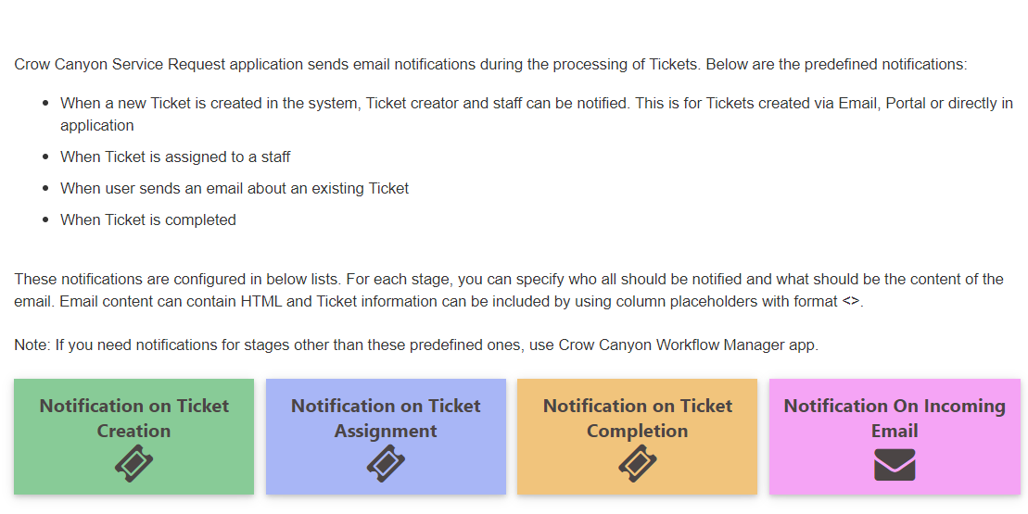

Notification on Ticket Creation

This sets the Auto-reply to the Requestor as well as the email notification to Staff whenever a new ticket is created. There is a template for the end user (Requester and/or Creator of the Ticket) as well as a template for the Staff (Category Owner and/or Assigned Team). There are also settings for the links that are sent via the notification.

Notification on Ticket Assignment

This allows you to change the settings on who gets notified when a ticket is assigned or reassigned. There is a template for the end user (Requester and/or Creator of the Ticket) as well as a template for the Staff (Assigned Staff, Previously Assigned Staff, etc). There are also settings for the links that are sent via the notification.

Notification on Ticket Completion

This allows you to change the settings on who gets notified when a ticket is Closed. There is a template for the end user (Requester and/or Creator of the Ticket) as well as a template for the Staff (Assigned Staff). There are also settings for the links that are sent via the notification.

Notification on Incoming Email

This is for enabling a notification to the Assigned Staff if the end user has sent in an email to the system regarding an existing ticket. The Assigned Staff will receive the forwarded email in their inbox.

Modify Tickets
Ticket can be modified by using one of these following options:
- Open Ticket (Display mode)
- Tickets list view ‘Items’ ribbon bar
- Drop-down menu accessed from Ticket title

Open Ticket (Display mode)
You can edit ticket by opening it in display mode and select ‘Edit Item’ on the top left corner as shown below
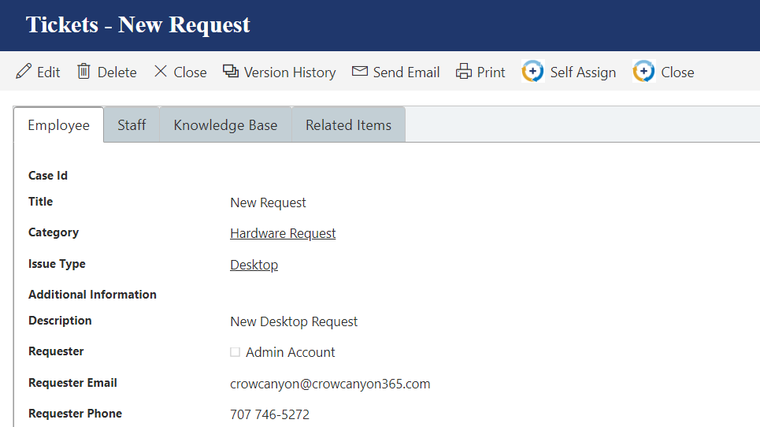

Tickets list view ‘Items’ ribbon bar
Ticket can be edited from the list view ‘Items’ ribbon bar on selecting a ticket as shown below
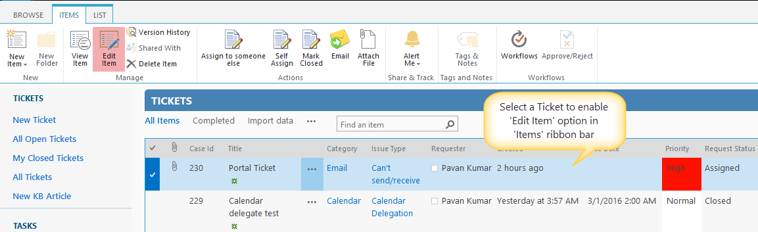

Drop-down menu accessed from Ticket title
Ticket can be edited from the drop down accessed from ticket list item title as shown below
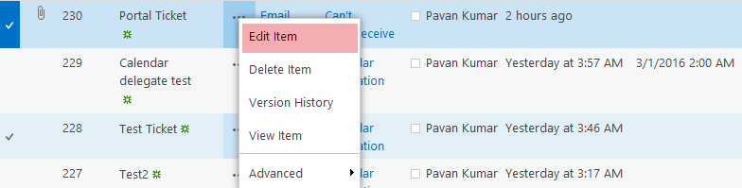

Custom Action Ticket Assignment

- Custom actions allow you to quickly assign and close tickets.
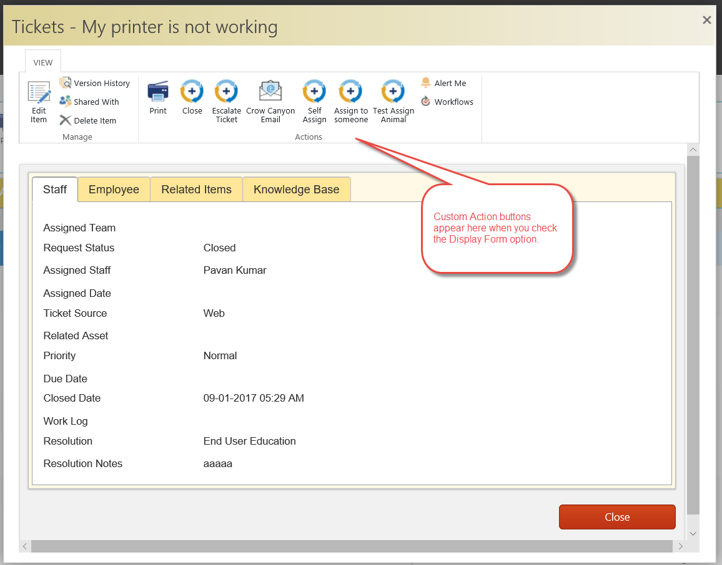

Close Ticket
You can close a Ticket by using one of the following options:
- Custom Action
- Request Status

Custom Action
Click on the “Close” Custom Action button in the Display Form ribbon:
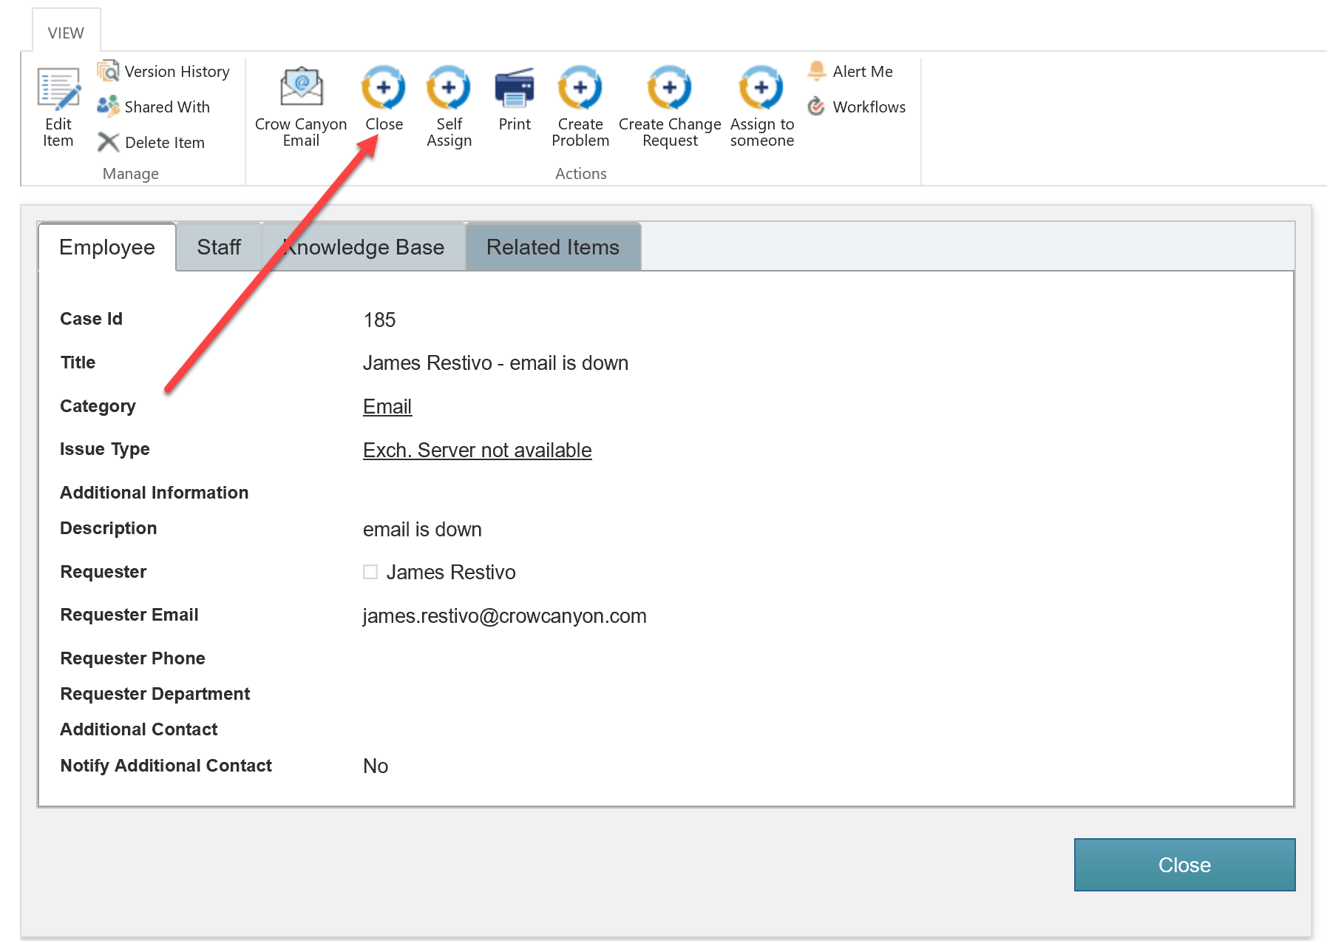
This will bring up a dialog box asking to input the Resolution and Resolution Notes:
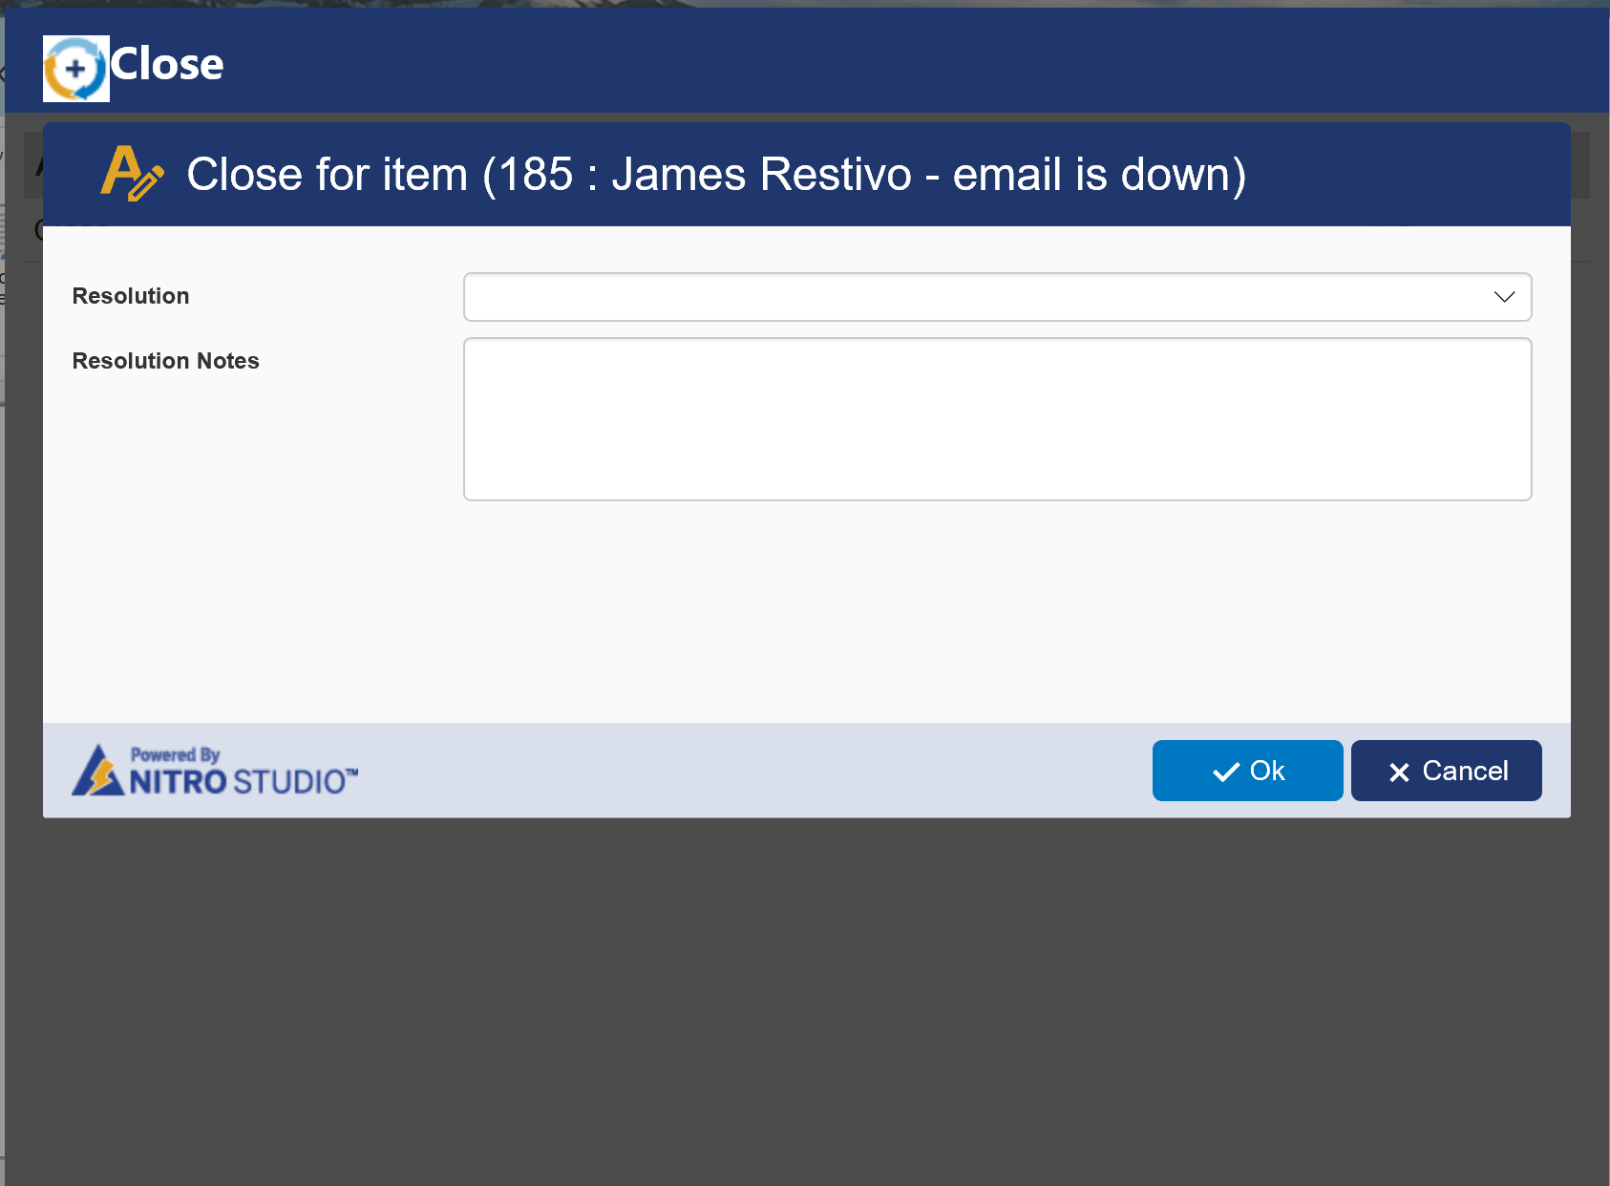

Request Status
Ticket can also be closed by setting ‘Request Status’ field to ‘Closed’ as shown below:
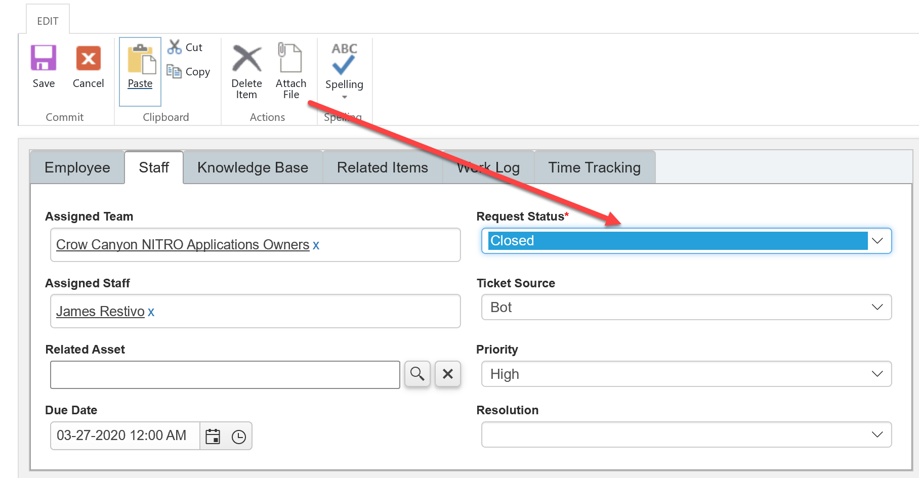

Emailing Tickets
You can email a ticket to anyone who may want to see it. You can use this feature as ‘For Your information’ for someone who does not want to have continuous notifications about the ticket, or for someone who misplaced a notification email.
You can send email from one of these following options:
- Open Ticket in Display mode
- ‘Items’ ribbon bar from within the list view of Tickets

Open Ticket in Display Mode
You can send email from the ‘Email’ option in ribbon of a ticket opened in display mode as shown using Crow Canyon’s Email Manager: https://www.crowcanyon.info/nitro/appmanual_v2/advanced-email.html

Items Ribbon Bar
If you select one item from a list view, you can access the Email button through the “Items” ribbon menu. If more than one item is selected, the Email button will be disabled.

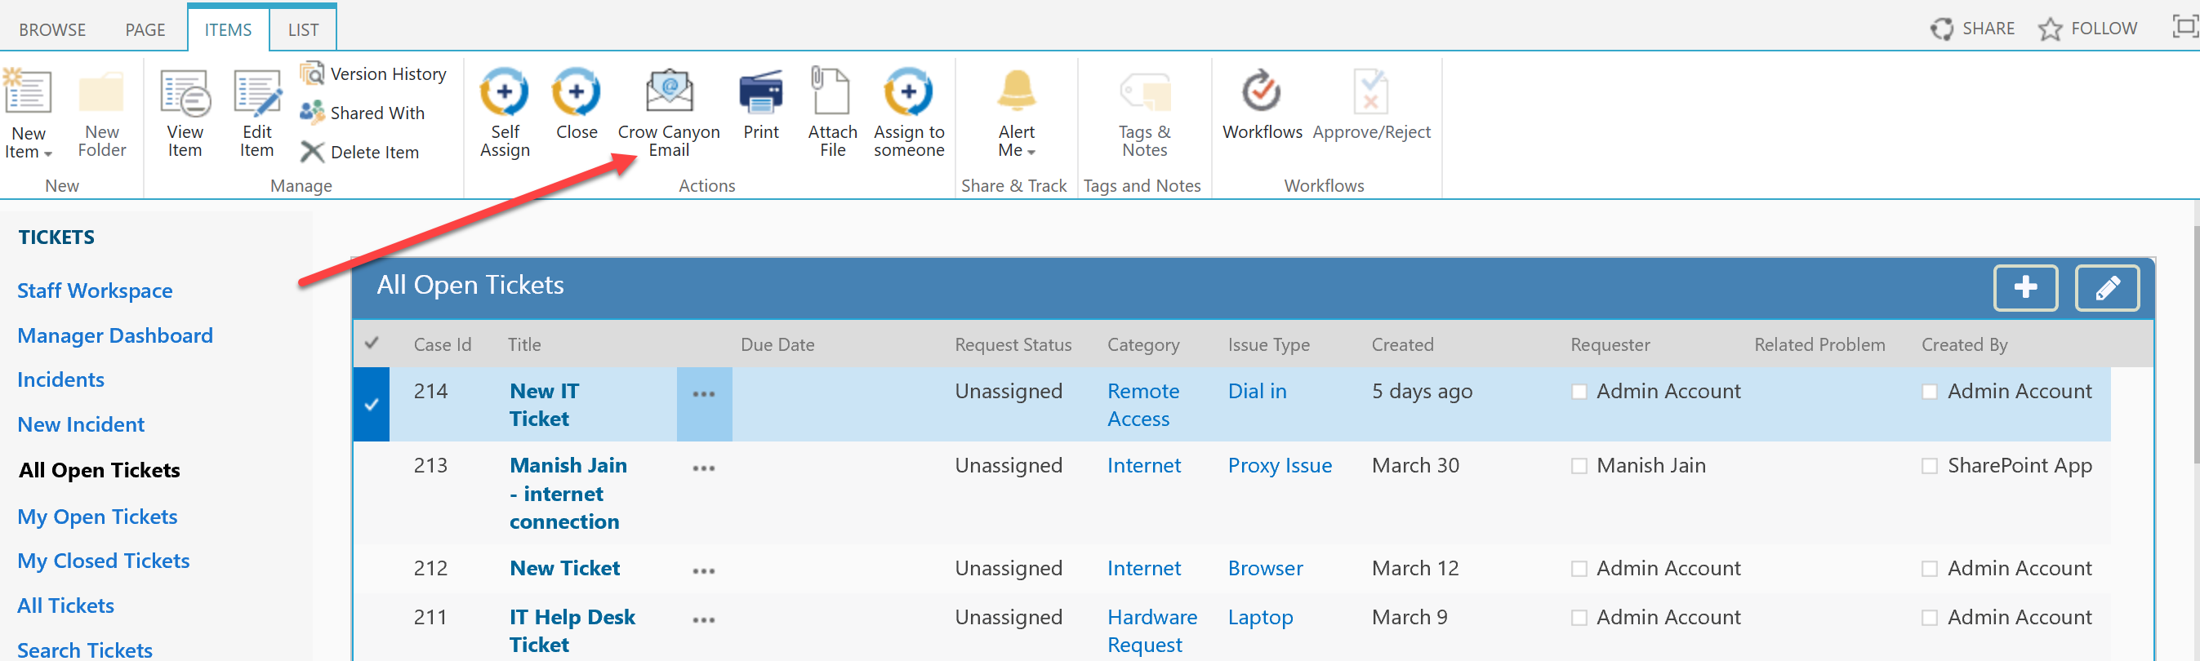

Workspaces

Manager Workspace
The Manager Workspace is a quick way for Managers to monitor staff work across the whole department.
- All overdue tickets
- My Assigned tickets
- Unassigned tickets
- User tasks
- Staff load
- Open tickets by category and priority
- Incoming tickets by month
- Closed tickets by month
All these elements are customizable web parts.
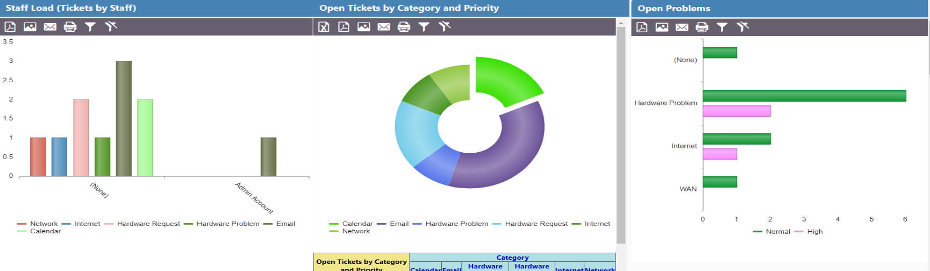
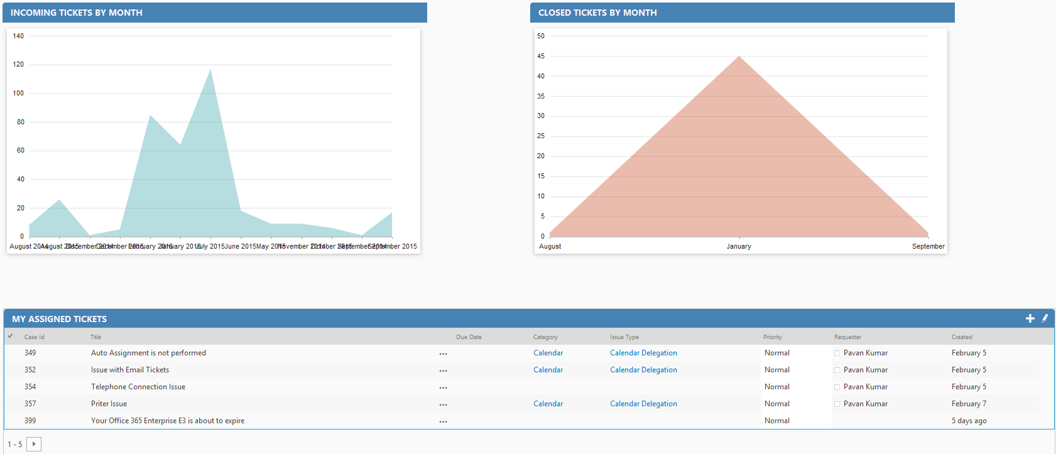

Staff Workspace
The Staff Workspace is a quick way for a staff member to see data assigned to him, including assigned tickets, unassigned tickets, assigned tasks, and open tickets by category, etc. All these elements are customizable web parts.
Note: From here staff can Work on tickets and tasks which are assigned to them

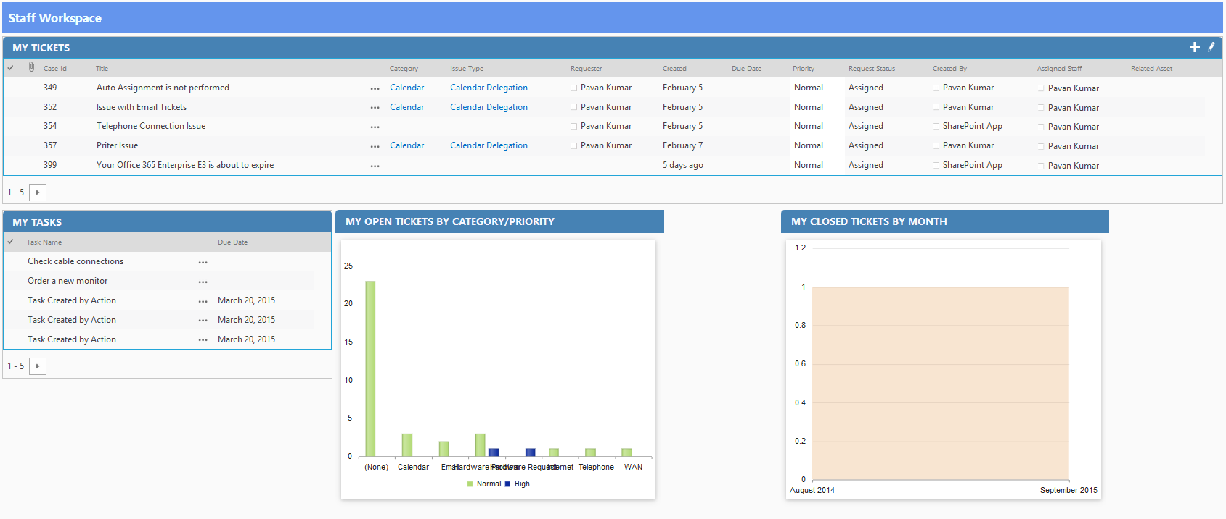

Knowledge Base

‘Knowledge Base’ is a quick way to search KB Articles which is configured as a top navigation link in the site as shown below
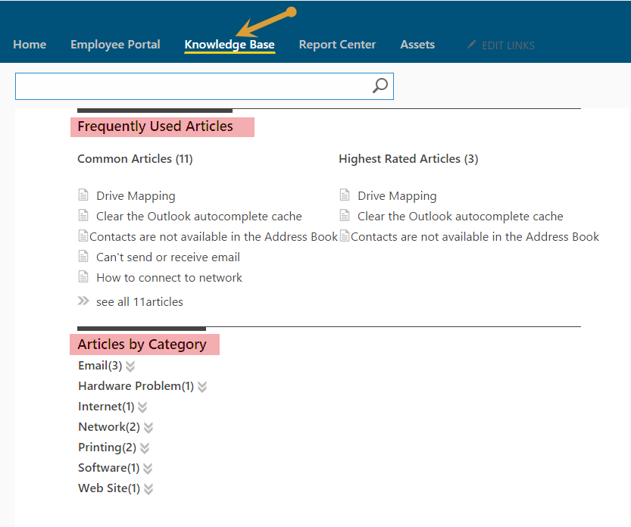
- You can search Articles directly by entering a Keyword, category, issue type or Title in the Search Box
- Frequently Used Articles
    - This Section is very useful for which are more popular
    - In this section we find two types
- Common type Articles
- Highest rated Articles
- Articles by Category
    - In this Section we find count of Articles under each category

Create KB Article
Quick Launch Link:
New KB Article can be created directly from Quick launch link under ‘Tickets’ heading ‘New KB Article’ as shown below.
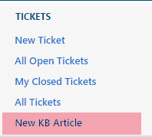
Tickets List:
In Tickets list under ‘Knowledge Base’ tab there is an option ‘Create KB Article’ check that option to create KB article for the ticket when the ticket gets closed
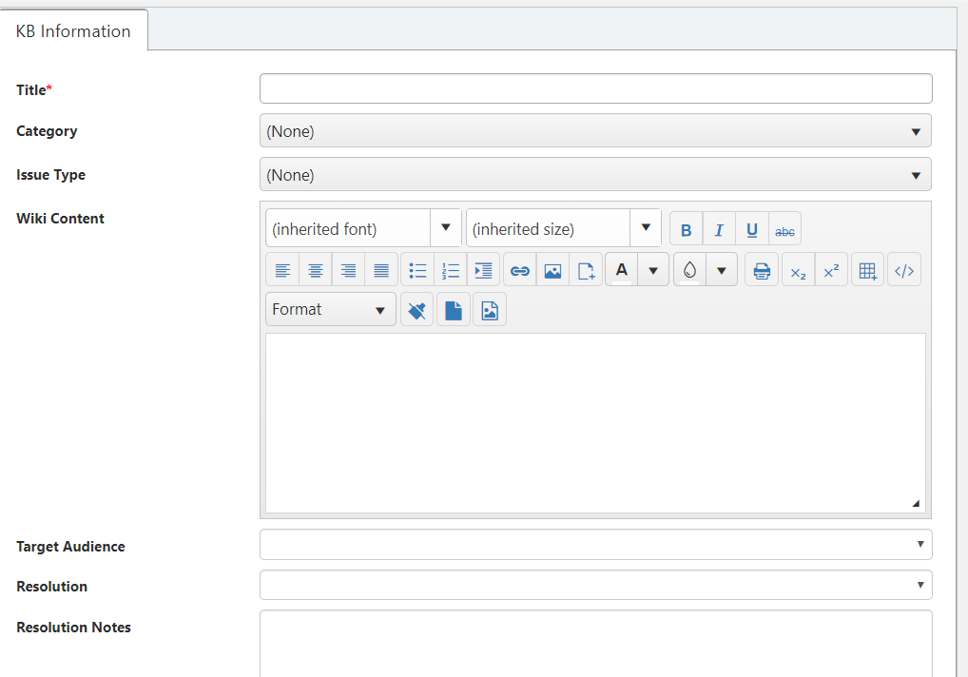
Note: KB article gets created as a list item in ‘Knowledge Base’ list based on the mappings specified in ‘Configuration’ list. To know more details about KB mappings refer: General Configuration link in Application Administration workspace

Report Center

- Report Center is configured as a top navigation link which is to show all the reports configured in the site as shown below.
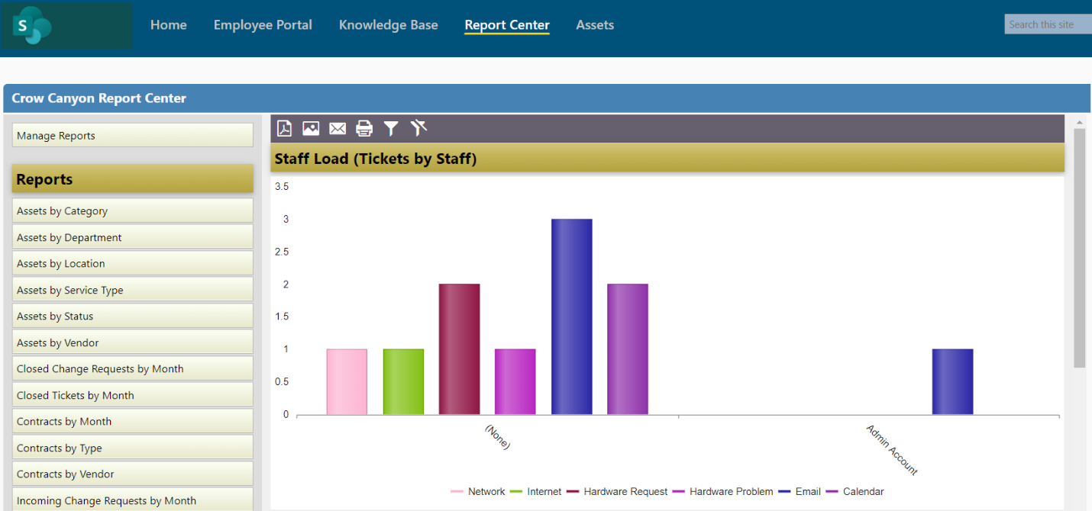
- Reports are configured in Dashboards to show progress of list items in the form of charts and Tables.
- To configure reports please refer to the NITRO manual: https://www.crowcanyon.info/nitro/appmanual_v2/report-center.html

Create SLA’s
1. For overdue tickets https://www.crowcanyon.help/article/288/
2. For Ticket Creation, Due Date https://www.crowcanyon.help/article/287/
3. Based on the Priority of The Ticket to Update Due Date and Configure Alerts https://www.crowcanyon.help/article/286/
4. Auto close tickets - https://www.crowcanyon.help/article/151

