User Manual for Purchase Order System
Introduction 1
Key Features 1
Personas 2
Permissions 2
Top links 2
Left Navigation links 5
Application Administration 5
Purchase Request Approval process 8
Submit for Approval 8
Using Custom Actions 10
Using Lazy Approval Process 11
Purchase Request Form 11
Purchase Order Creation from Purchase Requests 13
Purchase Order Form 15
Purchase Order Fulfillment process 16
Print Purchase Order 16

Introduction
Purchase Order system plays an important role in controlling business purchases in an organization. Crow Canyon Purchase Order system provides a SharePoint based application to track financial requests from beginning to end.
System is built using Crow Canyon NITRO platform on Microsoft SharePoint system. Application can be extended and customized easily using no-code configurations. NITRO Forms and List Views etc. are used for the UI. Purchase and approval process are configured using NITRO Custom Actions and Workflows. NITRO components give a lot of flexibility in tailoring the UI and processes to organization specific requirements.
Once the Purchase Request is submitted, approval process kicks-off and approvers receive email notifications. Approvers can take decision as per the choices configured. Based on the approver decision, Purchase Request will go to next level in approval process. Once the request is approved at all levels, Purchase Request will be approved. Users can then create Purchase Orders (or auto-generated as per configuration).

Key Features
- Built using NITRO Studio, so provides complete configurability
  - UI based no-code configurations
  - Option to add custom JavaScript / CSS for advanced scenarios
- Easily create and track Purchase Requests
- Customizable approval process
  - Approvals based on the cost, department, type etc.
  - Multi-level serial/parallel process that can be extended up to any level
- Secure access
  - Restricted and secure access to updates/approvals
  - Specific parts of forms can be made read-only or hidden depending on data and user groups
  - Specific permissions can be assigned to Purchase Items based on conditions such as department etc.
- Automated notifications on approvals, denials and other state changes
- Reminders and escalations
- Reporting for financial control and cost management
- Dashboards with filtered data for easy access to important parts of system
- Printing and distributing of Purchase Orders
- Monitor activity throughout the approval process

Personas
Purchase Order system has two main group of users as detailed below. In addition, item level permissions can be configured for more groups as per business requirements. These groups or individual users can have permissions on specific purchase requests based on department etc.

Administrators
Users who can configure the application. This includes defining the approval levels and approvers, form configurations, permissions etc. They can be specified in a SharePoint group with full control permissions on the application site. Or they can be the Site Collection administrators. These users can access “Application Administration” page to configure the application.

Regular Users
This group of users use the Purchasing application by submitting Purchase Requests, approving requests, fulfilling purchase orders etc.

Permissions
- Everyone should have read permission on the site collection
- Administrators should have “Full Control” permission on the Purchase Order application site
- Users need “Contribute” permissions on the Purchasing application site to create Purchase Requests and Purchase Orders

Top links

Home
Users can see all the Purchase Requests (PR) and Purchase Orders (PO) along with status and progress tracker. Users can take the required actions from this page.
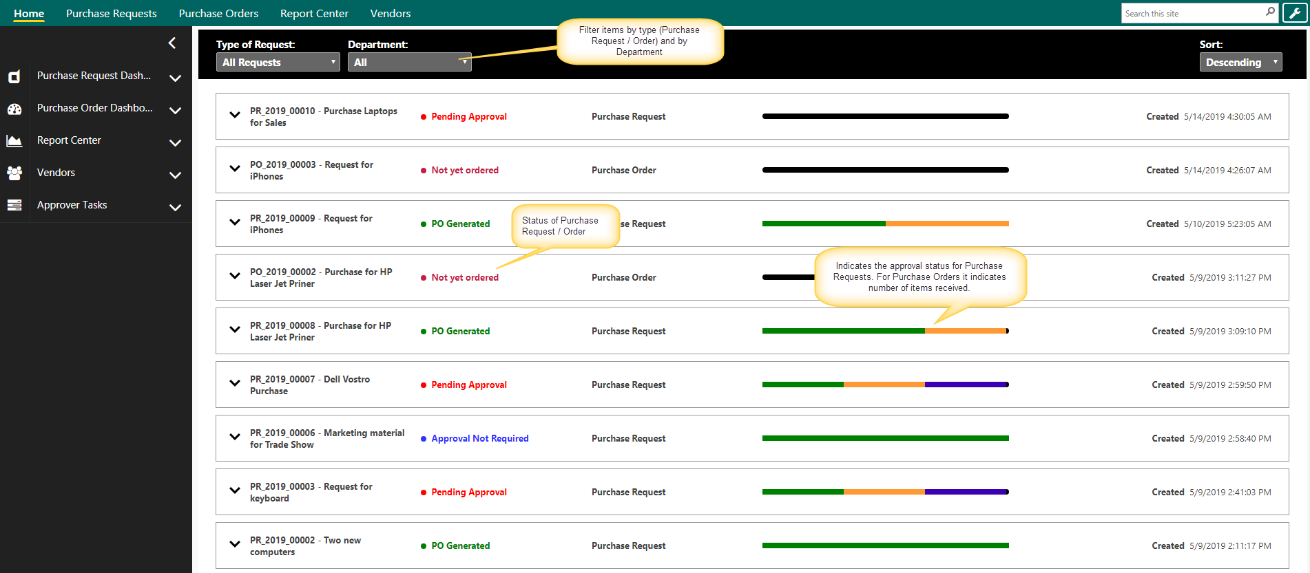
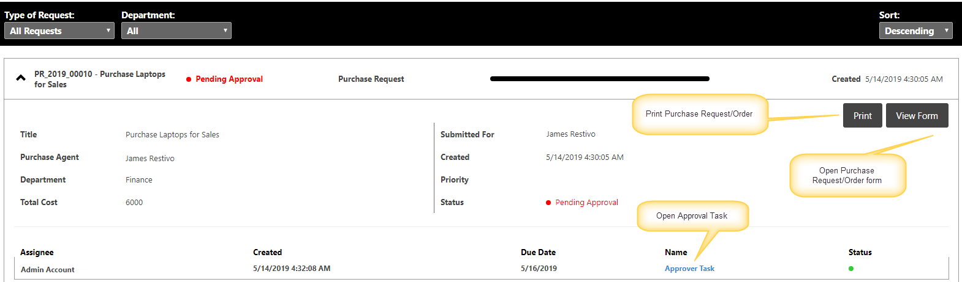

Purchase Requests Dashboard
This page shows
- Tiles: Clickable cumulative counts for various status like Open purchase requests, pending approval etc.
- Graphical Reports
- Tabular Reports: Like My Purchase Requests, All open Purchase Requests etc.
By default, Purchase Request application comes with Crow Canyon branding as shown in below image. Refer this article for more details on branding and how to change it.
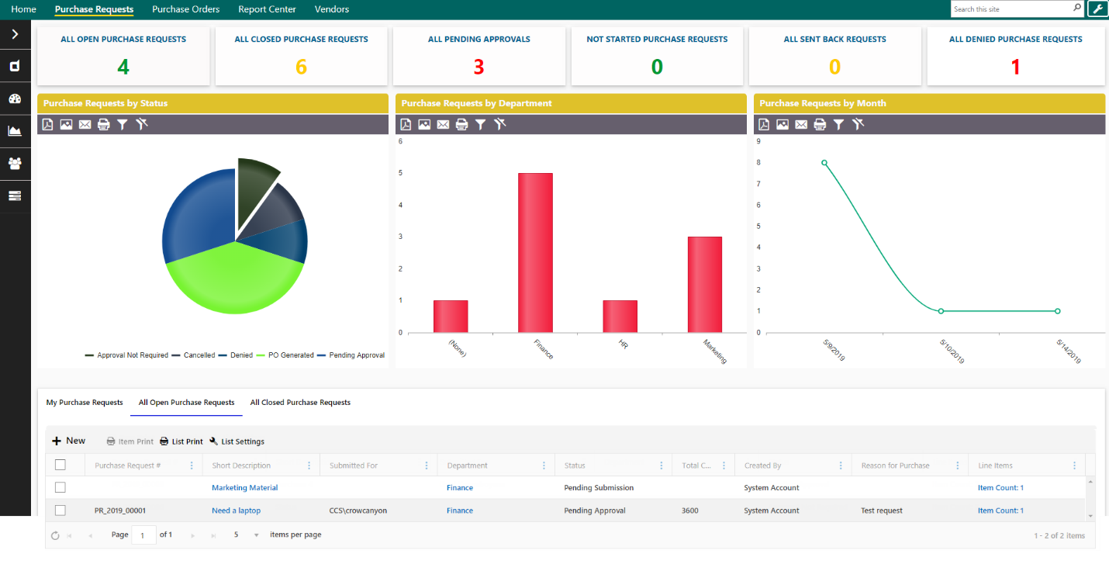

Purchase Orders Dashboard
This page has following sections:
- Clickable Tiles that show count of Purchase Orders in different states
- Graphical Reports
- Tabular Reports to show Open Purchase Orders, Purchase Orders to be ordered and to be reconciled etc.
Purchase Orders cannot be created directly from the Purchase Orders list. Purchase Orders can only be created from approved Purchase Requests.
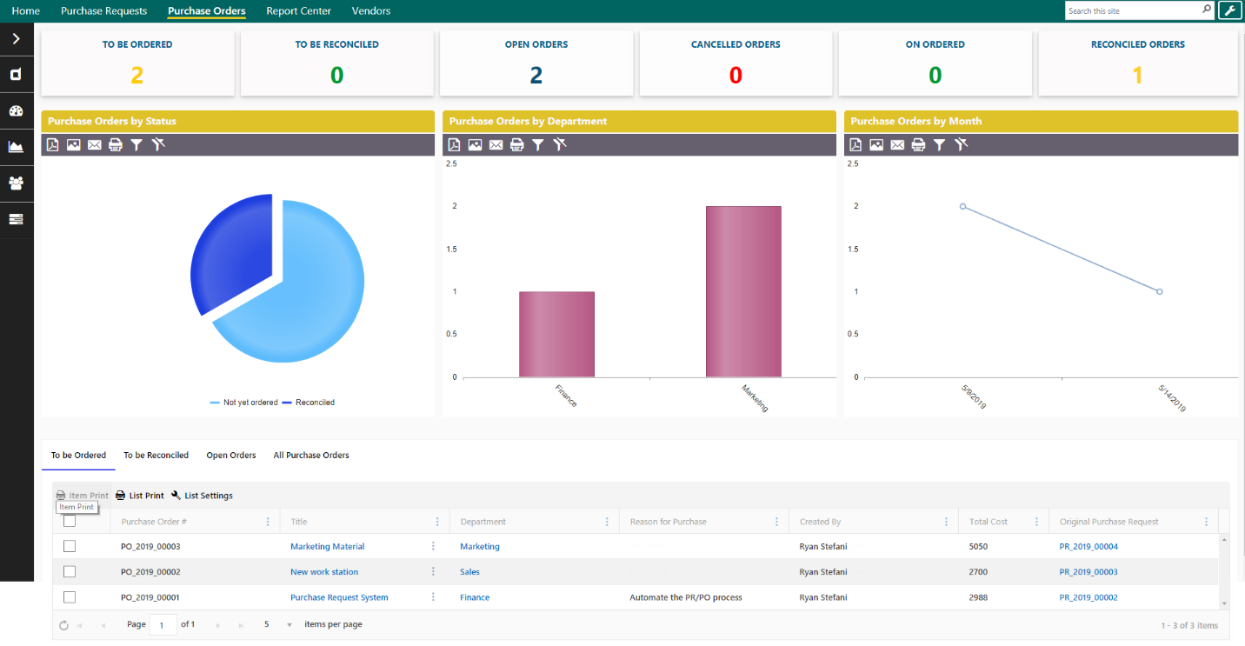

Report Center
Different reports configured on the Purchase Requests and Purchase Orders are shown on this page. Reports can be created/updated using NITRO Reports component. Refer this article for more details on the Reports.

Vendors
This page shows all Vendors in the system. We can add/update vendors from this page.

Left Navigation links

Purchase Requests Dashboard
This link navigates to the dashboard page for “Purchase Requests”

New Purchase Request
Users can create new Purchase Requests using this link

All Purchase Requests
This page has several tabs to show Purchase Requests with different stages. Also, users can see PRs submitted by themselves

Search Purchase Requests
This page can be used to search Purchase Requests in the system. Simple and advanced options are available to search as per the requirement

Purchase Order Dashboard
This link navigates to the dashboard page of “Purchase Orders”

Report Center
Navigates to the Report Center page to view various reports configured in the system

Vendors
Navigates to the “Vendors” page to view and update vendors

Approver Tasks
Users can see their pending approval tasks and open them to approve/deny. They can also see tasks for other users; however, they can’t update the approval decision for tasks not assigned to them.

Application Administration
Application Administration workspace provides easy access to configure the Purchase Order application.
Accessing the Application Administration workspace page
Application Administration page is accessed by clicking the settings icon on the top right side of the page. Users need to have at least “Manage Web” permissions on the site to see this icon and navigate to the page.

To grant “Manage Web” permission level, go to root site collection Site Settings Site Permissions Click Permission Level’s in the ribbon Edit the required permission level Select “Manage web Site” permission under Site Permissions section and save the permission level.
For more details regarding permissions levels, please refer this article.
Application Administration page
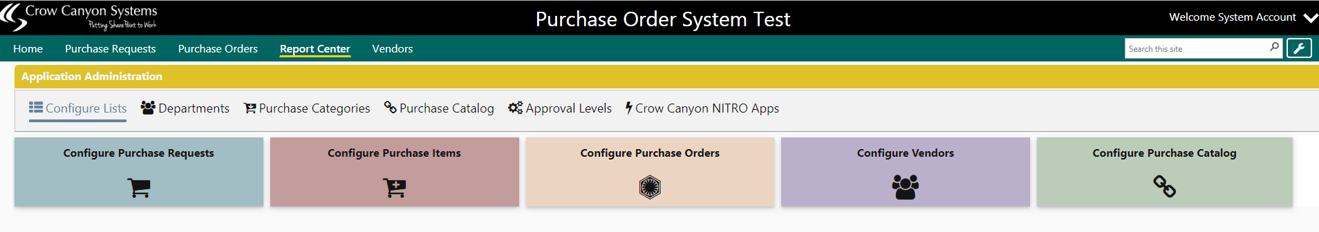
This workspace page allows Administrators to configure the following:
- Configure Lists
- Departments
- Purchase Categories
- Purchase Catalog
- Approval Levels
- Crow Canyon NITRO Apps

Configure Lists
Administrators can add/update the columns, Forms, Custom Actions etc. for Purchase Requests, Purchase Items, Purchase Orders, Vendors and Purchase Catalog.
These are the core lists that compose the purchasing application.

Departments
This list is used to specify the departments available in the system. Based on department approval levels can be specified. Custom permissions can also be configured based on department using Crow Canyon NITRO Workflows.

Purchase Categories
Define the required Purchase Categories.

Purchase Catalog
This is a catalog of frequently used line items that users can easily add to the purchase requests.

Approval Levels
Administrators can define multiple approval levels in this list. Here one Approval Level can be linked to multiple “Departments”. This list will take “Type of Purchase”, “Department”, “Amount”, “Purchase Agent”, “Level” and “Due Hours” as input for the Approval Levels.
Approval Tasks will be created for the approval levels based on the “Department”, “Type of Purchase” and the “Total Cost” of the line items in the Purchase Request.
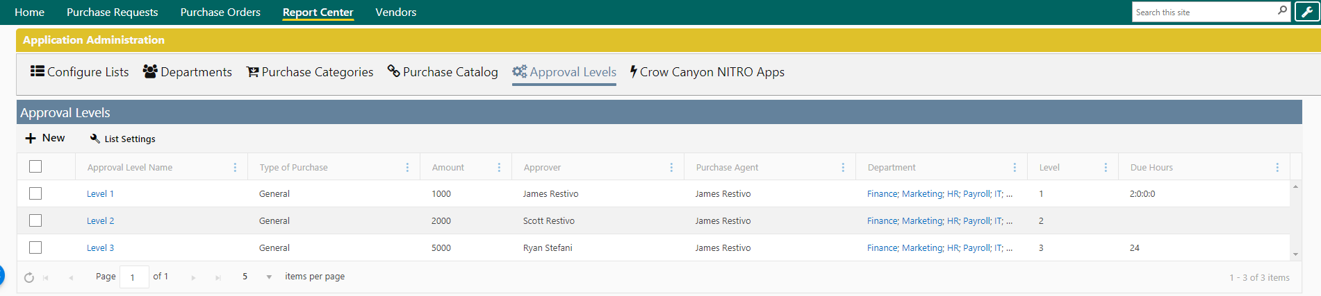
Approval Level Form
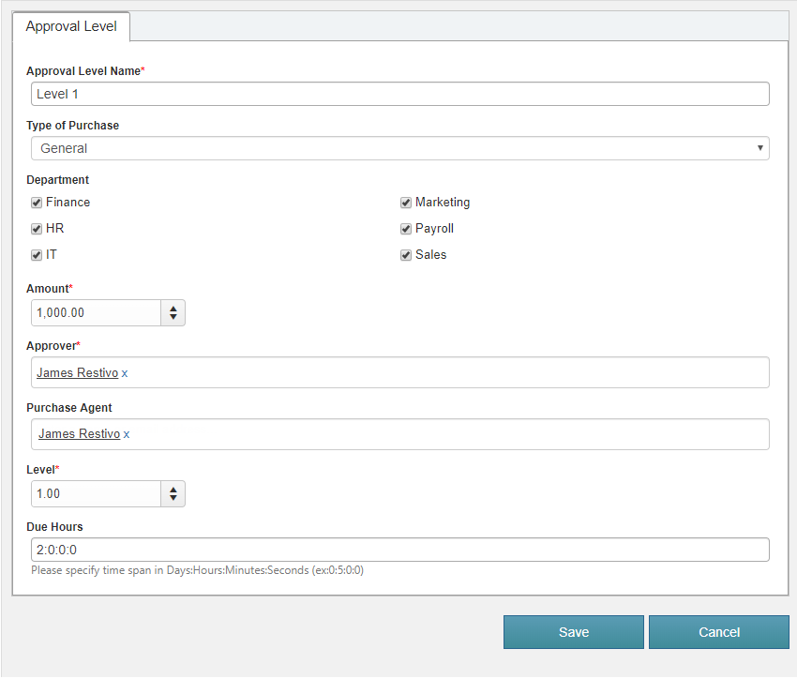

Crow Canyon NITRO Apps
We can navigate to configuration pages of various NITRO components from this tab. We can then configure Forms, Workflows and other features to customize the application. For more details about the NITRO features, refer this article.
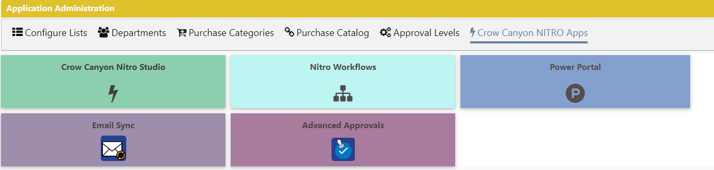

Purchase Request Approval process
Approval process works based on the approval levels defined in the system. These can be defined based on the department, total cost of the request and type of purchase etc. One or more levels can be defined for different combinations of these parameters. Administrators need to setup the Approval Levels before requests can be submitted.

Approval flow
Below flow chart explains the overall approval process in the Purchasing application. This example is for a three-level approval process.
Crow Canyon Purchasing application has a flexible approval process to define any number of approval levels based on the department, amount and other parameters.
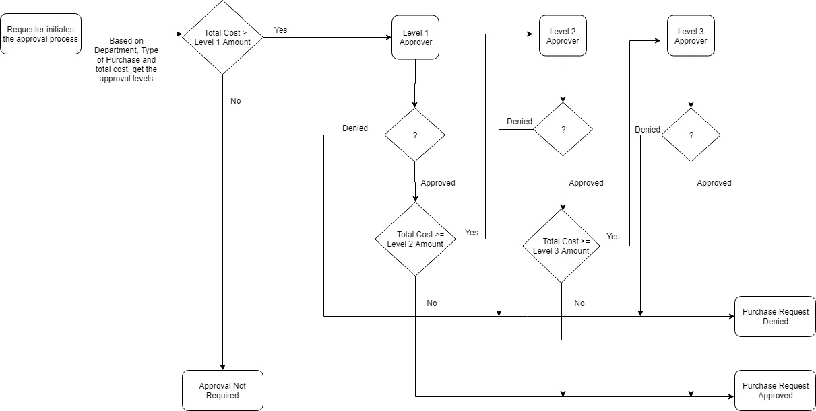

Submit for Approval
Requester initiates the approval process for the Purchase Request by clicking the “Submit for Approval” button (available in New, Edit and Display forms).
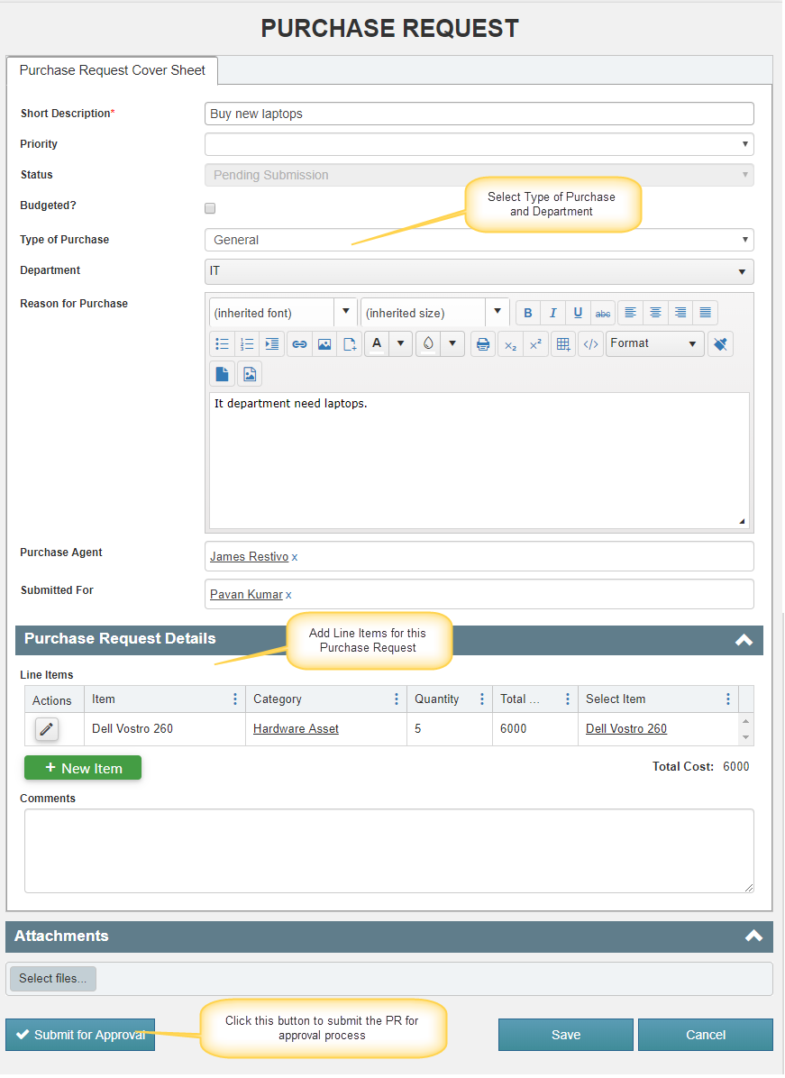
Once the Request is submitted for approval:
- Purchase Request Id will be generated for the Purchase Request. This is a custom generated Id with below format.
Ex: PR_2019_003

Format of this Id can be modified as per your organizational needs, refer this article for more details.

- Based on the “Type of Purchase”, “Department” and the total cost of the Purchase Request, approval tasks will be created for applicable approval levels. If none of the approval level is applicable based on the request parameters then request will be approved with status as ‘Approval Not Required’

- When an approval task is created, approver will receive email notification with links to the Purchase Request and the approval task.
Note: Notifications are configured using Crow Canyon NITRO Workflows and these notifications are configurable. To modify the notification templates, go to Application Administration NITRO Workflows Edit “Notify Approver on task submission” workflow Edit “Notify Approver on task creation” and “Notify Submitted for on Approval Task Creation” send mail actions and modify the mail templates as required.
- Approver can “Approve”, “Deny” or “Send Back” the request using action button in the approval task form

- Based on the approval decision, Purchase Request will go for the next level in the process (Approved/Denied/Next level approval task)
Approvers can take the decision in two ways:
- Using Custom Actions
- Using Lazy approval process

Using Custom Actions

Approve
- This action will be visible only to the user to whom task is assigned
- This action will set the approver task decision to “Approved”
- It will create the next level approver task or approve the Purchase Request based on the applicable approval levels for the request
- When Purchase Request is approved, Requester and Purchase Agent will receive email notifications
Note: To modify the Approval notification mail template, go to Application Administration Crow Canyon NITRO Apps NITRO Workflows Edit “Purchase Request Updated Send Mail” workflow Edit “Send Approval mail” send mail action and modify the mail template as required.

Send Back
- This action will be visible only to the user to whom task is assigned
- This action will set the approver task decision to “Sent Back” and update the Purchase Request Status to “Sent Back”
- An email will be sent to Requester and the Purchase Agent
Note: To modify the Approval notification mail template, go to Application Administration Crow Canyon NITRO Apps NITRO Workflows Edit “Purchase Request Updated Send Mail” workflow Edit “Send mail on sent back” send mail action and modify the mail template as required.
After this step, Requester can modify the Purchase Request and re-submit it for approval.

Deny
- This action will be visible only to the user to whom task is assigned
- This action will set the approver task decision to “Denied” and update the Purchase Request Status to “Denied”
- An email will be sent to Requester and the Purchase Agent
Note: To modify the Approval notification mail template, go to Application Administration Crow Canyon NITRO Apps NITRO Workflows Edit “Purchase Request Updated Send Mail” workflow Edit “Send Denied Mail“ send mail action and modify the mail template as required.
Once the Purchase Request is denied, it cannot be resubmitted.

Using Lazy Approval Process
Approver can also approve/deny the request directly from the email notification that is received when approval task is assigned to the user. User can click “Approve”, “Deny” and “Send Back” links in email for the corresponding action. For this we need to configure the lazy approval email address for the “Approver Emails” list.

SharePoint On-Premises
Enable the “Incoming Email Address” for the “Approver Emails” list and configure the lazy approval email address.
To configure the lazy approval process, configure the email sync for “Approver Emails”.
Go to Site Contents Approver Emails list and configure incoming email address for this list
Note: If the incoming email feature is not enabled in the server, refer this article to configure the incoming emails for a SharePoint server.

SharePoint Online
To configure the lazy approval process in SharePoint online, configure the lazy approval email address in email sync settings. Refer instructions from this article

Purchase Request Form
Purchase Request form is configured using Crow Canyon NITRO forms as shown below. Form can be changed from the NITRO Forms designer. Adding new columns to the list and to the form can be done from the designer and form layout can be changed as well. Below columns are used in the Purchase Request approval and other processes, these columns shouldn’t be updated/removed without consulting Crow Canyon.
Columns:
- Short Description
- Status
- Type of Purchase
- Department
- Purchase Agent
- Submitted For
- Line Items
- Total Cost
- Approval Level
- Level
- Approved Date
- Purchase Quantity
- Purchase Order
- Approval Tasks
- Purchase Request #
- Reason for Purchase
- Reason for Cancellation

Refer NITRO forms section in this article for instructions to configure NITRO forms.
Short Description: Provide short description for the Purchase Request
Priority: Specify the priority of this Purchase Request
Status: Shows the current status of the Purchase Request
Type of Purchase: Specify the Type of Purchase
Department: Specify which department is going to purchase the items
Reason for Purchase: Specify reason for this Purchase Request
Submitted For: Will be auto filled with logged in username, can be changed if required
Purchase Agent: Specify the Purchase Agent who will handle the Purchase Order
Line Items:
To submit the Purchase Request, user need to specify at least one line item. Line items can only be added from the Purchase Request form. Line Items are not allowed to be created directly from the “Purchase Items” list.
Once the Purchase Request is submitted, Line Items are made read-only. This is done to prevent changing the total amount and other aspects of line items during or after the approval process.
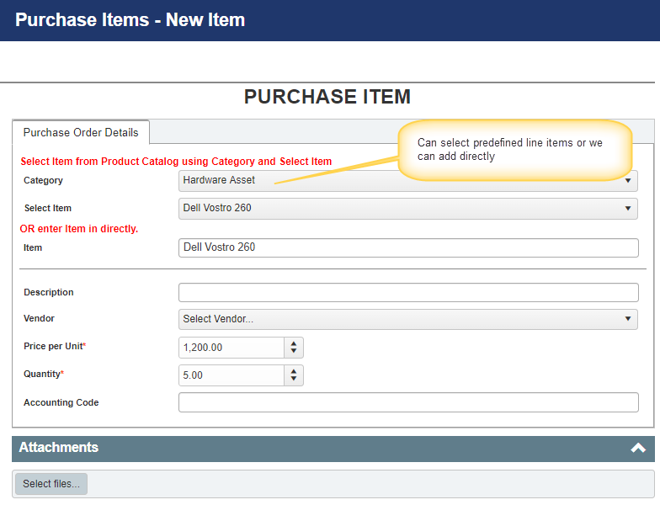

Purchase Order Creation from Purchase Requests
Purchase Orders are created from approved Purchase Requests. They are not allowed to be created directly from the Purchase Orders list as new items.
User can create a new Purchase Order for a Purchase Request or link an existing Purchase Order to it. This can be done from the buttons in the Purchase Request form ribbon as shown below:
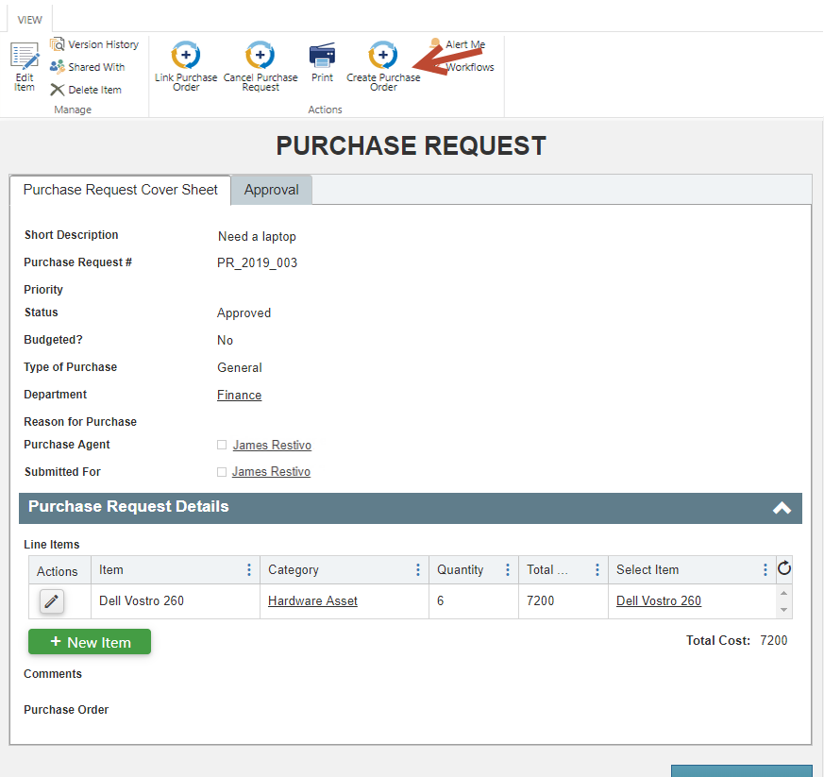

Create Purchase Order
- This action will be visible only when Purchase Request Status is “Approved” or “Purchase Order Cancelled” or “Approval Not Required”
- This action will create a new Purchase Order as per the details of the Purchase Request and link it to the Purchase Request. Details of Purchase Request that are mapped to Purchase Order are configurable
To modify Purchase Request to Purchase Order column mappings, go to Purchase Request list List Settings Crow Canyon Custom Actions Edit “Create Purchase Order” custom action and add/modify the column mappings as required.

Link Purchase Order

- This action will be visible only when Purchase Request Status is “Approved” or “Purchase Order Cancelled” or “Approval Not Required”
- This action will link an existing Purchase Order to the Purchase Request. It will update the line items and total cost of the Purchase Order

Purchase Order Form
Purchase Order form is configured using Crow Canyon NITRO forms as shown below. Form can be changed from the NITRO Forms designer. Adding new columns to the list and to the form can be done from the designer and form layout can be changed as well. Below columns are used in the approval and other processes, these columns shouldn’t be updated/removed without consulting Crow Canyon.
Columns:
- Status
- Purchase Agent
- Total Cost
- Reason for Purchase
- Updated Cost
- Purchase Order #
- Line Items
- Purchase Requests
- Reason for Cancellation
- HiddenStatus
- Purchase Quantity
- Department
- Original Purchase Request

Refer NITRO forms section in this article for instructions to configure NITRO forms.
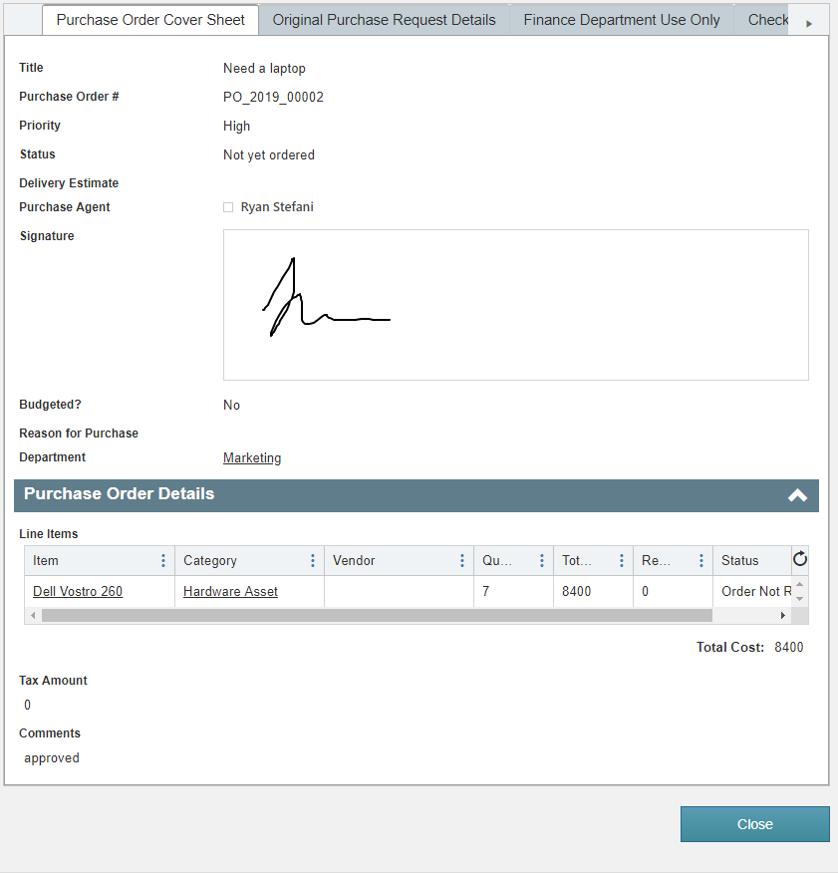

Purchase Order Fulfillment process
Application has a feature to track delivery of line items requested in the Purchase Request, including partial delivery. Once all the items are received, Purchase Order status will be automatically set to Fulfilled.
Users will use action “Update Received Quantity” to update Line Items received quantity. For this, open the line item from the Purchase Order and click “Update Received Quantity” action. This action will take the input for the “Received Quantity”. When the “Quantity” and “Received Quantity” for all the Line Items become equal, Purchase Order status will be set to Fulfilled.
Fulfilled is the final value for Purchase Order status, further modifications are not allowed once this status is reached.
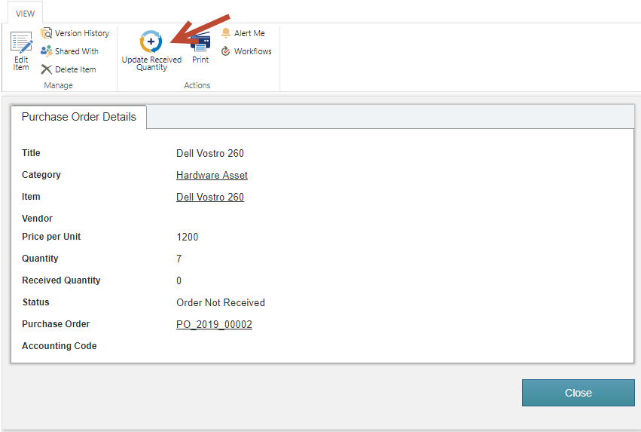

Print Purchase Order
Once Purchase Order is created, it can be printed for sending to vendor or any other purpose. Application comes with a standard print template that is configured using NITRO Print Manager.
Administrators can modify the print template as needed. Go to Site Contents Purchase Orders list List Settings Crow Canyon Print Manager Edit Purchase Order Template and configure the print template as required.
Refer this article for sample print template configurations.
Sample print template:
