Onboarding: Administrator Guide

Onboarding: Administrator
Administrators are the users who can configure the application. This includes defining the approval levels and approvers, form configurations, permissions etc. They can be specified in a SharePoint group with Full Control permissions on the application site. Or they can be the Site Collection administrators. These users can access “Application Administration” page to configure the application.

Administrator Guide Steps for Onboarding Application
Administrators have access to Admin Dashboard page.

Apart from this page, Administrators also have access to ‘Application Administration’ where several elements of the program can be modified.

Application Administration
Application Administration workspace provides easy access to configure Onboarding application.
Accessing the Application Administration workspace page
The Application Administration page is accessed by clicking the settings icon on the top right side of the page and selecting Application Administration from the dropdown. Users need to have at least “Manage Web Site” permissions on the site to see this option in the dropdown and navigate to the page.
To grant “Manage Web Site” permission level, go to root site collection àSite Settings à Site Permissions à Click Permission Levels in the ribbon à Edit the required permission level à Select “Manage Web Site” permission under Site Permissions section and save the permission level. By default, the Full Control permission level includes this option. You can create additional custom permission levels that include this option as well:
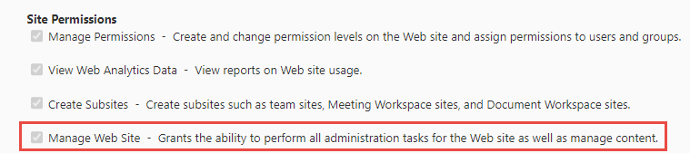
For more details regarding permissions levels, please refer this article.
Click ‘Application Administration’ in the settings as shown below:

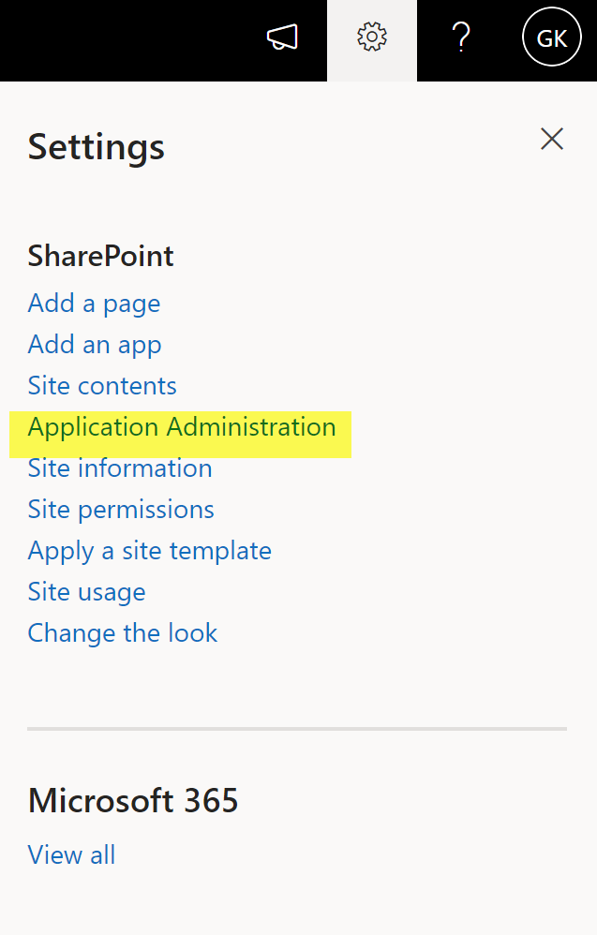

Application Administration page

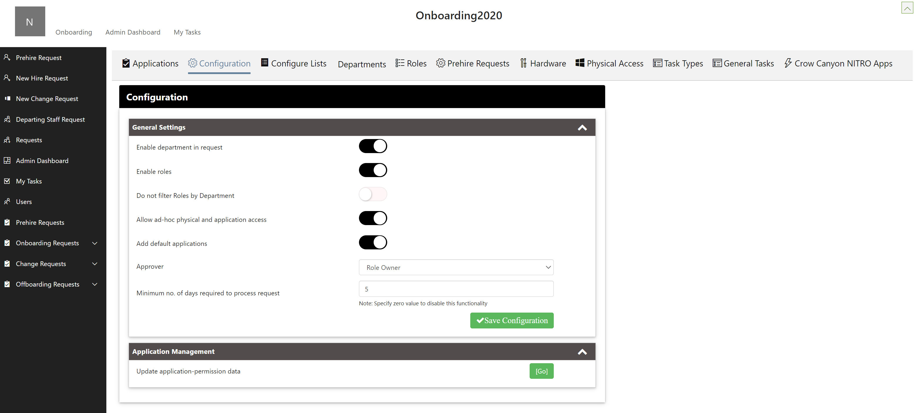

This workspace page allows Administrators to configure the following:
- Applications
- Configuration
- Configure Lists
- Departments
- Roles
- Prehire Requests
- Hardware
- Physical access
- Task Types
- General Tasks
- Crow Canyon NITRO Apps

Applications
All applications are specified with permission and owner in Applications List as shown below:
Title: Title of the application. When adding new applications title can be provided as per application name.
Permissions: For the application mentioned in the title, permissions levels can be specified here. Not all the members of the organization will have the same permission levels on an application. It depends on roles and usage.
For example: For Cisco VPN application 3 permission levels are defined
Administrator
Contribute
Read
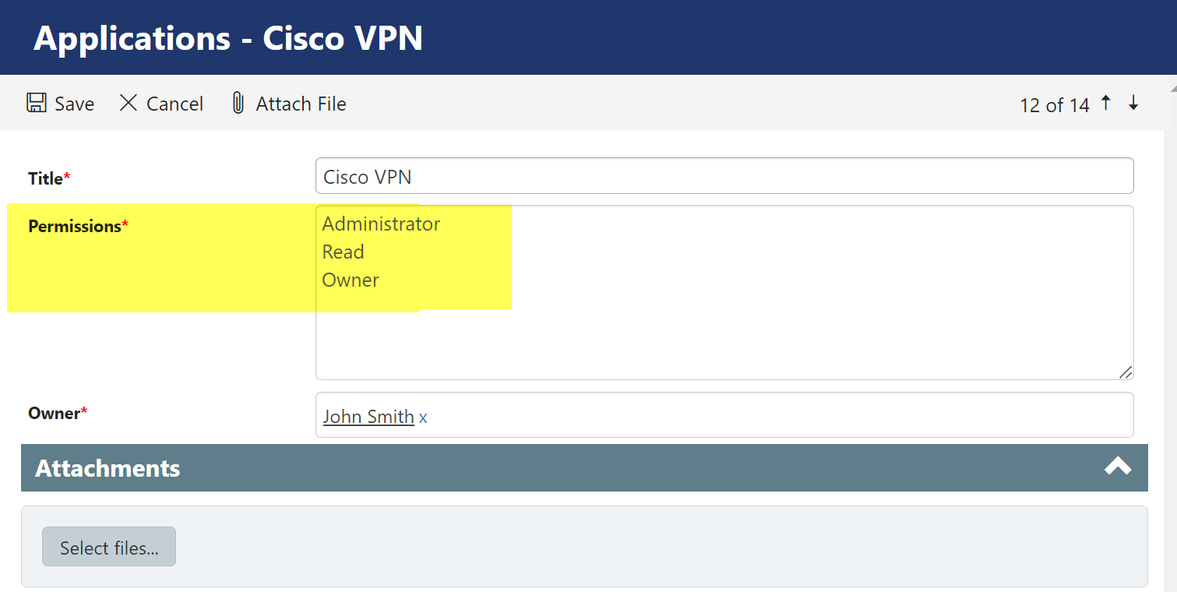

As the name suggests, some members will have read access and others will have administrative access.
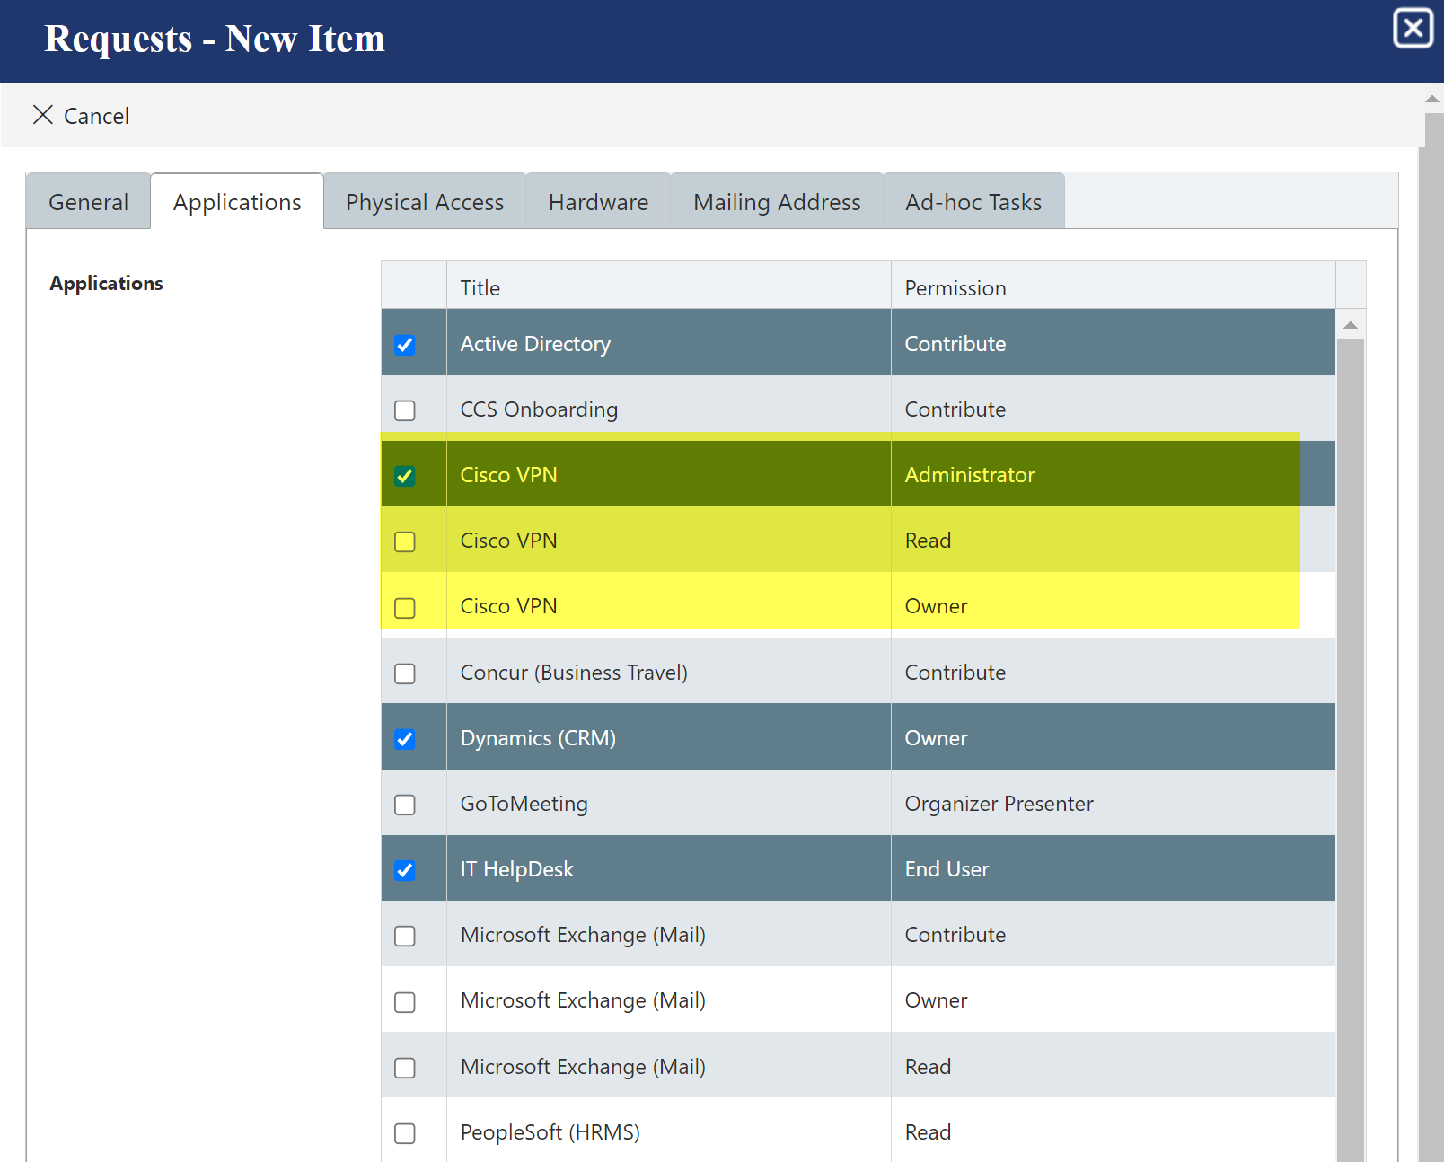

These permission levels can be defined in Applications.

Owner: Owner of the application
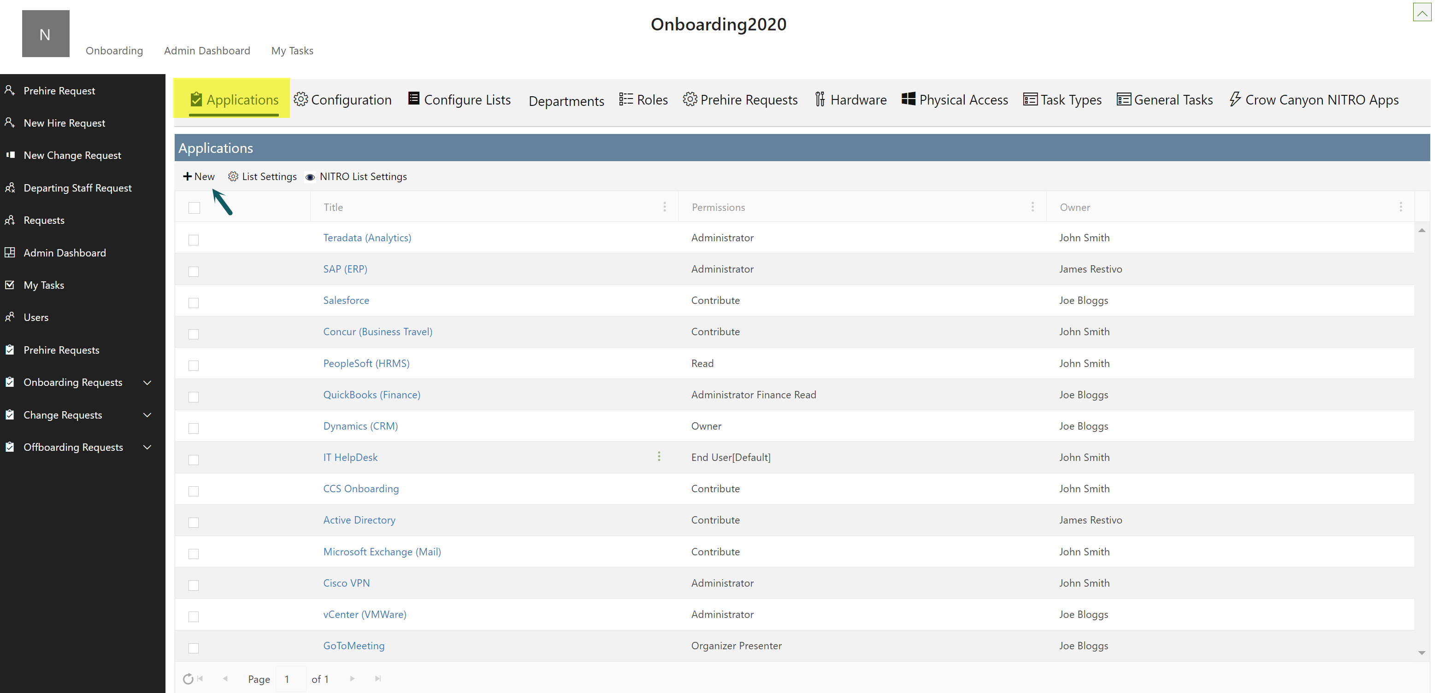
Click ‘New’ to create new Application.

Configurations
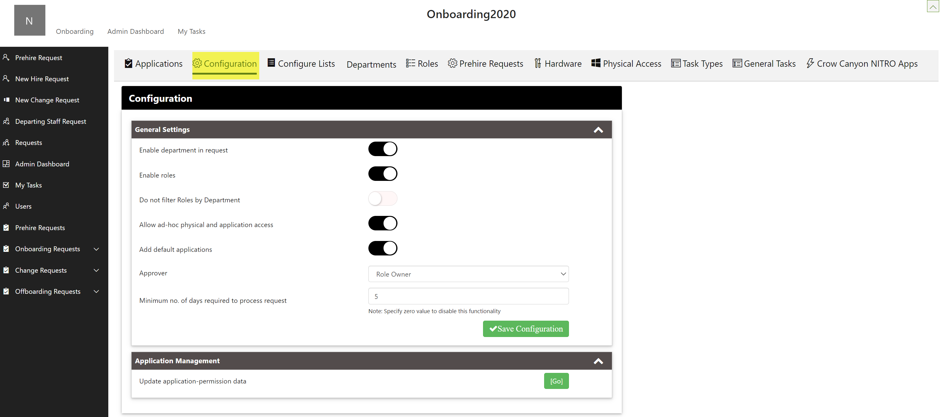
Enable department in request: To show the Department dropdown in the Onboarding/Offboarding/Change Request, enable this feature. Department can be used to filter the options for the “Role” field.
Enable roles: To show the Roles dropdown in the Onboarding/Offboarding/Change Request, enable this feature. The Role can be used as a template for access.
Do not filter Roles by Department: Enable this feature so as to not filter the roles by department. When this feature is enabled then roles drop-down while onboarding will show all the roles irrespective of the department. If this feature is not enabled then only department specific roles are displayed in the drop-down.
Allow ad-hoc physical and application access: If this feature is enabled. It will allow selecting the ‘Applications’. ‘Physical Access’ and ‘Hardware’. If this feature is not enabled then ‘Applications’, ‘Physical Access’ and ‘Hardware’ is auto selected as per ‘Role’ Specified.
For Example:
Without Enabling ‘Allow ad-hoc physical and application access’ feature:
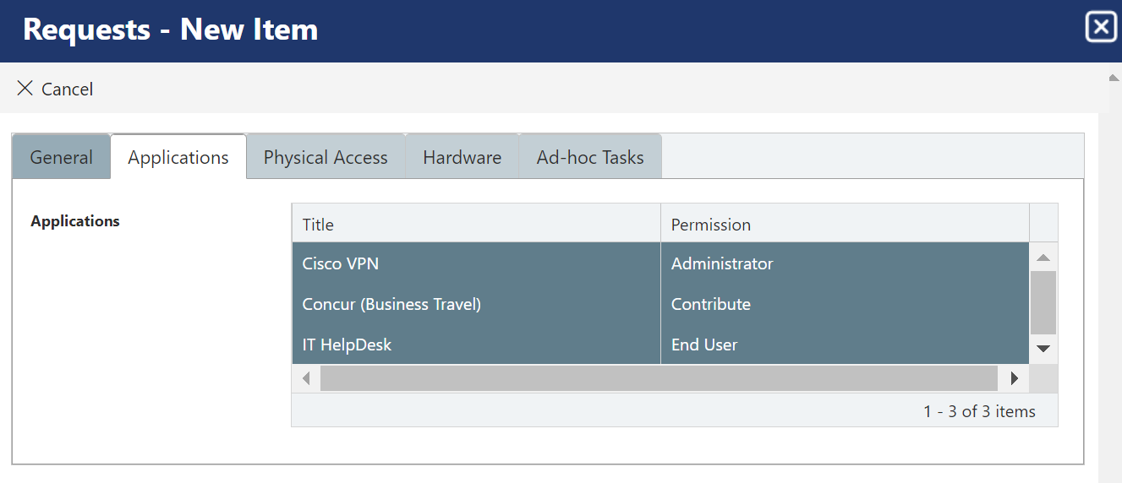
With Enabling ‘Allow ad-hoc physical and application access’ feature:
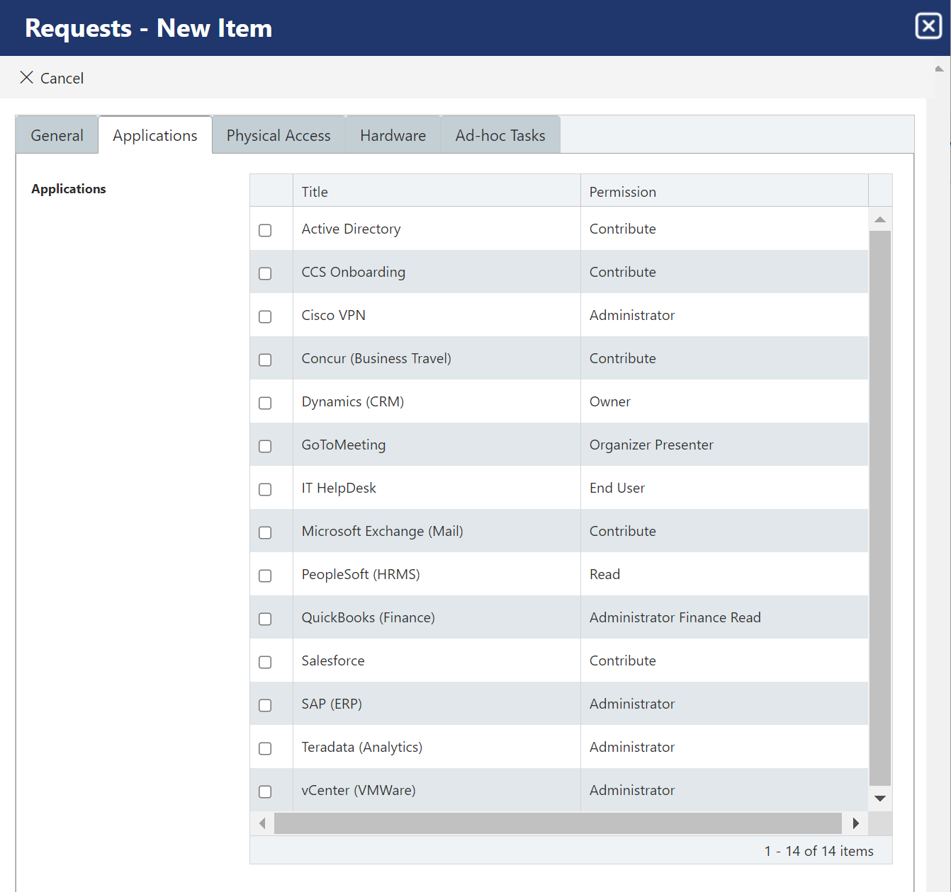
Add Default Applications: By enabling this feature, default applications are added in the request.
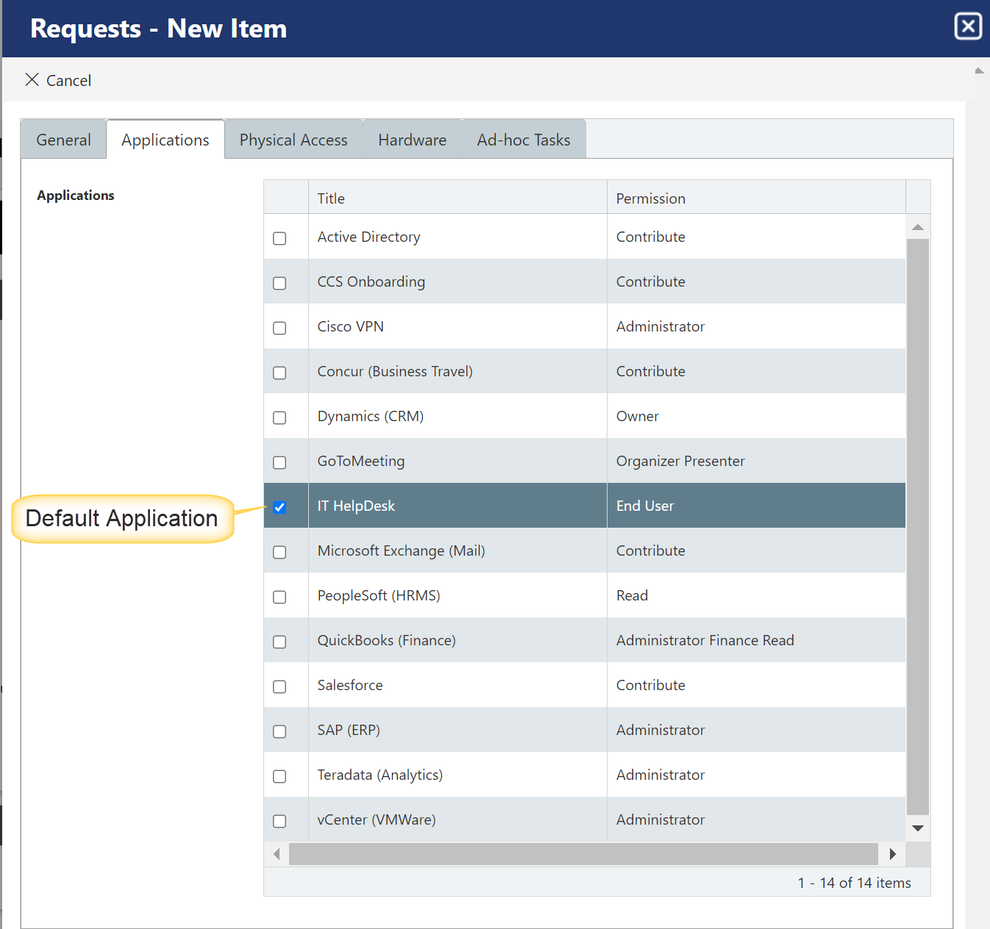
Permission for this application is specified as shown below in Applications List
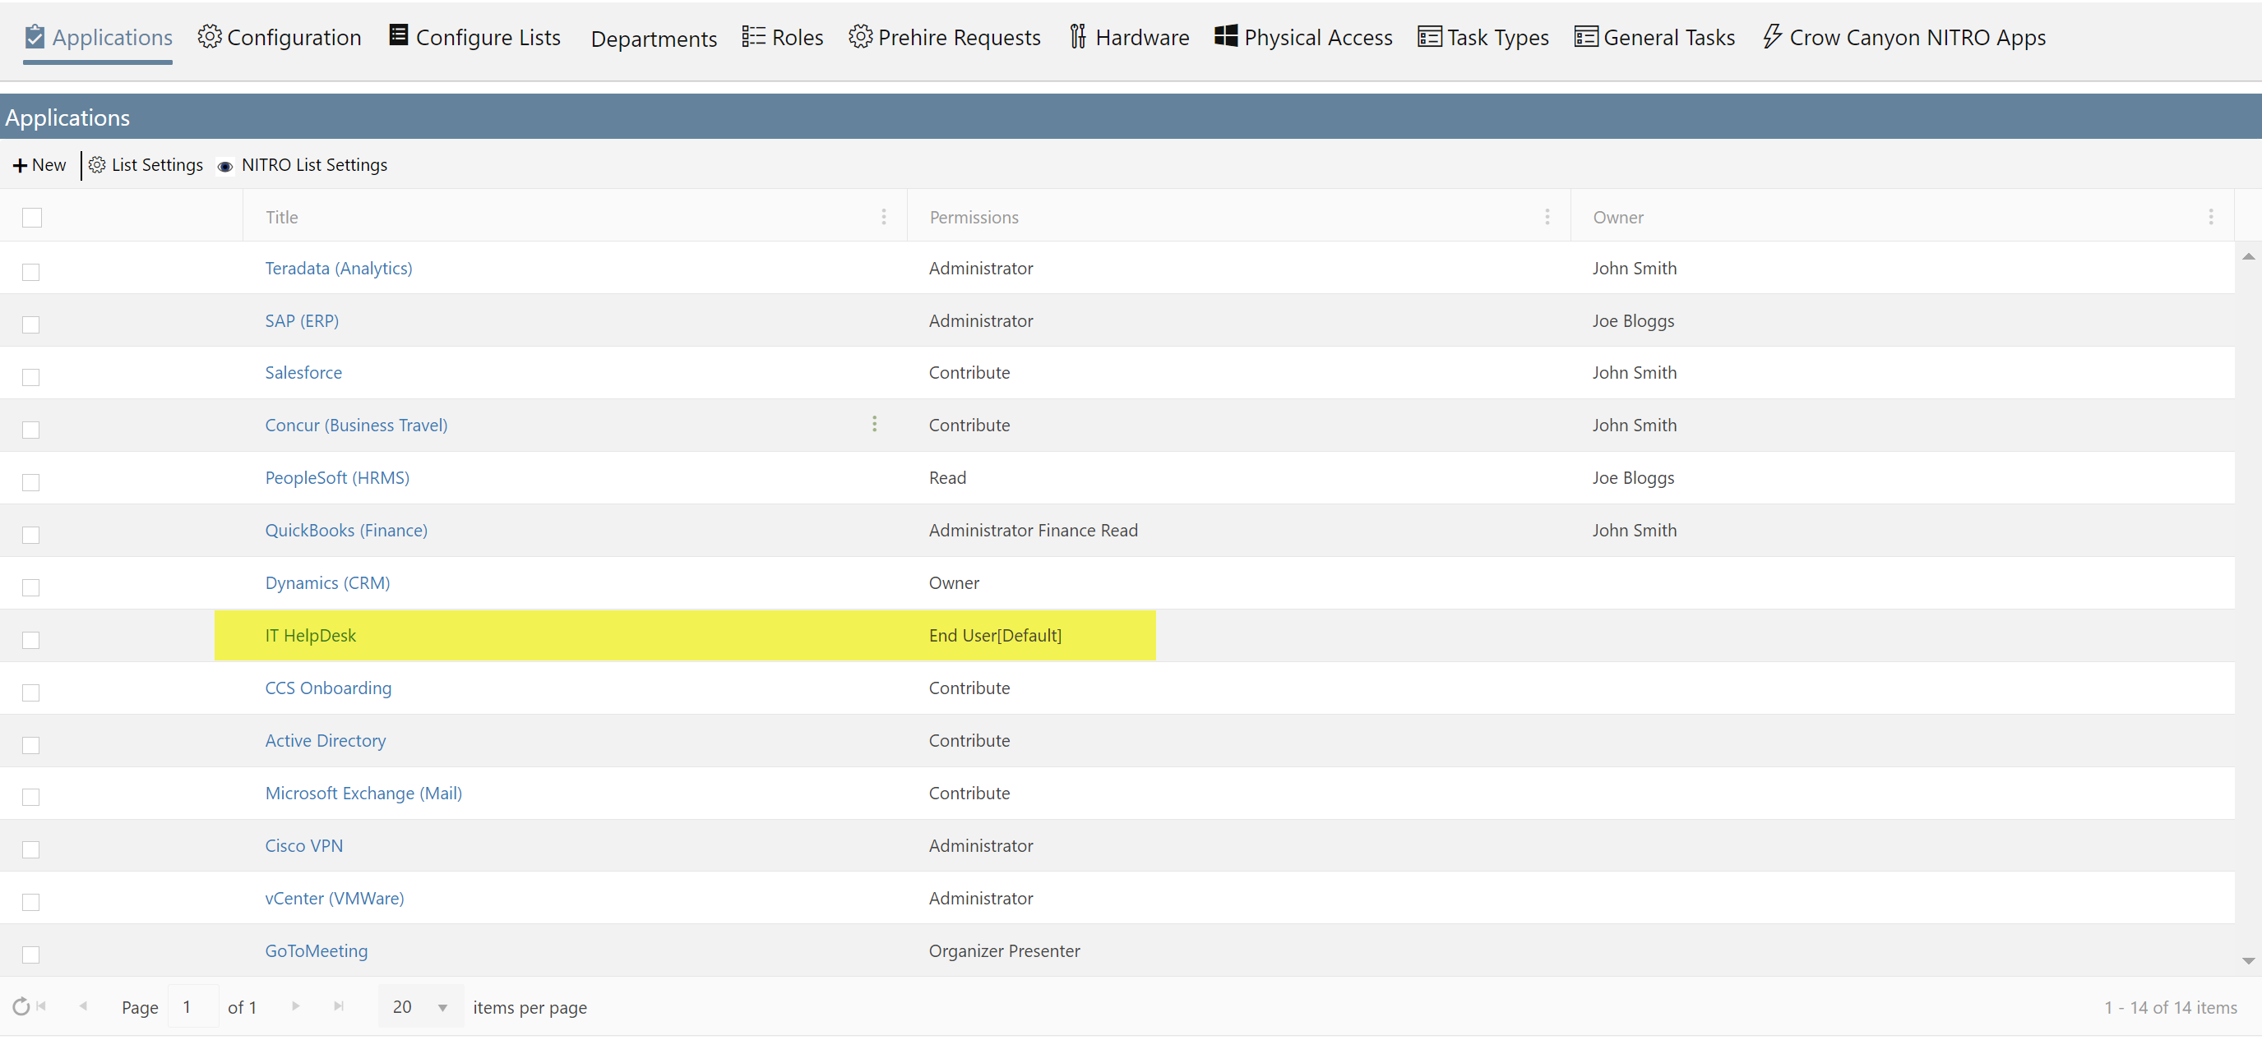
Approver: This dropdown column will show three types of approval scenarios.
- No Approval Required: If this is selected, then Onboarding request will not go for any approval. It will directly create the tasks.
- Role Owner: In Requests List, there is ‘Role’ Column in which Role Owner is selected. Approval Tasks will be created for that Role Owner.
- Manger/Supervisor: If this is selected, Approval Tasks will be created for Manager/Supervisor.
Minimum no of days required to process request: Specify the minimum no. of days to complete the Onboarding request. This message will be shown in ‘Effective Date’ column in General Tab of Requests New Item Form.
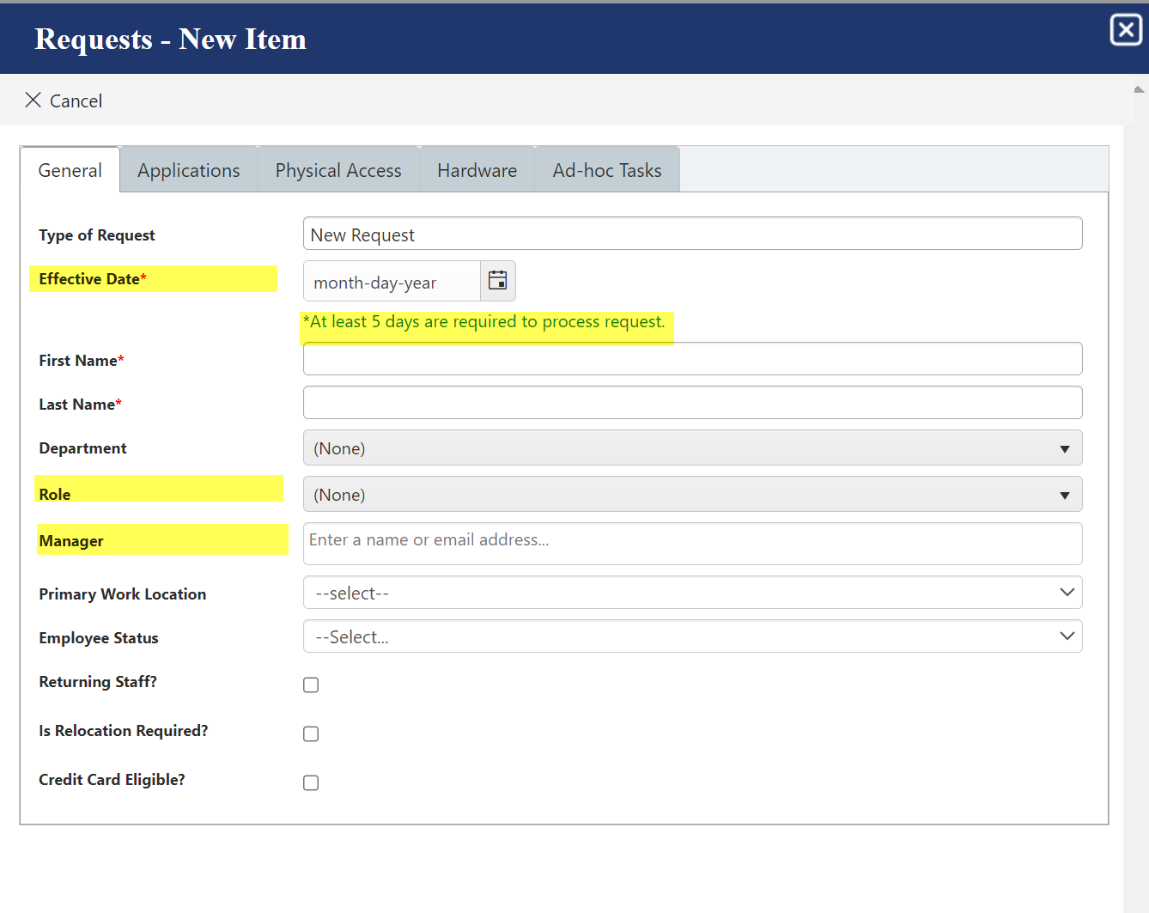

Update Application-permission data: In the Applications List, to update ‘Title’ and ‘Permission’ column data click ‘Go’ button on the right side of ‘Update Application-permission data’ column in ‘Configuration’ tab. Once updated, a message ‘Application Successfully Synched’ will be displayed.
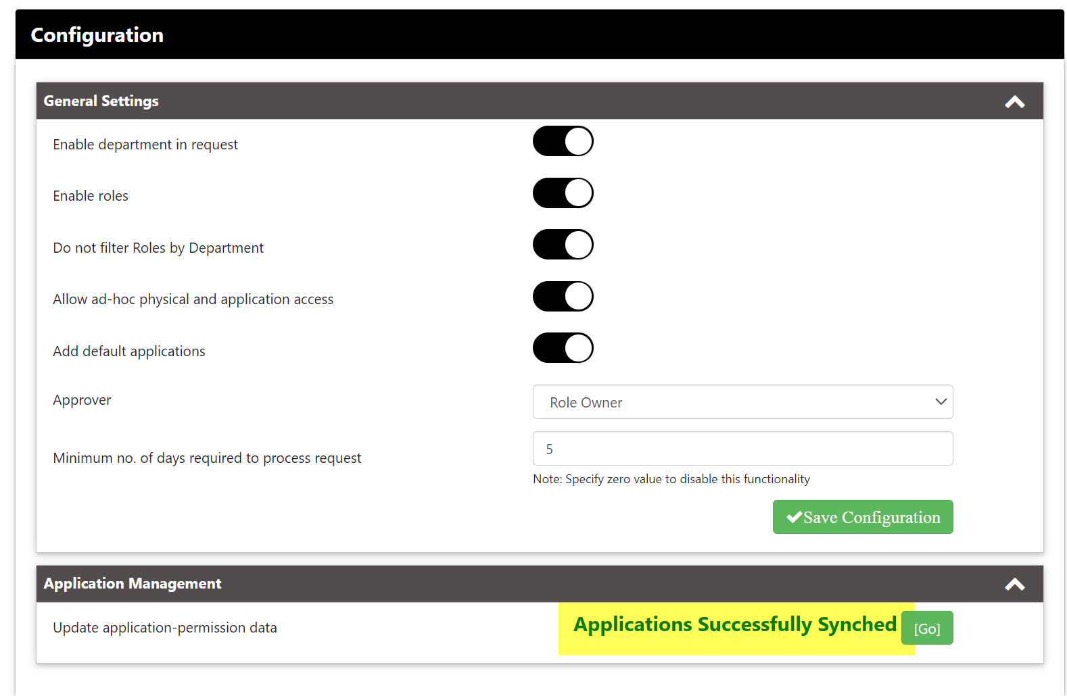

Configure Lists
Below page shows the link to List Settings page for each of the core lists used in Onboarding application
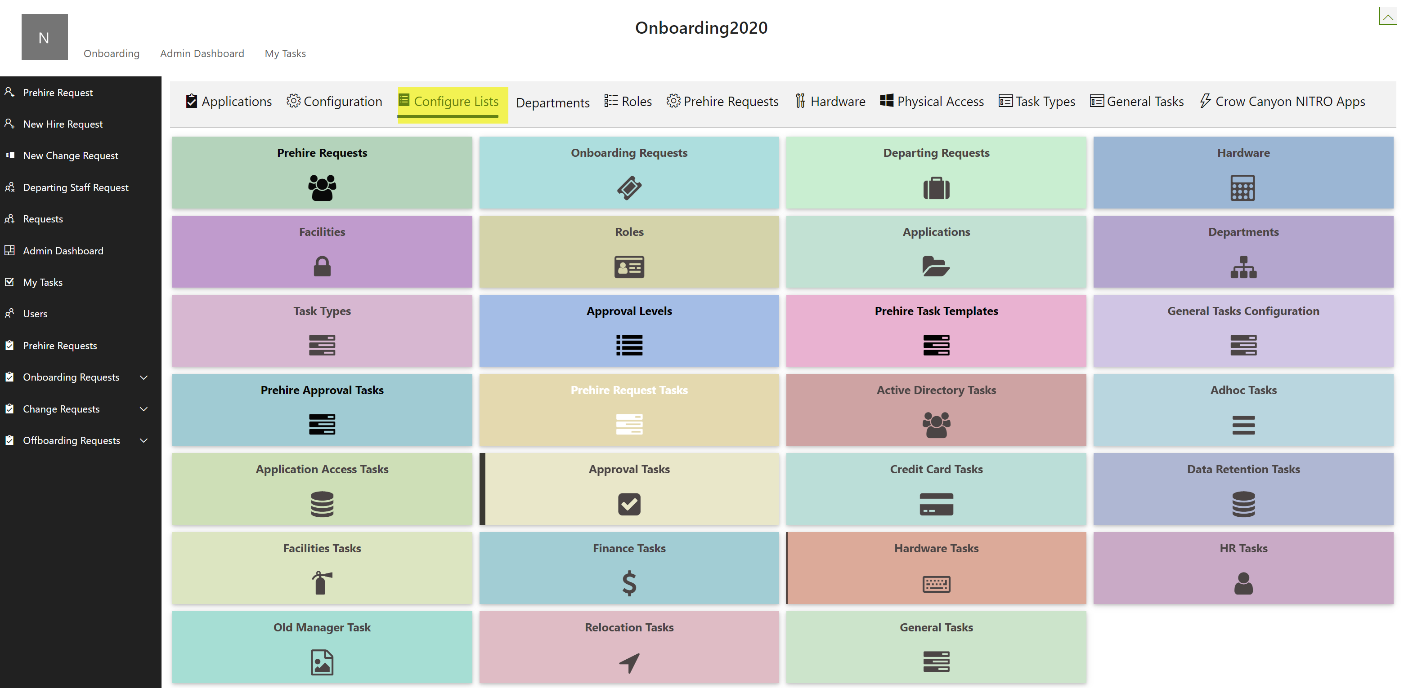
Click the corresponding title to access the List Settings for the given list. This is useful if you need to quickly access NITRO Forms, NITRO Custom Actions, list views, and other elements in List Settings.

Departments
Here we can add/delete departments. The departments present here will appear in the department drop-down in the onboarding application
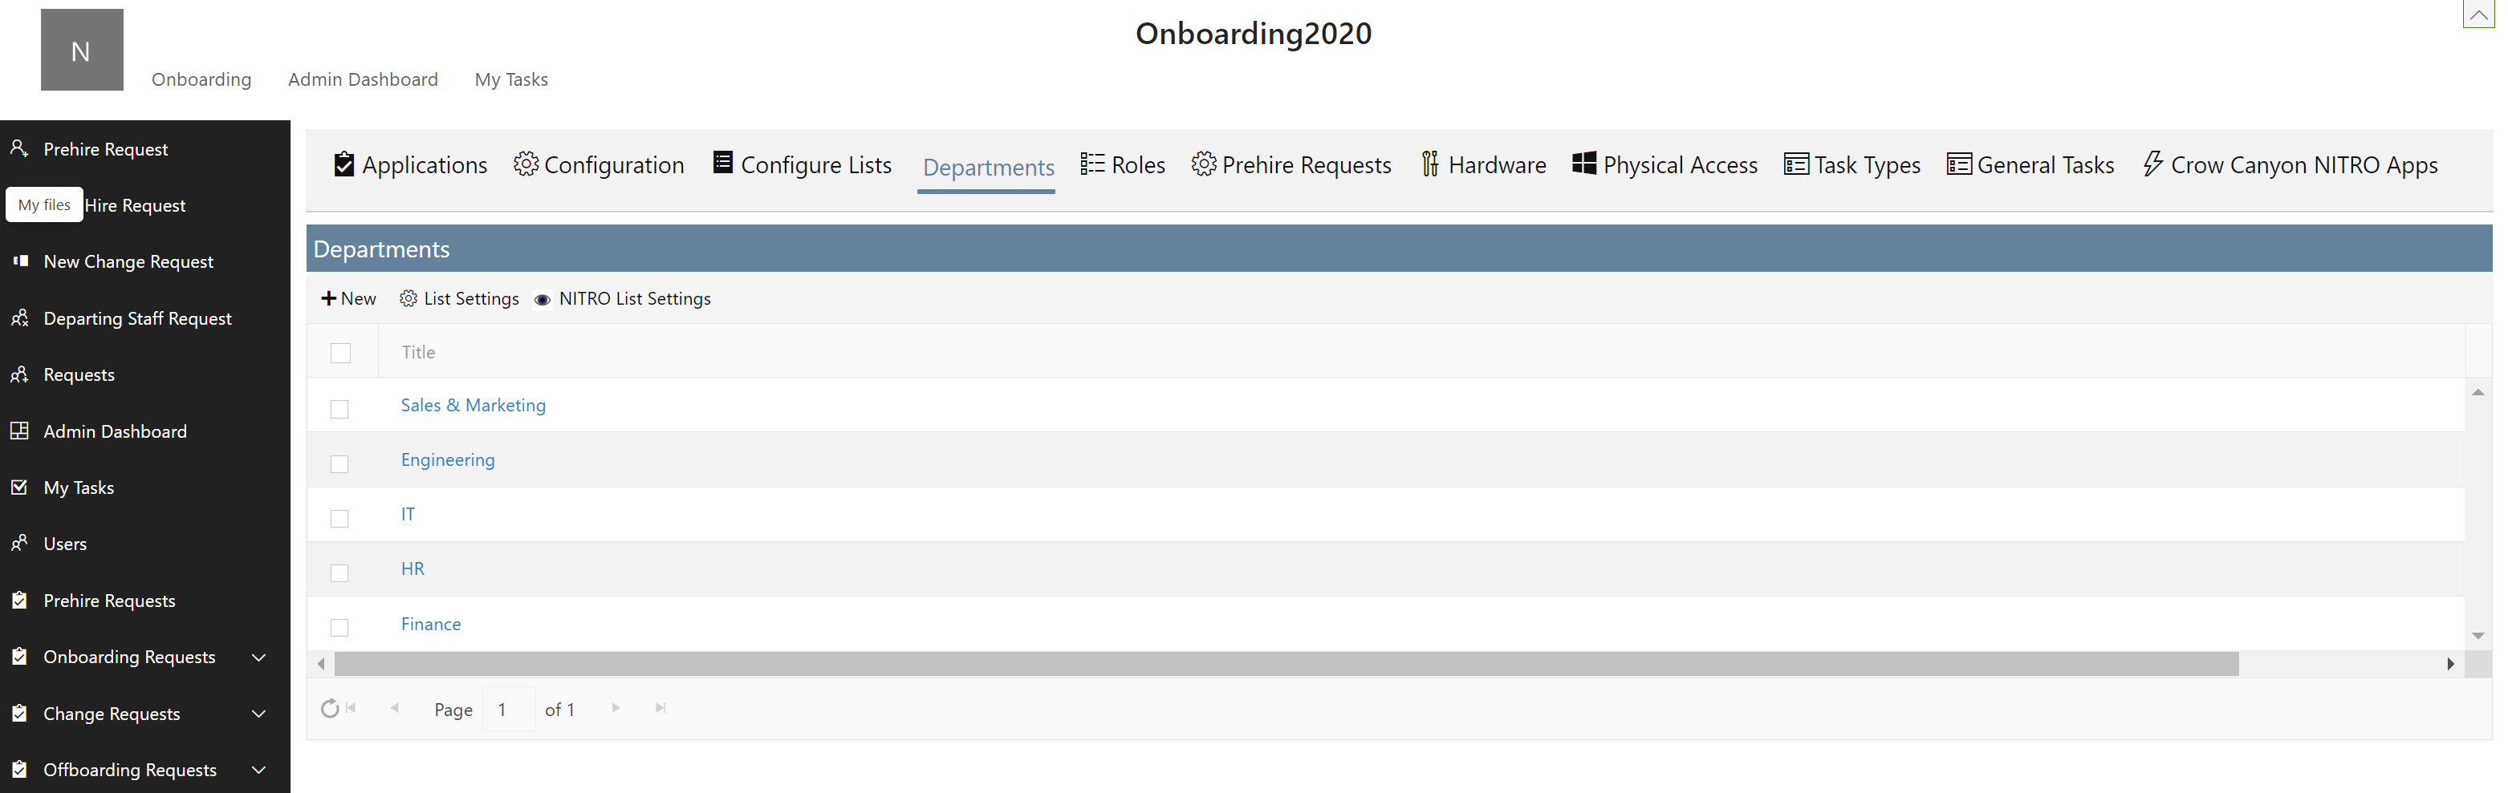

Roles

Here we can add/delete roles for departments. The department dropdown will have values from the department list. We can also select applications, physical access, hardware required for such a role. These will be auto-selected in the Onboarding/Offboarding/Change Request form.

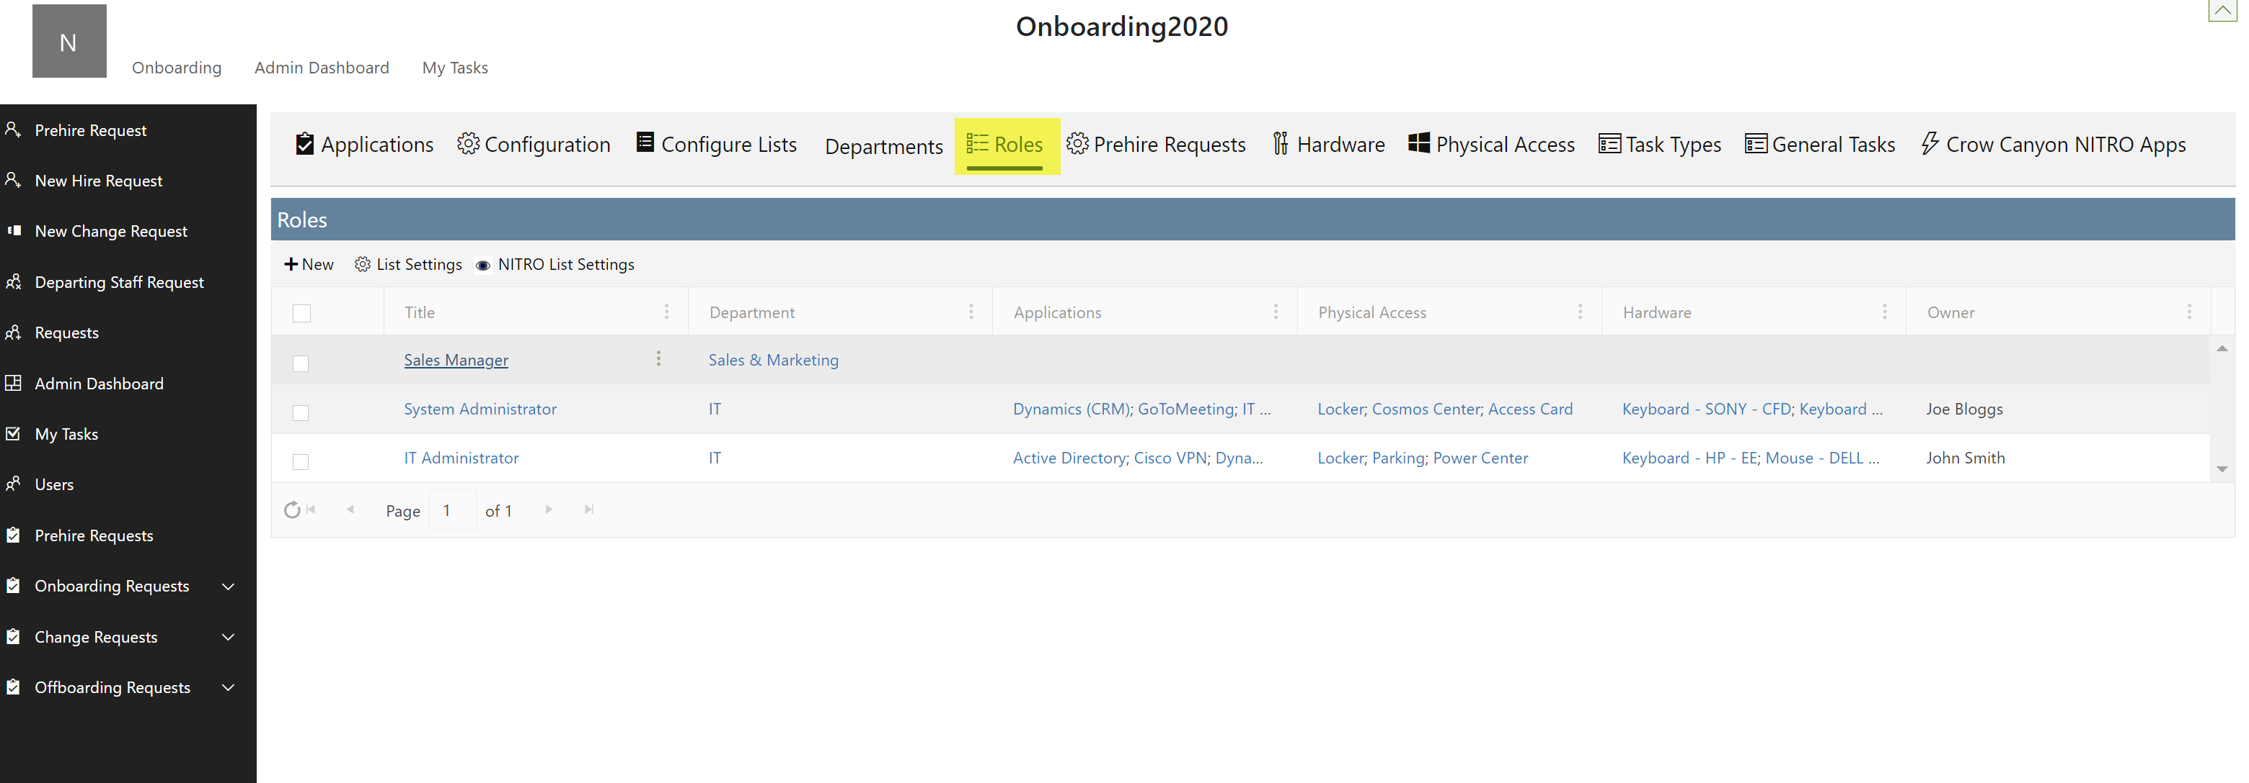

Prehire Requests

Approval Levels - A pre-hire request once submitted goes through approval process. It is a series of steps that must be followed to approve and provide access to various application for a new member.
Here various approval levels can be defined. For a pre-hire request to proceed, approvals are required from all the approval levels defined here.
Here we can define approval levels required from Pre-hire requests. Also, the tasks that auto-trigger after pre-hire request is approved can also be listed here.
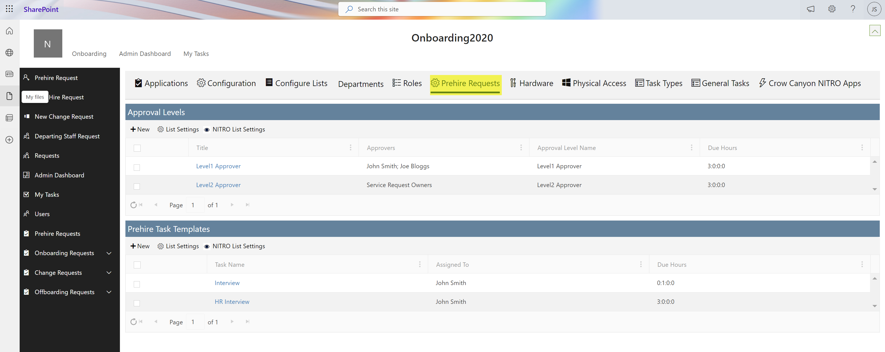
Approval Levels options can be defined as shown in the below screenshot:
Title: Title of the approver
Departments: Department of the approver
Approval Level Name: Provide name of the approval level
Level: Approval level
Approvers: Name of the approvers for this approval level
Due Hours: Time span in which decision on approval has to be taken
Request Approvers: Specify approvers column placeholder from Prehire request list
Request level approved date: Date of approval for this level in the Prehire request form
Request level approved by: Column internal name to save ‘Approver Name’
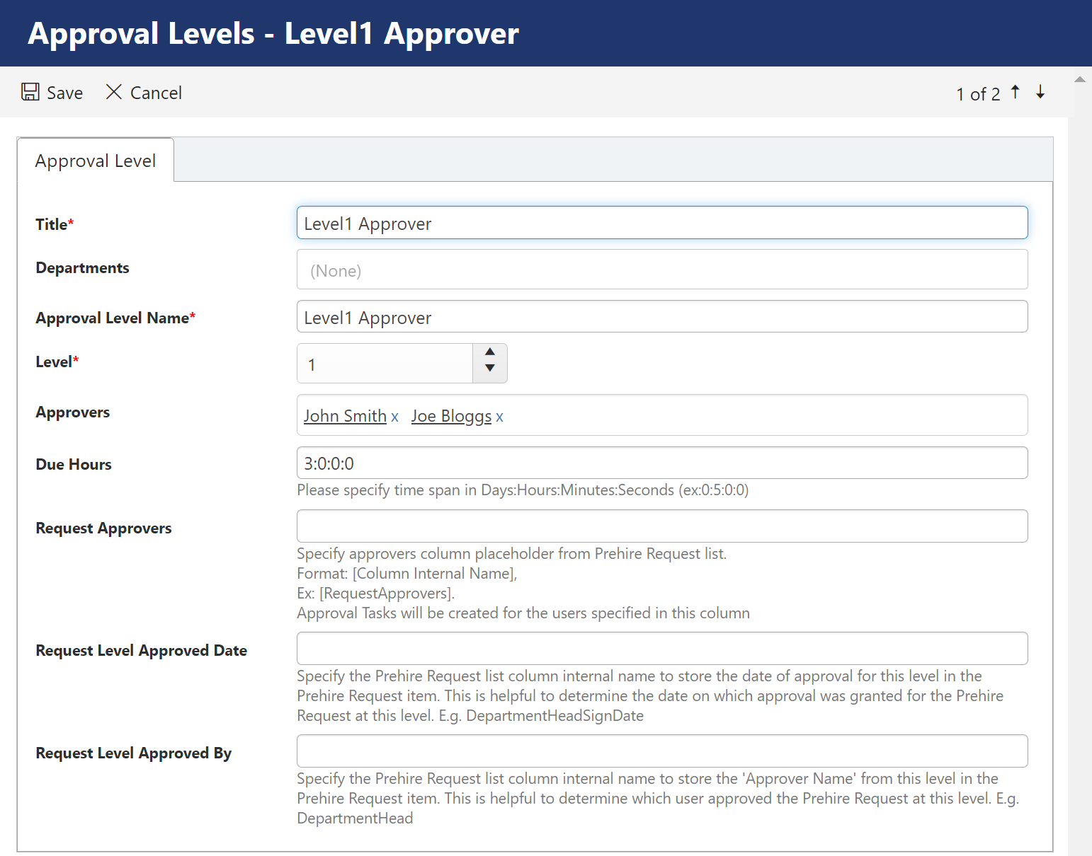
Prehire Task Template can be configured as below: The tasks get auto-triggered and are assigned to a user once all the approvals are received.
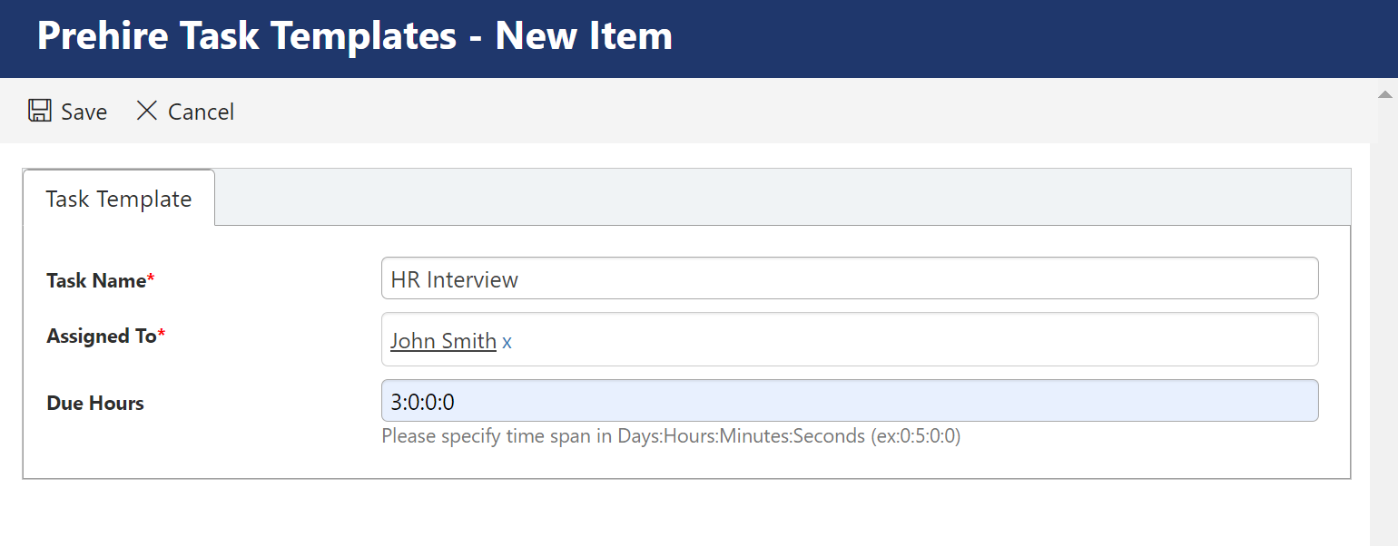

Hardware

All the hardware device that may be required along with their category, make and model are listed here.
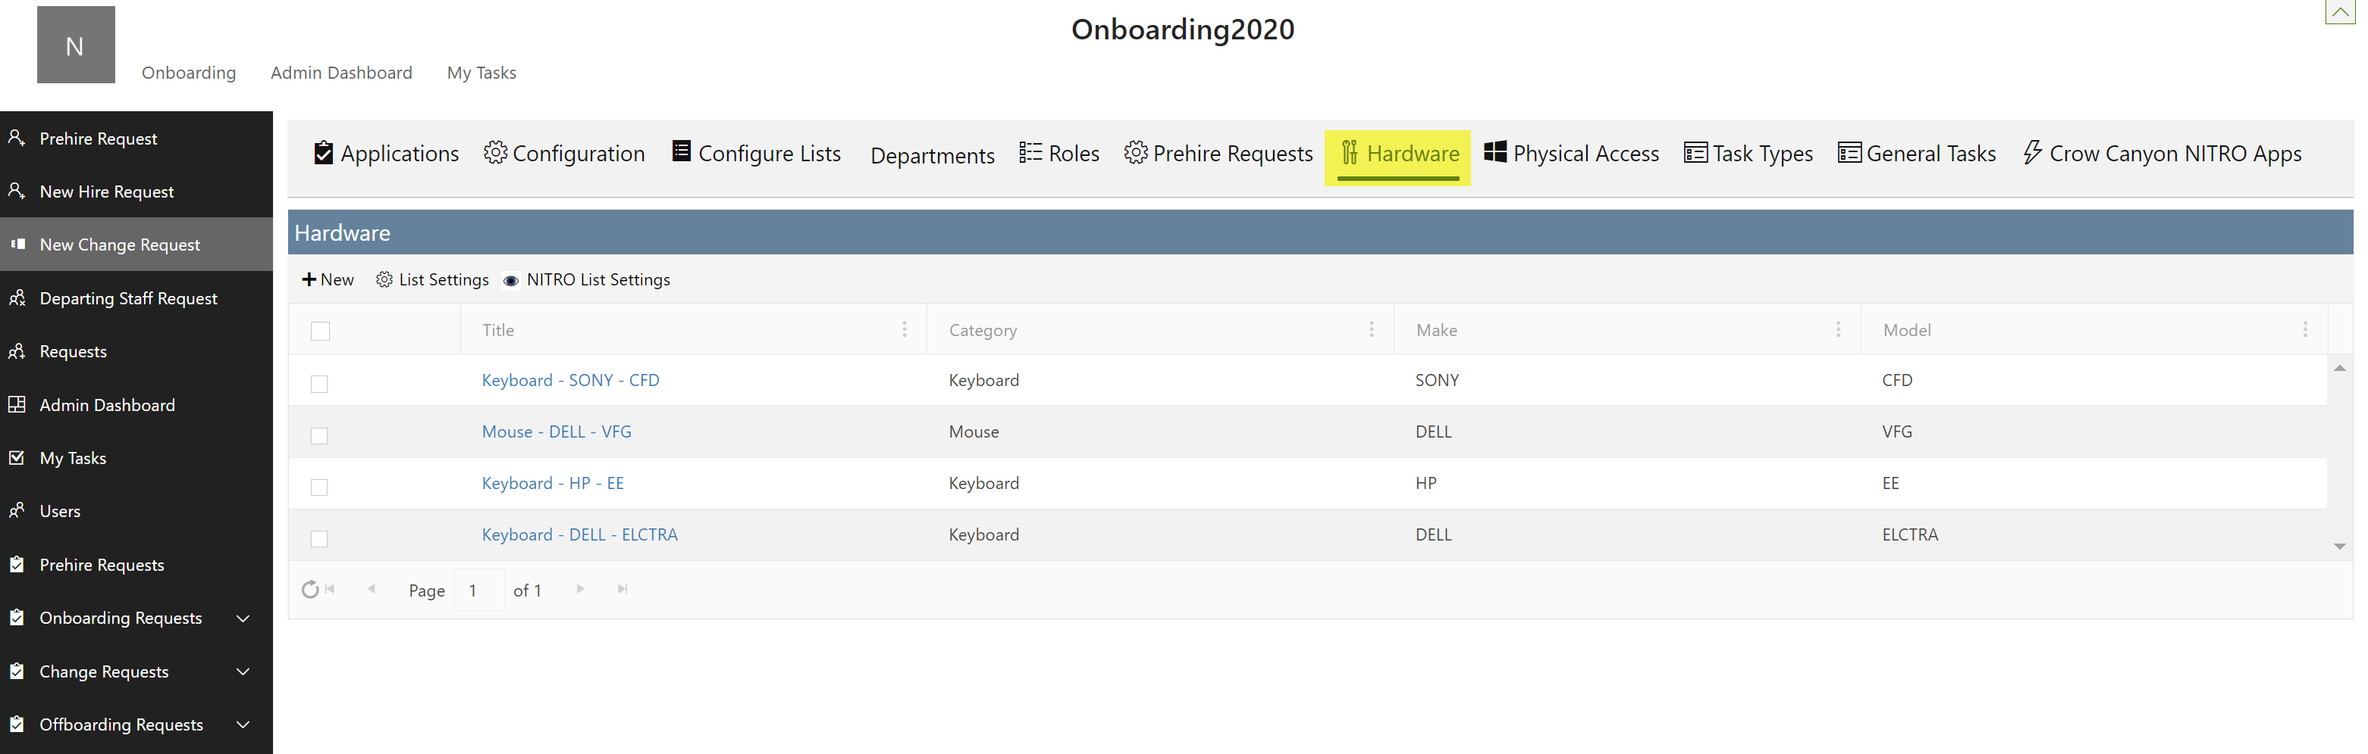

Physical Access

This is the list of physical access that may be required.
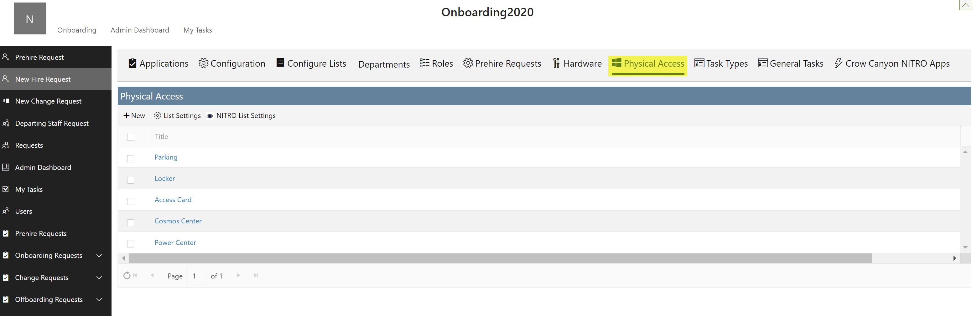

Task Types

All the onboarding tasks can be added here along with the owner of that task.
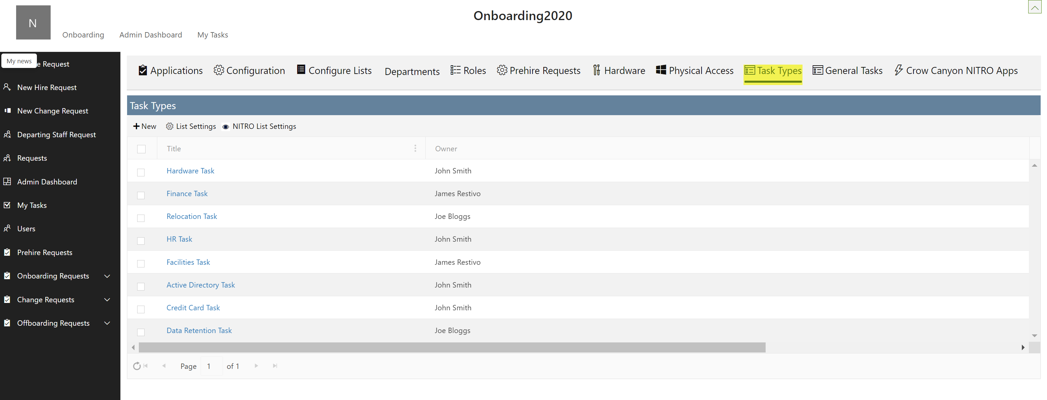

General Tasks

Here we can add general tasks like New request, Change request or departing request etc.
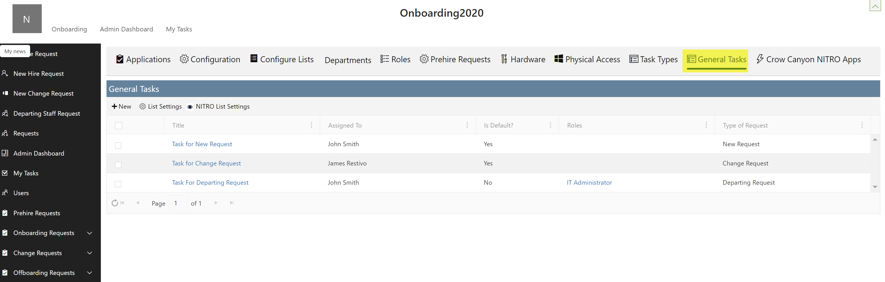

Crow Canyon NITRO Apps
Administrators have access to commonly used NITRO apps in Onboarding application as shown below:
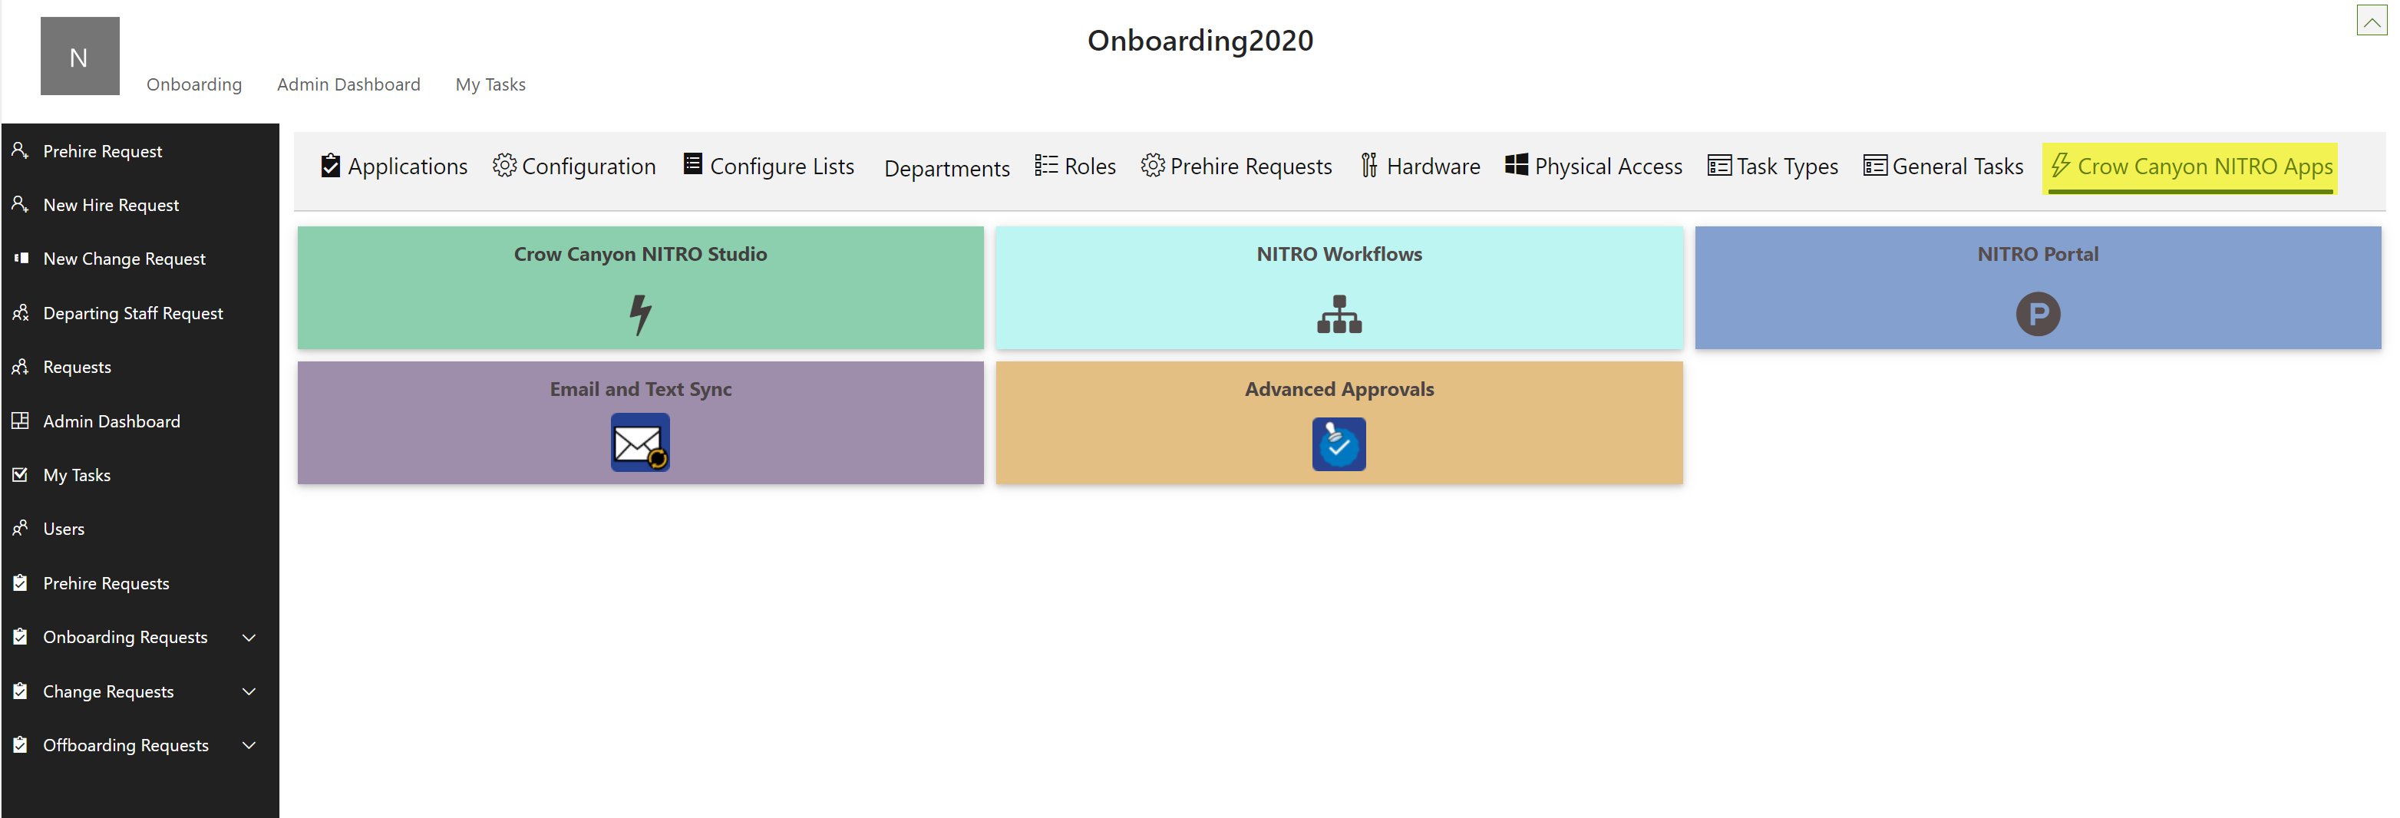

- Crow Canyon NITRO Studio: Crow Canyon NITRO Studio is an easy-to-use no-code solution that provides the components to build highly configurable applications in SharePoint online.
- NITRO Workflows: NITRO Workflows allows you to automate your business processes by creating complex workflows that execute based on changing data conditions or times. It has powerful, robust features that will enhance the productivity of your developers yet can also be simple enough for process automation by power users. All workflows are comprised of a name, a source list, a triggering event, optional conditions to streamline or restrict the workflow, and one or more actions that can create, update or delete list data, send emails and manage list permissions.
- Email and Text Sync: Email Sync creates a connection between an Exchange or Office 365 mailbox and a SharePoint list. Emails sent to the specified mailbox are converted to SharePoint list items. The emails can come from internal users or external customers. One use of Email Sync is that if employees are used to sending to a certain mailbox for support or other services, they can continue to do this while a new SharePoint or Office 365 application is used by staff to manage those requests, issues, inquiries, etc. Another use is with a web form where users or customers enter information; the web form then sends an email to the mailbox with the form data, where it is converted to a SharePoint list item.
Text Sync creates a connection between a phone number (provided by Twilio during account setup) and a SharePoint list. Texts sent to the specified phone number are converted to SharePoint list items. The texts can come from internal users or external customers. Text Sync is mainly used in conjunction with Action Verbs. The way it works is that the text is parsed, and words are mapped to columns in a SharePoint list. This could be mapping the Action Verb and the Ticket ID to columns in this list. A NITRO Workflow can run on that list using the "Item is Created" trigger. The Workflow reads the columns that have the Action Verb and ID in them and then runs that appropriate action (Update Item, Send Email, etc.). This process greatly automates the application for text users and gives them a wide range of possible responses.

Advanced Approval: NITRO Advanced Approvals allows new items to be approved, denied or sent back via an automated email approval process.

Key Features

  - Items can be approved, denied or sent back
  - Approval notification emails are configured through templates and automatically sent based on the approval action.
  - An item can have multiple levels of approvals.

Admin Dashboard
This page will show
- Onboarding Request Tasks – We can see all the onboarding request tasks on this page
- Change Request Tasks – We can see all the change request tasks on this page
- Offboarding Request Tasks – We can see all the departing request tasks on this page
- Progress dashboard – This dashboard can be used to see the progress of all the tasks

Onboarding Request Tasks

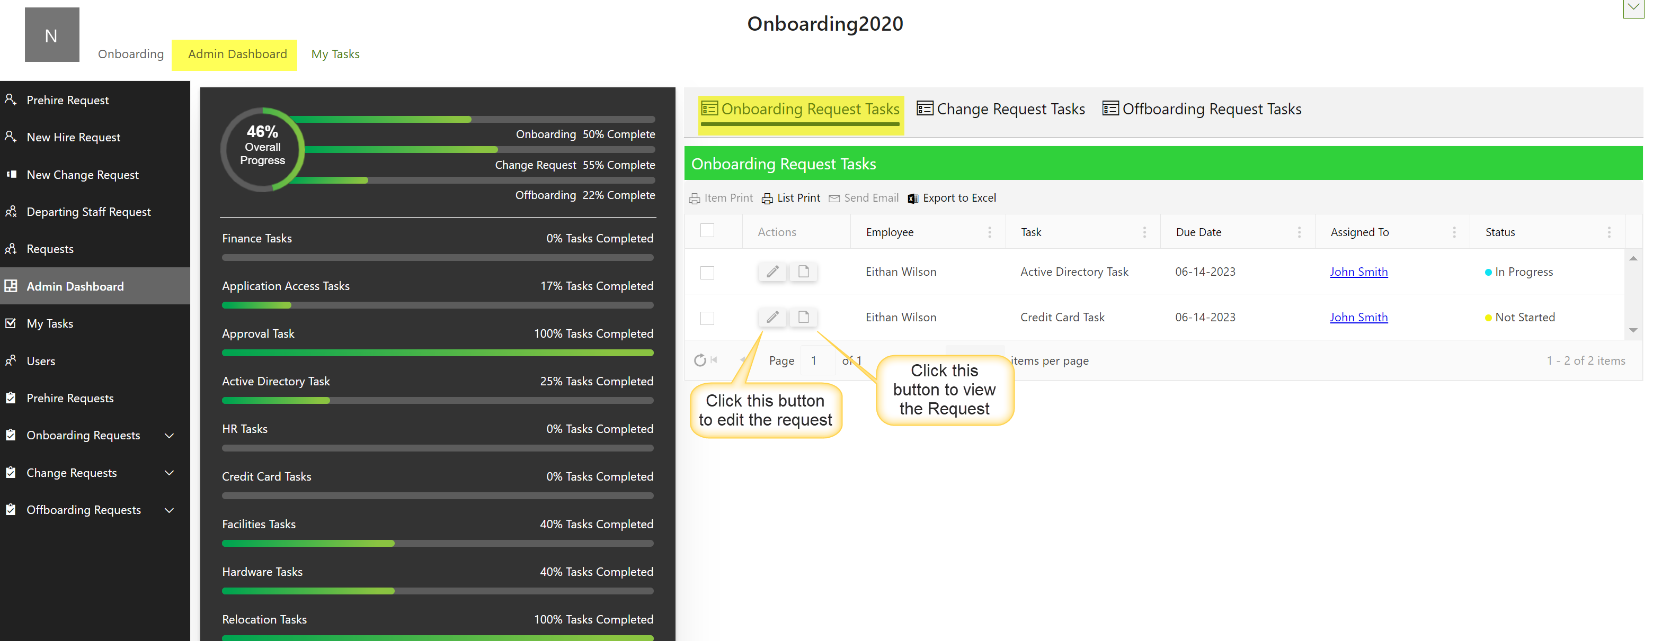

View the Request

Task can be marked as completed or reassigned to someone else using this option.
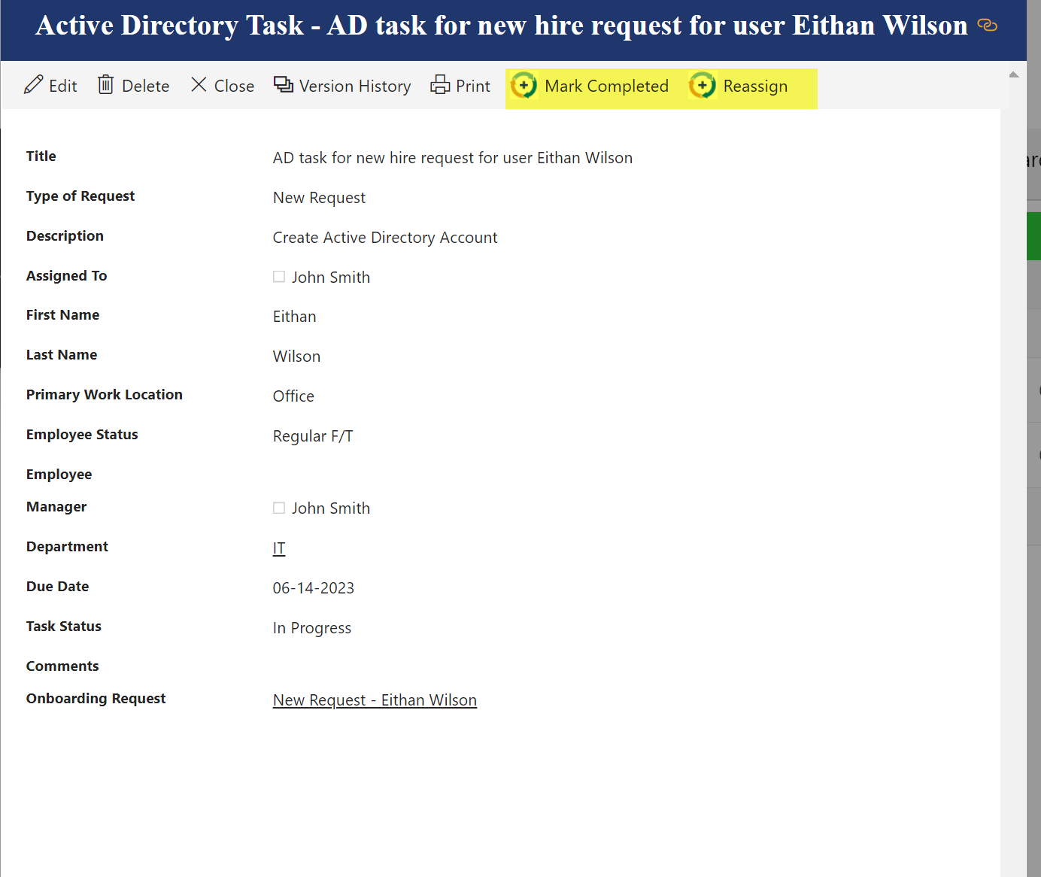
Edit Request
Any changes required to a request can be made through this option
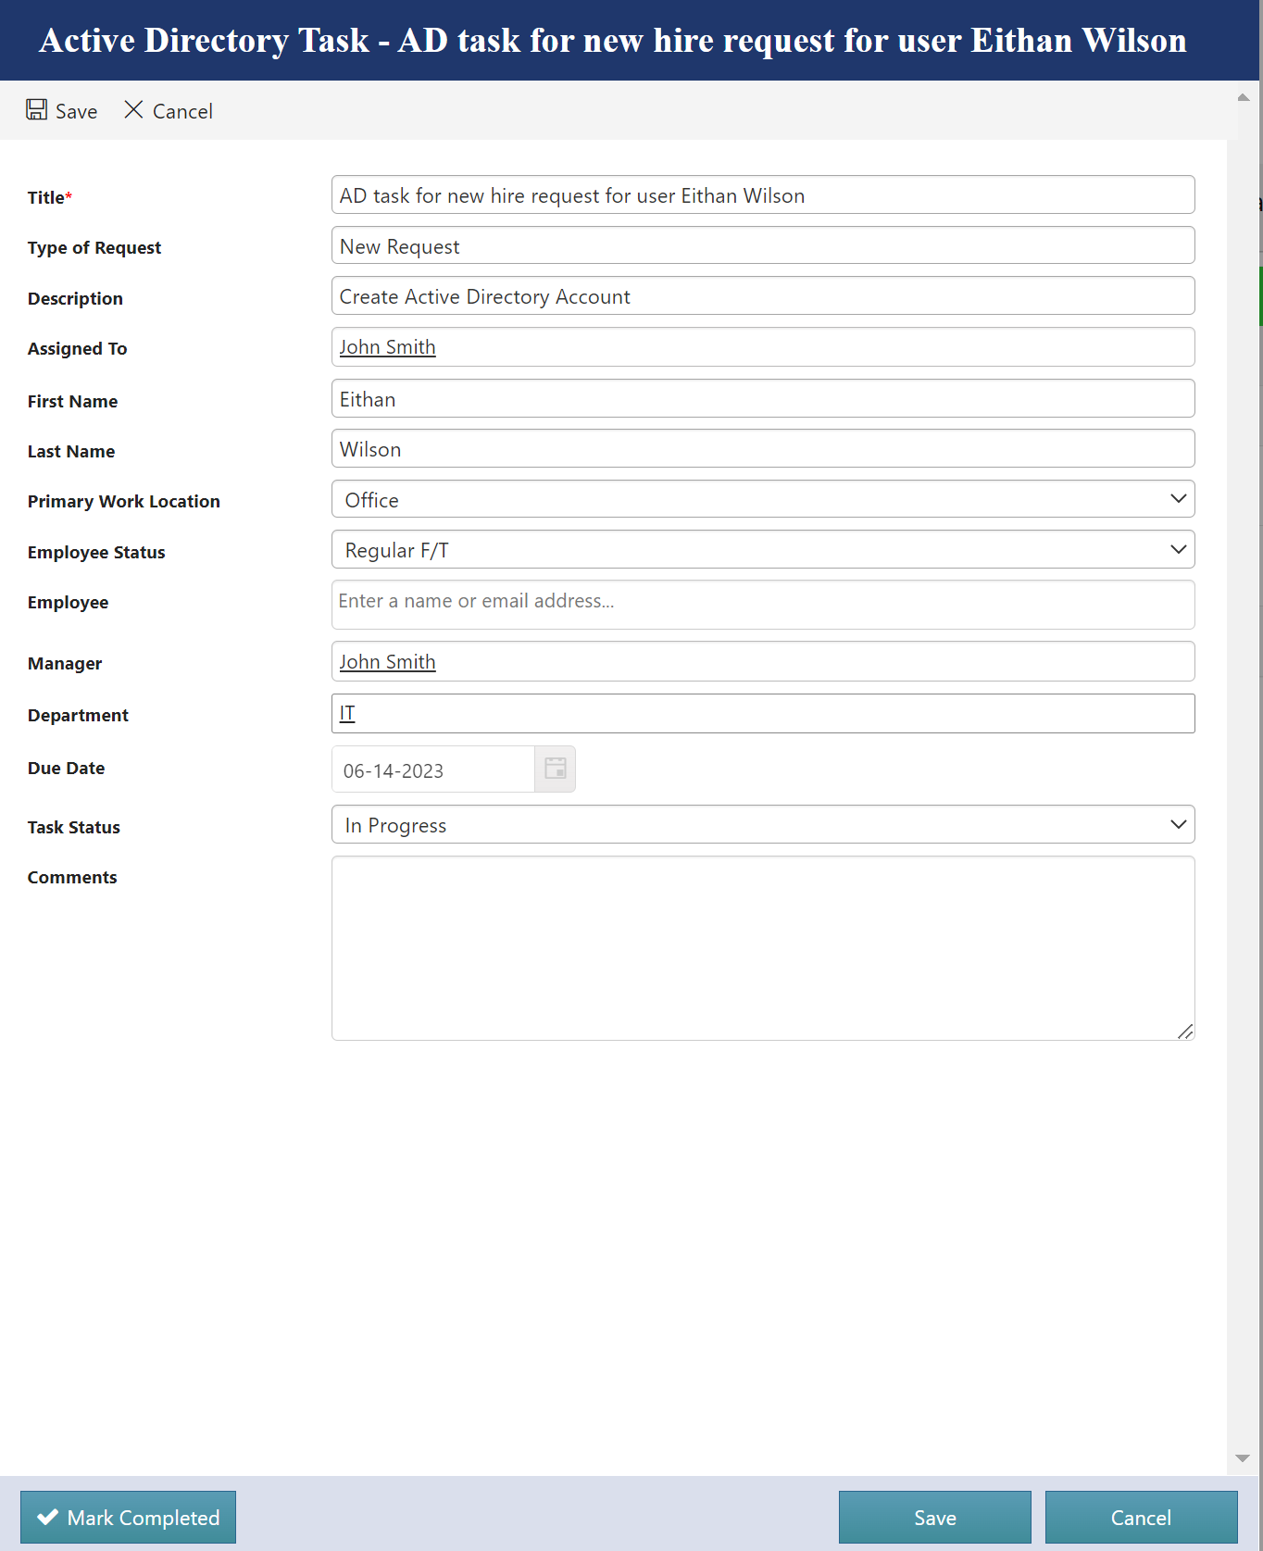

Change Requests Tasks
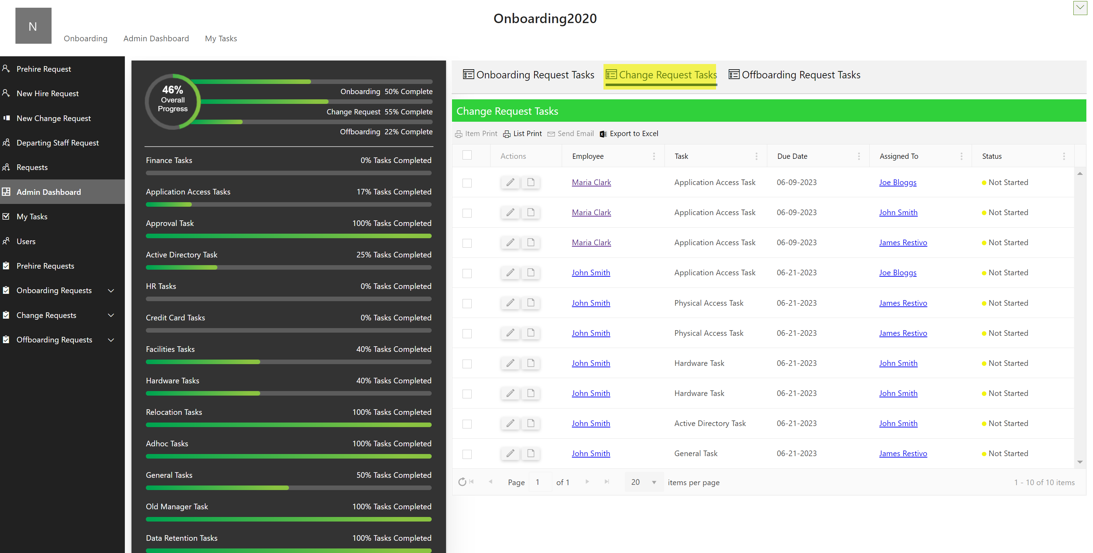

View change request task
Task can be marked as completed, or in progress or can be reassigned as shown below
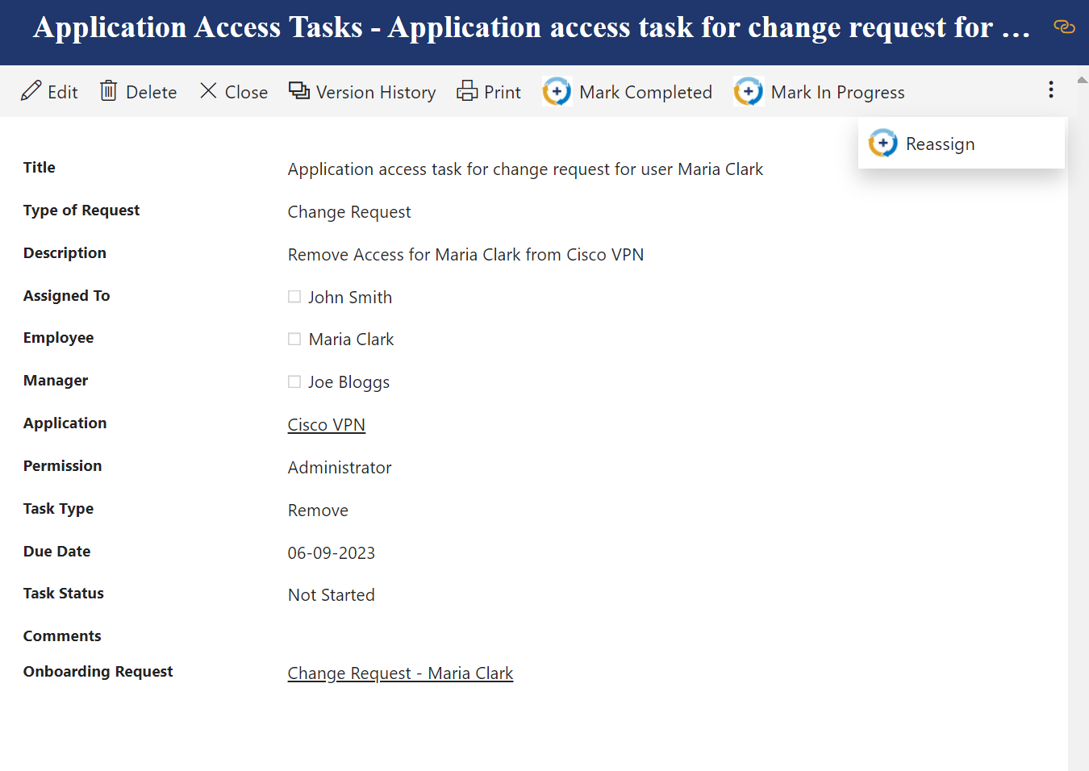
Edit change request tasks
Tasks can be updated using the edit option.
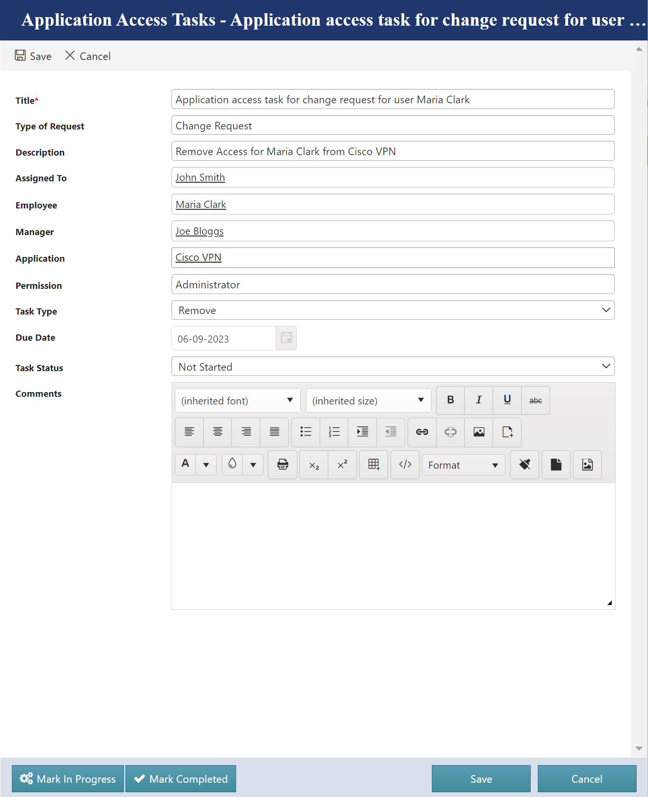

Offboarding Request Tasks
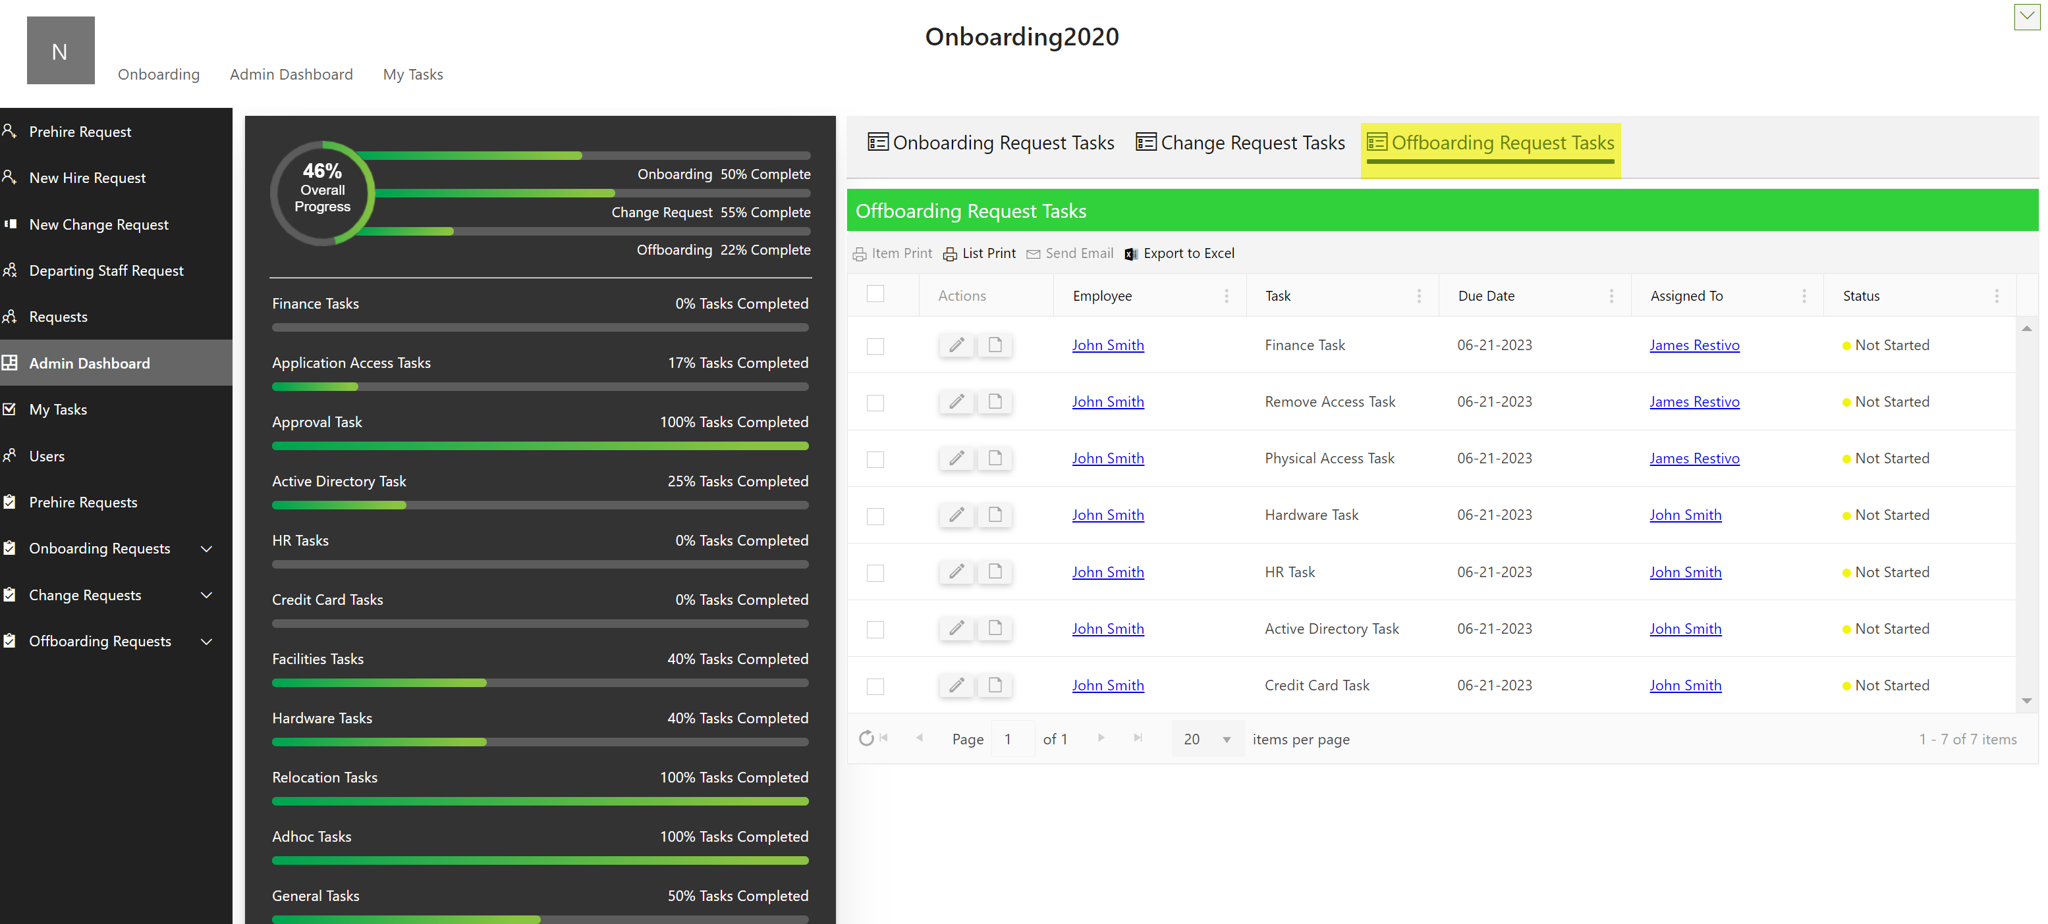

View Offboarding Request Tasks
Task can be marked as completed, in progress or can be reassigned
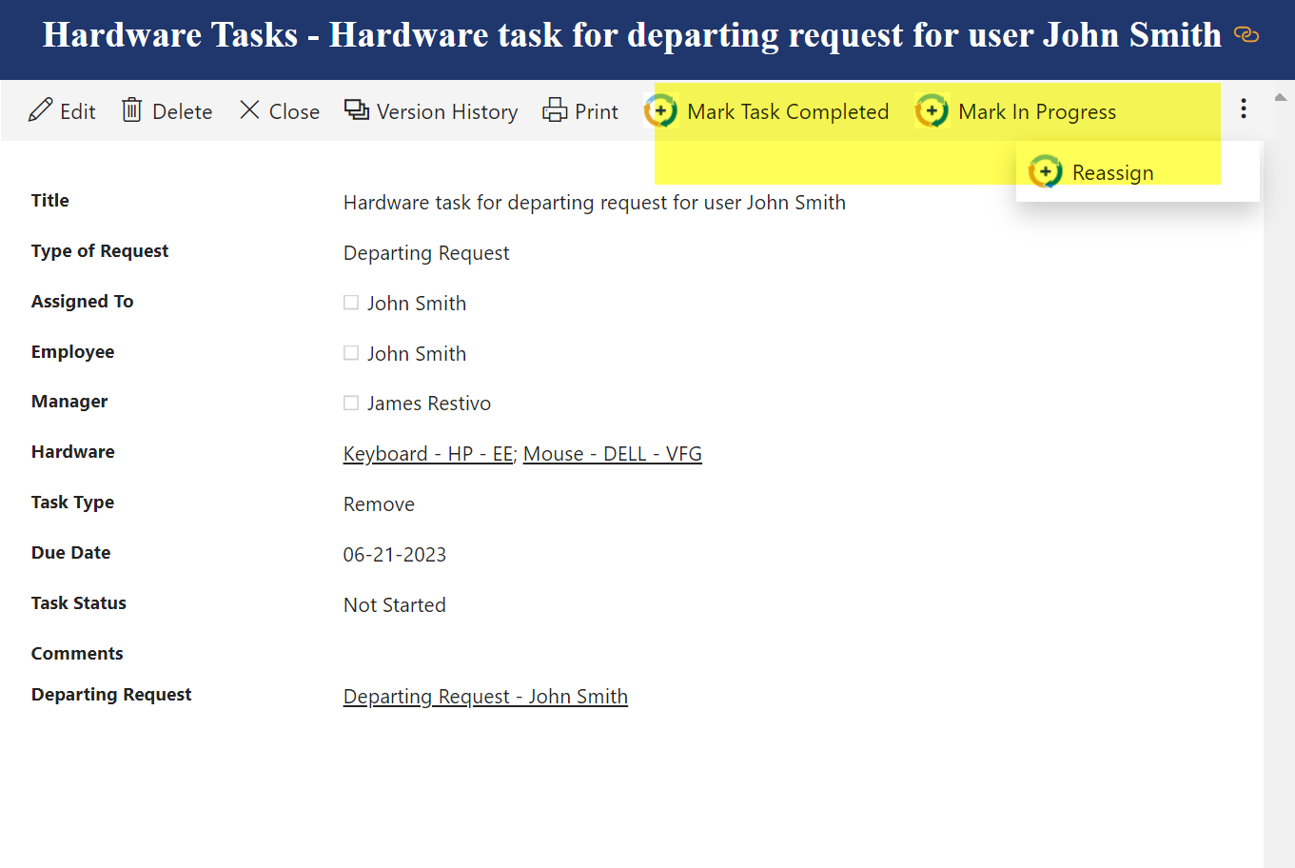
Edit Offboarding Request Tasks
Task can be updated using the edit option as shown below
