Contents
Employee Portal 1
Submit Ticket, Request, or Work Order 2
View My Tickets, Requests or Work Orders 3
Search Knowledge Base 4
Quick Tickets, Requests, or Work Orders 5
Notifications 7
Quick Links 7

Employee Portal

The Employee Portal is your best way to create Tickets, Requests, or Work Orders, view Tickets, Requests, or Work Orders and Search Knowledge Base articles. The Employee Portal home page is as shown below:
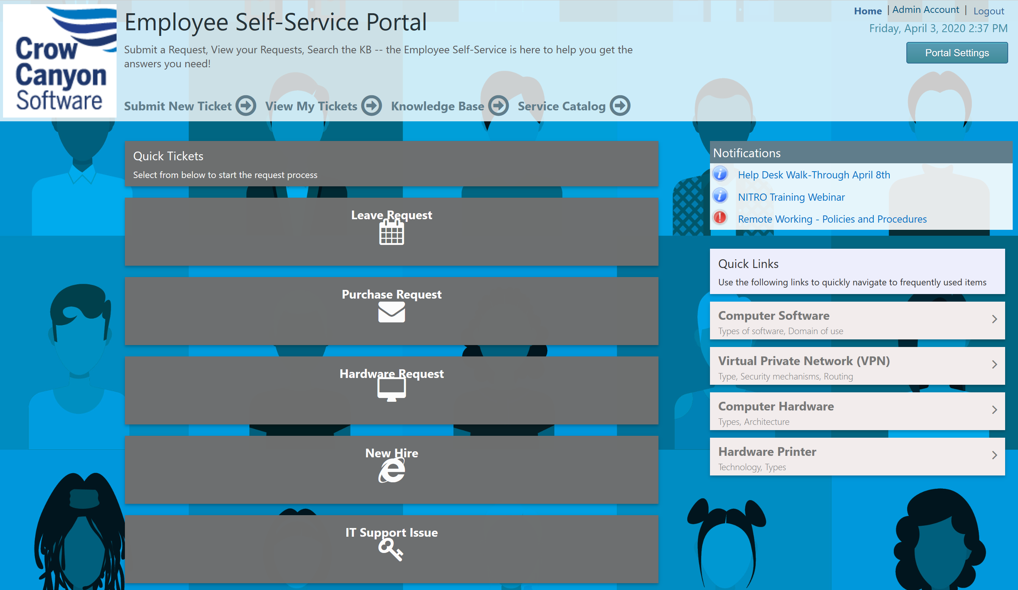

Submit Ticket, Request, or Work Order

From the Employee Portal you can create Tickets, Requests, or Work Orders using the ‘Submit New Ticket’ button on the Home page.
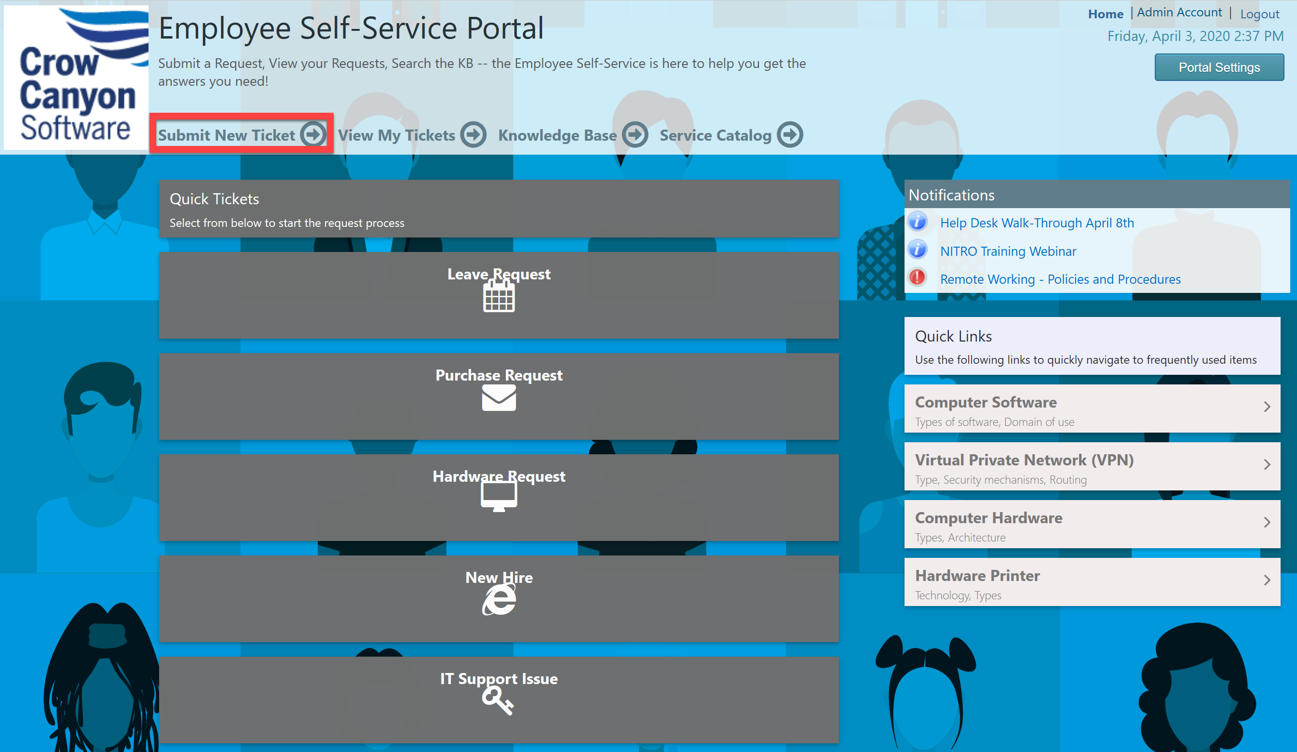
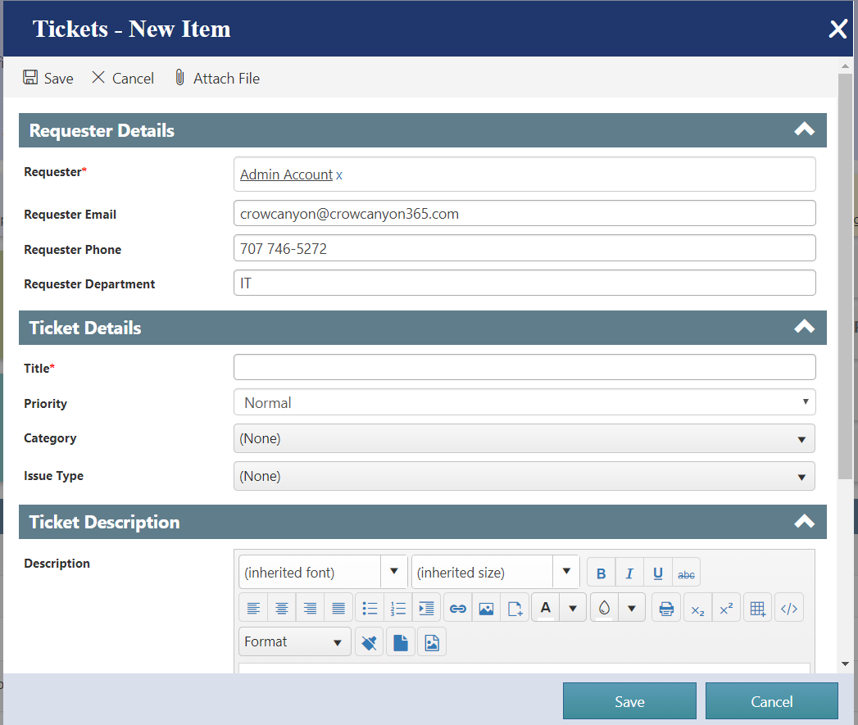

View My Tickets, Requests or Work Orders

View My Tickets, Requests, or Work Orders will display all the tickets in the list as shown below. By default this shows all tickets that the logged in user has submitted.
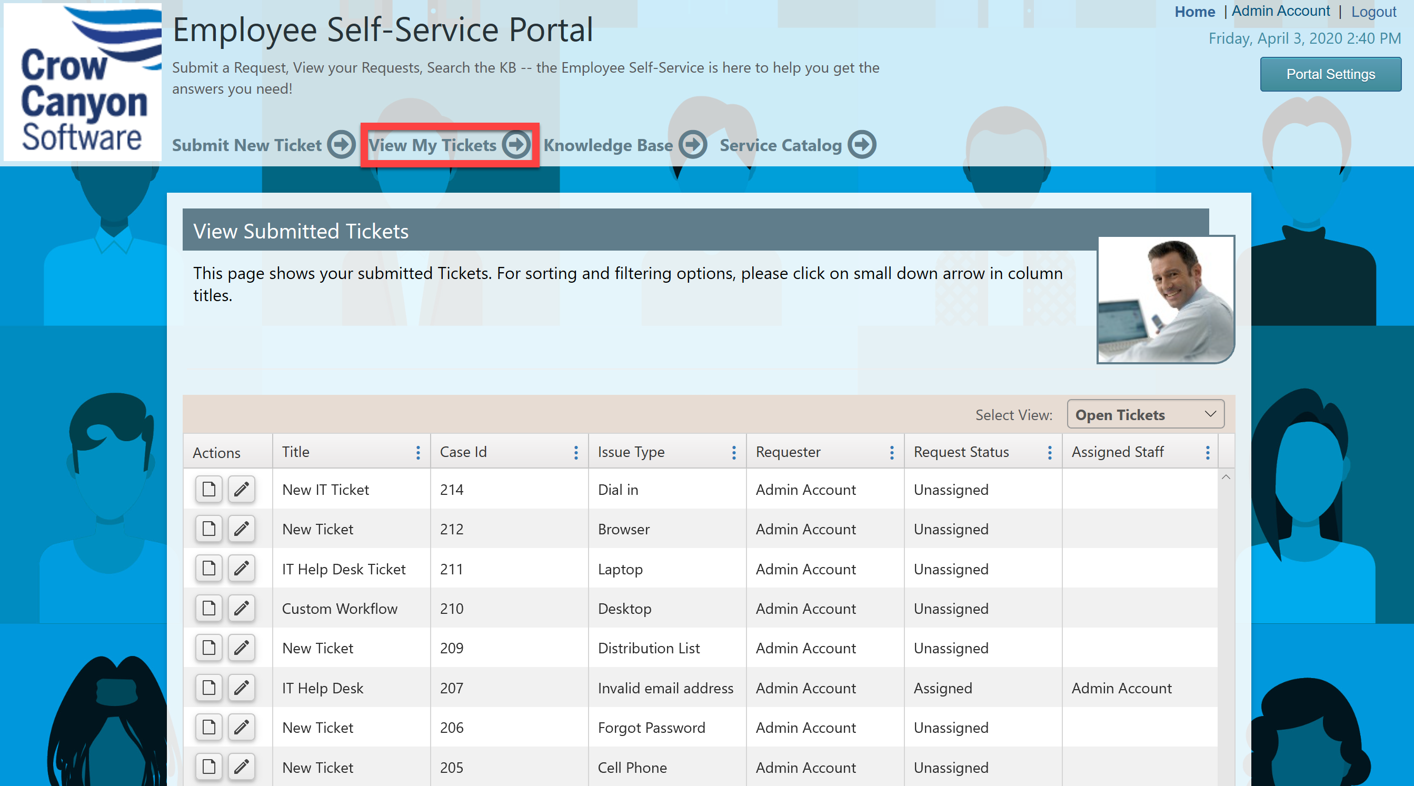

Search Knowledge Base

You can search a repository of articles specific to your organization by clicking on the Knowledge Base link, and then entering your search term in the provided search box.
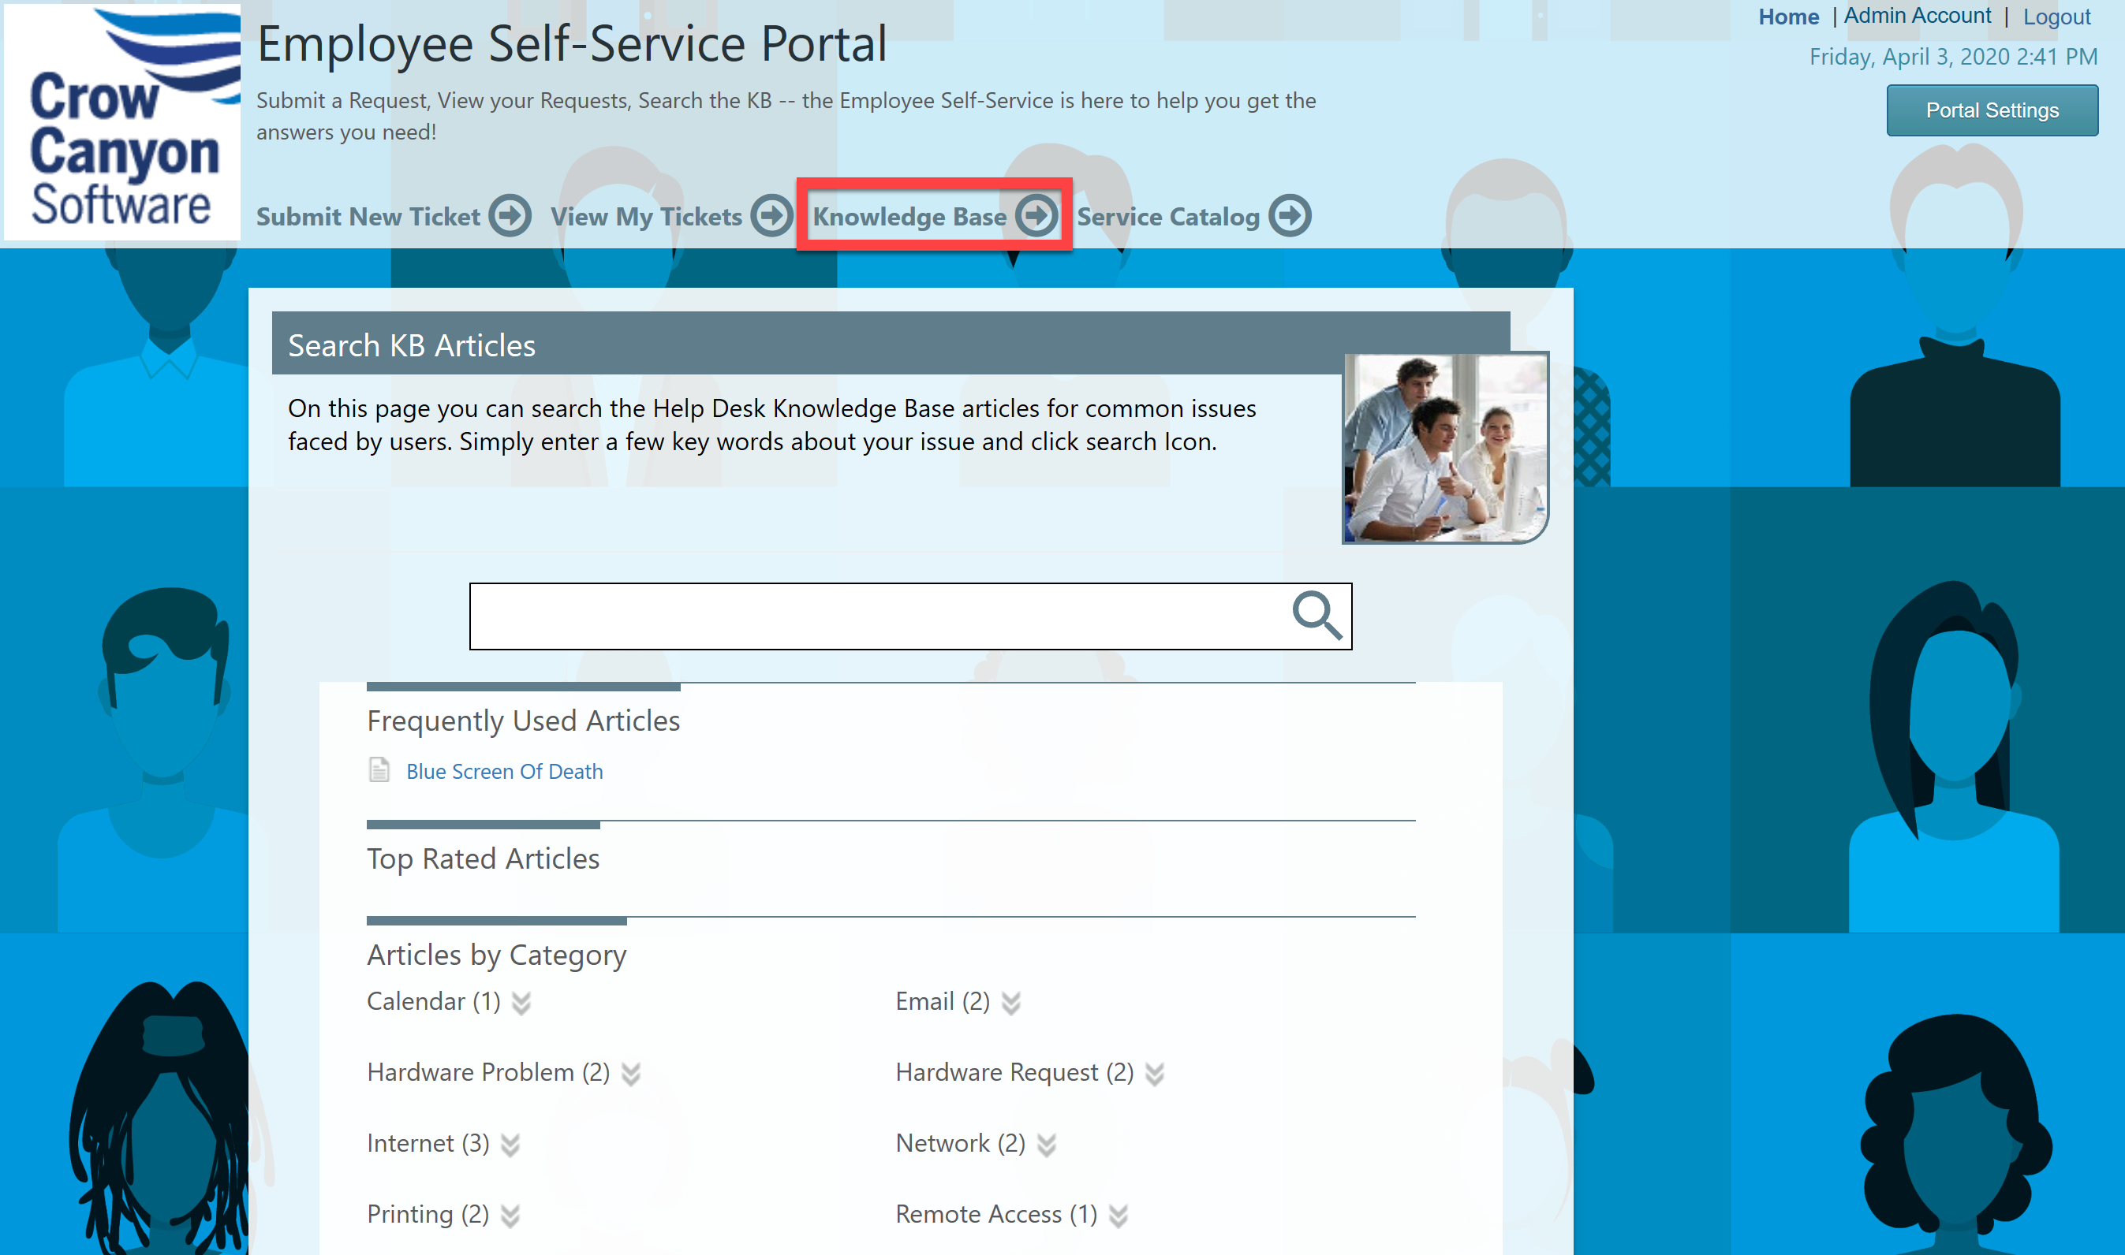

Quick Tickets, Requests, or Work Orders

Quick Tickets, Requests, or Work Orders is to provide quick way to create tickets with the specified Category and/or Issue Type. These may also be links out to other forms, resources, or web pages.
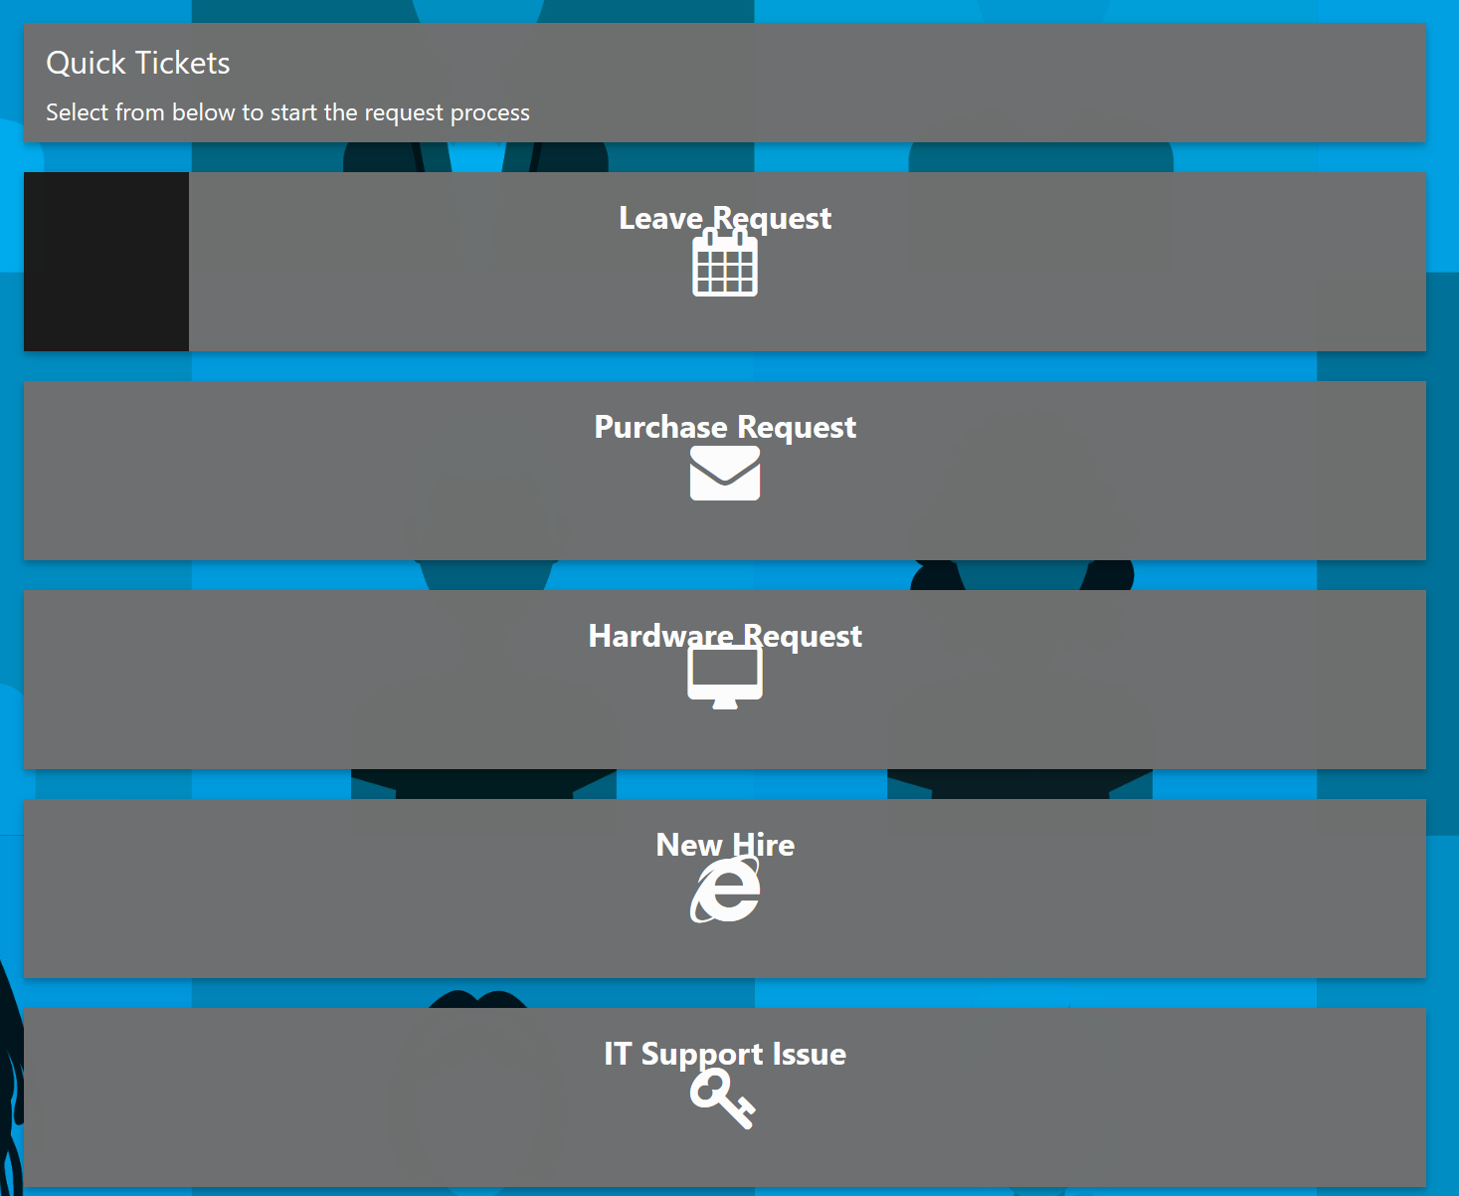
For example, click on ‘Hardware Request’ tile in Quick Tickets, Requests, or Work Orders and you can see that the Category and Issue Type gets populated automatically in the submit form.
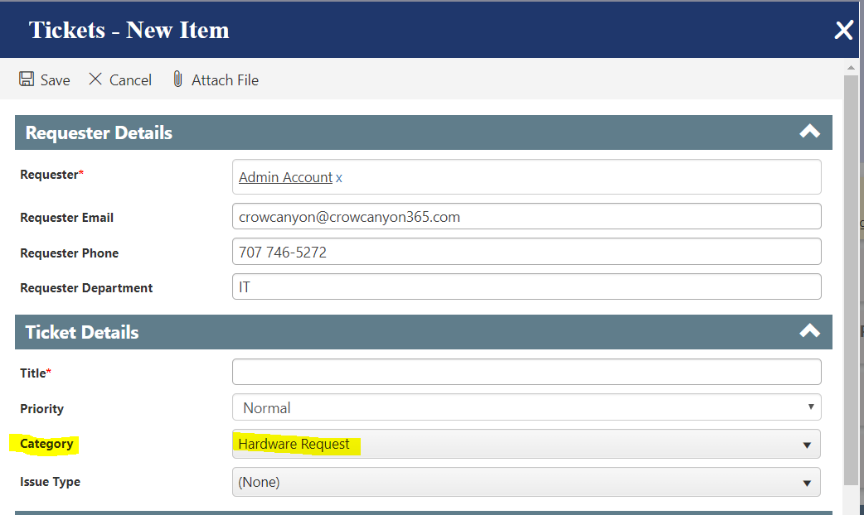

Notifications
Notifications can be advisories and important information provided by your back end team
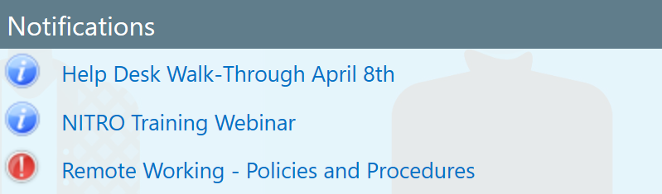

Quick Links
Quick Links are typically links connecting you to commonly used resources for your organization.
