Contract Management User Guide

Contents
Introduction 2
Key Features 2
Personas 3
Administrators 3
Regular Users 3
Permissions 3
Top links 3
Contracts 3
Report Center 4
Vendors 4
Approver Tasks 5
Left Navigation links 5
Contracts 5
New Contract 5
All Contracts 10
Pending Approvals 11
Contract Documents 11
Vendors 12
New Vendor 12
Report Center 12
Approver Tasks 13
Application Administration 13
Configure Lists 14
Departments 14
Contract Renewal Options 14
Approval Levels 14
Crow Canyon NITRO Apps 15
Contract Renewal Approval process 16
Approval flow 16
Submit for Approval 16
Using Custom Actions 18
Approve 18
Deny 18
Contracts Form 19

Introduction

Contract Management system helps an organization in creating and managing contracts. Crow Canyon Contract Management system provides a SharePoint based application to create, track and renew Contracts.
System is built using Crow Canyon NITRO platform on Microsoft SharePoint system. Application can be extended and customized easily using no-code configurations. NITRO Forms and List Views etc. are used for the UI. Contract renewal and approval process are configured using NITRO Custom Actions and Workflows. NITRO components give a lot of flexibility in tailoring the UI and processes to organization specific requirements.
Once the Contract renewal is submitted, approval process kicks-off and approvers receive email notifications. Approvers can take decision as per the choices configured. Based on the approver decision, Contract renewal will go to next level in approval process. Once the contract is approved at all levels, Contract will be renewed.
The renewal process can also be set to Auto-renewal in which case the approvals will not be required.

Key Features
- Built using NITRO Studio, so provides complete configurability
  - UI based no-code configurations
  - Option to add custom JavaScript / CSS for advanced scenarios
- Easily create and track Contracts
- Customizable approval process
  - Approvals based on the cost, department, type etc.
  - Multi-level serial/parallel process that can be extended up to any level
- Secure access
  - Restricted and secure access to updates/approvals
  - Specific parts of forms can be made read-only or hidden depending on data and user groups
- Automated notifications on approvals, denials and other state changes
- Reporting for financial control and cost management
- Monitor activity throughout the approval process.

Personas
Contract Management has two main group of users as detailed below. In addition, item level permissions can be configured for more groups as per business requirements. These groups or individual users can have permissions on specific contract based on department etc.

Administrators
Users who can configure the application. This includes defining the approval levels and approvers, form configurations, permissions etc. They can be specified in a SharePoint group with full control permissions on the application site. Or they can be the Site Collection administrators. These users can access “Application Administration” page to configure the application.

Regular Users
This group of users use the Contract Management application by submitting New Contracts, approving requests, tracking milestones etc.

Permissions
- Everyone should have read permission on the site collection
- Administrators should have “Full Control” permission on the Contract Management application site
- Users need “Contribute” permissions on the Contract Management application site to create Contracts

Top links

Contracts
This page is like a dashboard that shows.
- Tiles: Clickable cumulative counts for various status All Contracts, expiring in 30 days etc. User can click on the tiles to drill down and get the details
- Graphical Reports
  - Contracts by Department
  - Contracts by Status
  - Contracts by Type
- Tabular Reports: Like Contracts, External Documents, Internal Documents
By default, Contract Management application comes with Crow Canyon branding as shown in below image. Refer this article for more details on branding and how to change it.
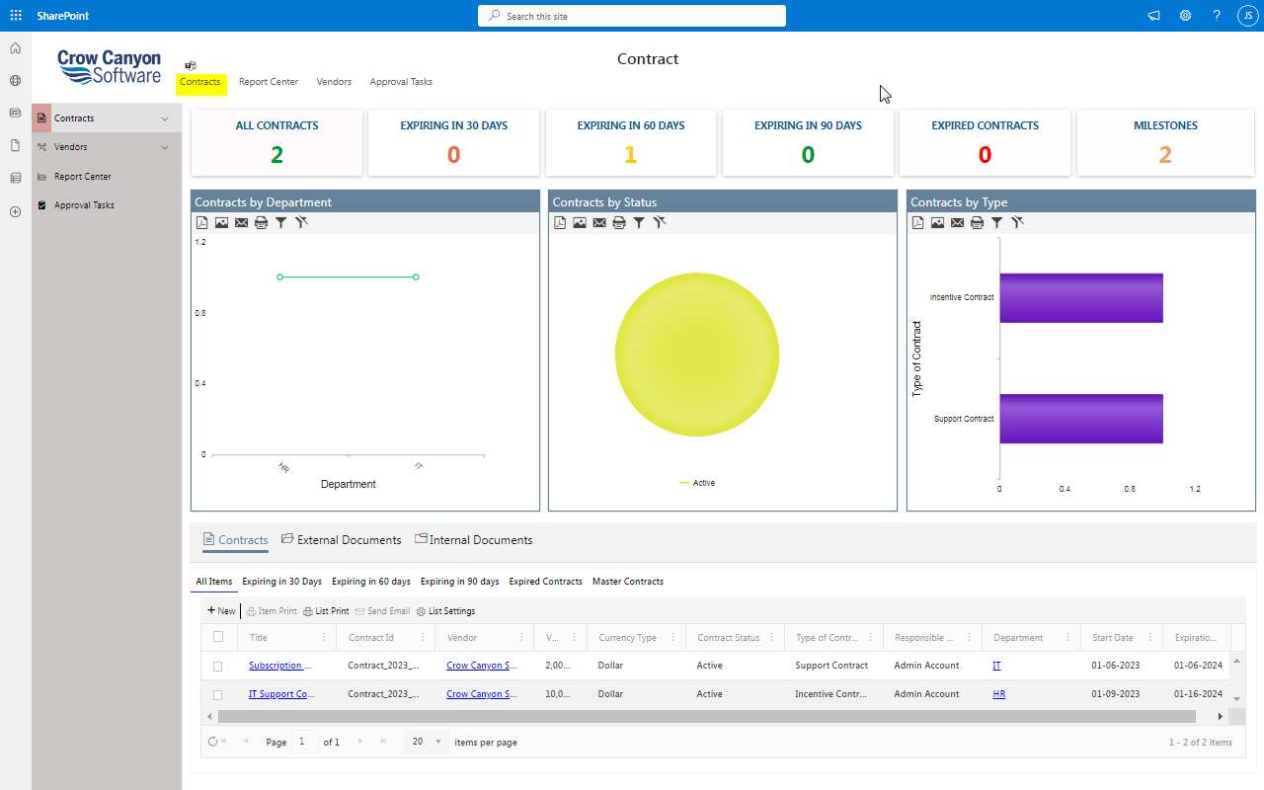

Report Center
Different reports configured on Contracts are shown on this page. Reports can be created/updated using NITRO Reports component.
Refer this article for more details on the Reports.
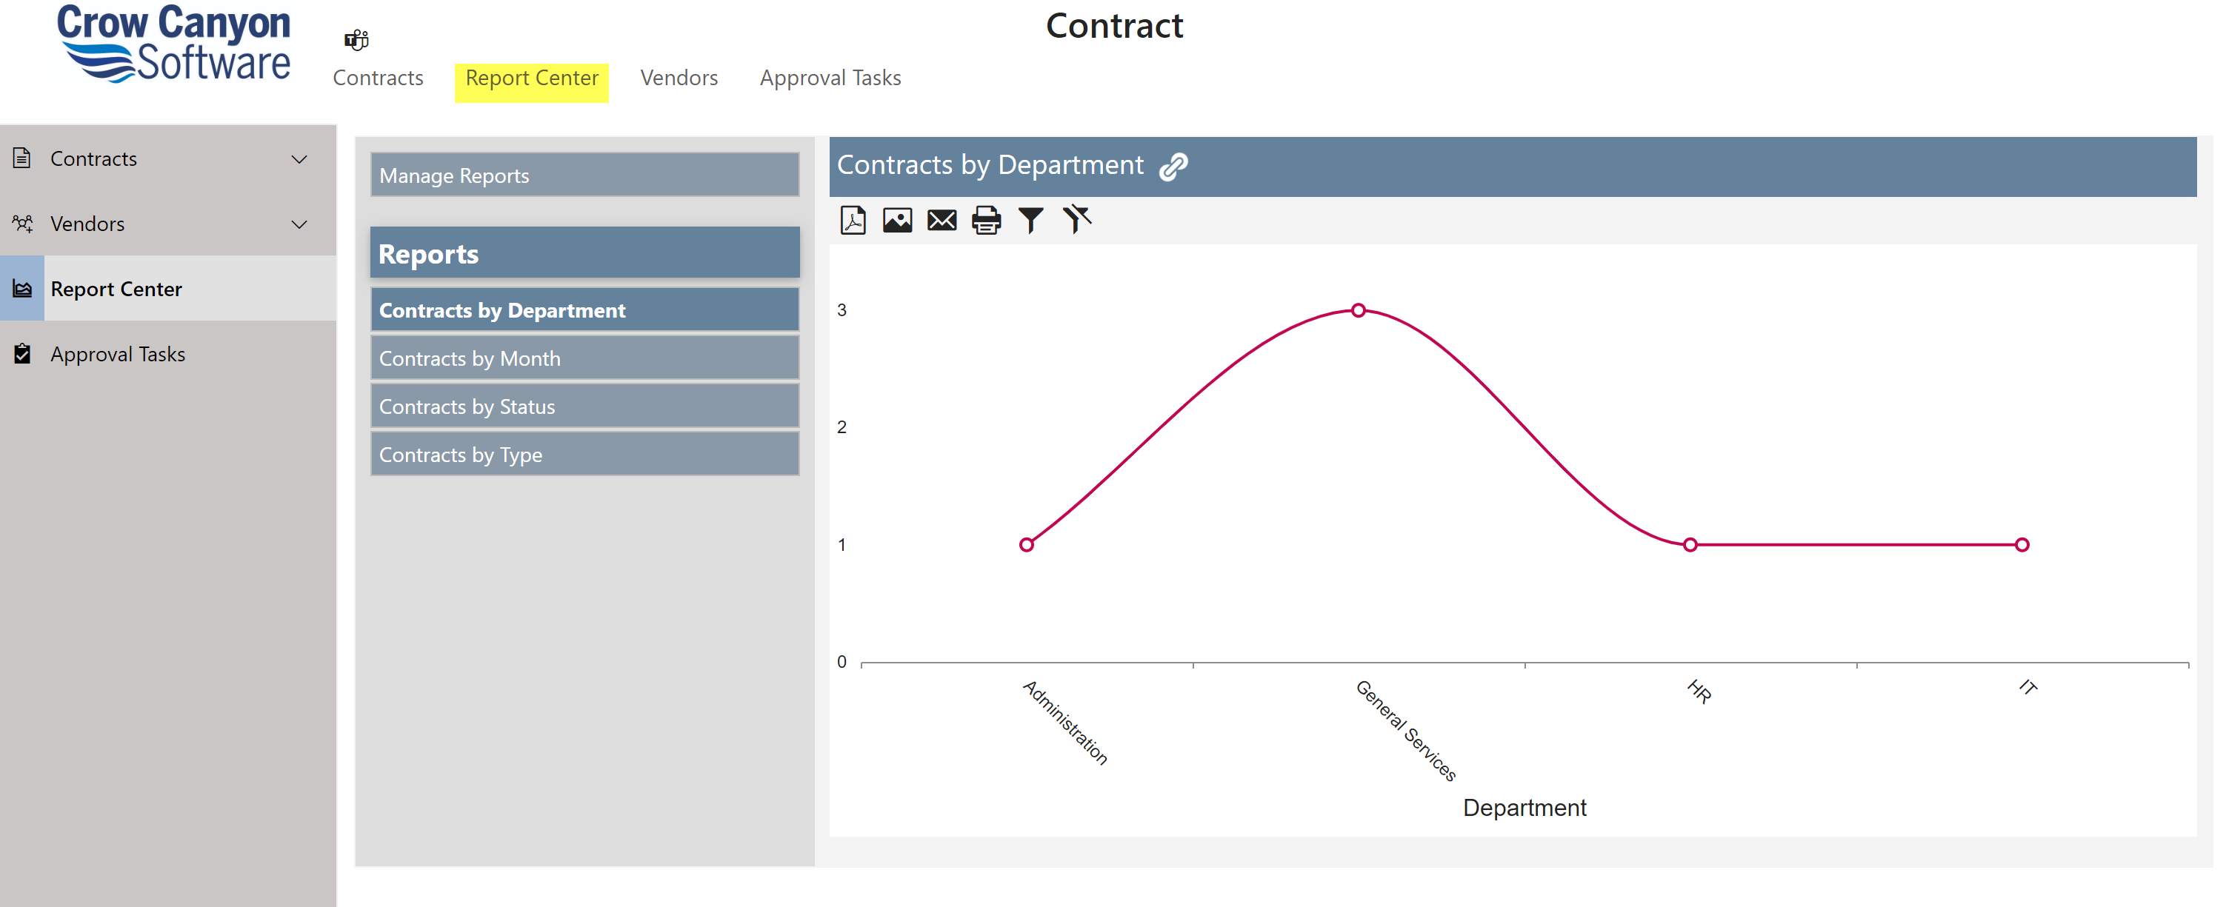

Vendors
This page shows all Vendors in the system. We can add/update vendors from this page.
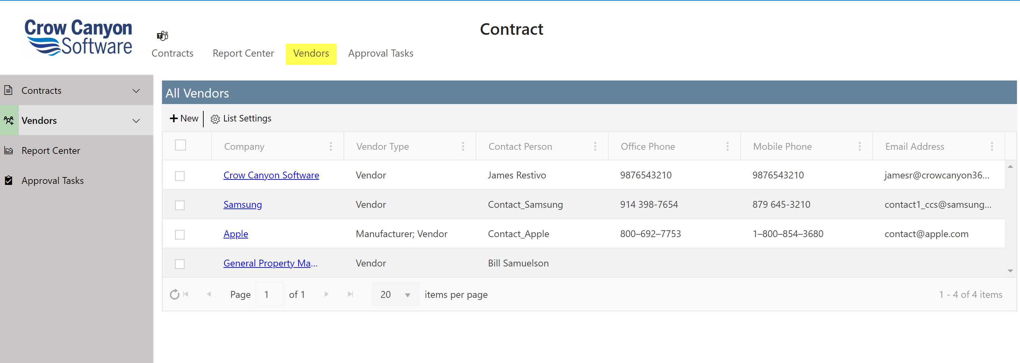

Approver Tasks
Users can see their pending approval tasks and open them to approve/deny. They can also see tasks for other users; however, they can’t update the approval decision for tasks not assigned to them.
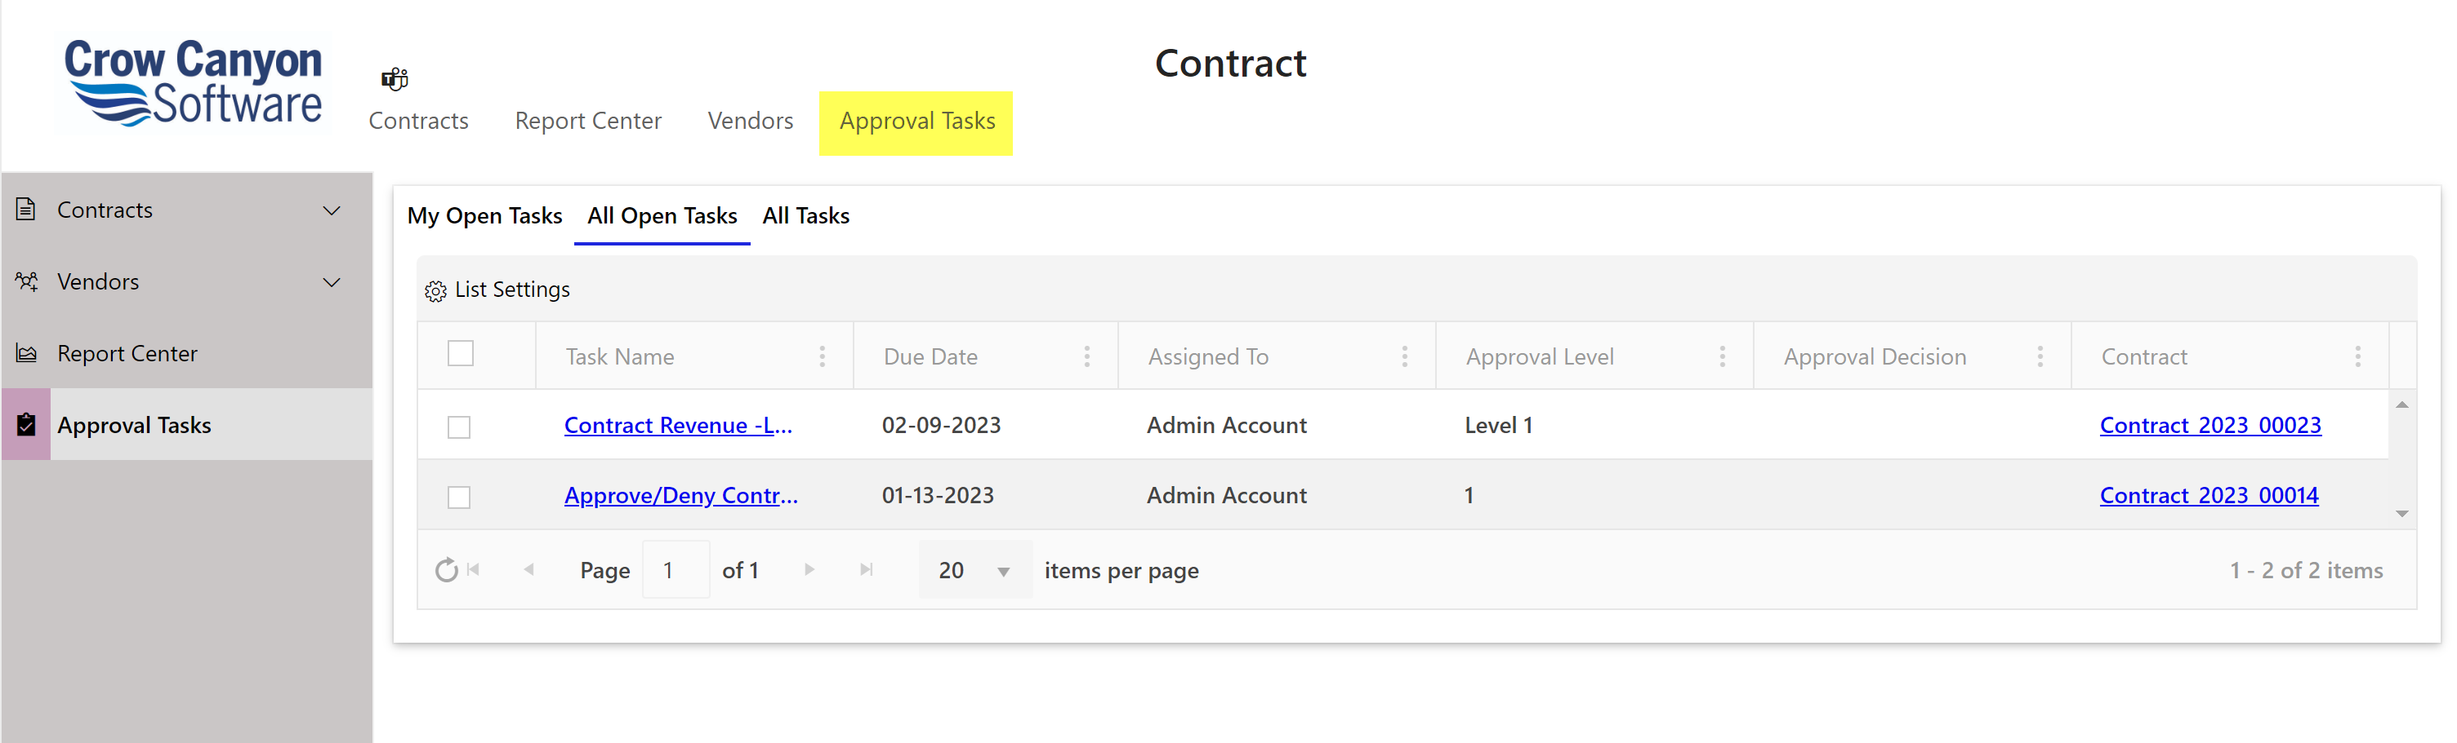

Left Navigation links

Contracts
This link navigates to the page for “Contracts”

New Contract
Users can create new Contract using this link as shown below. When form is saved Contract Id will be generated for the Contract. This is a custom generated Id with below format.
Ex: Contract_2023_00021

Format of this Id can be modified as per your organizational needs, refer this article for more details.

Contract Info Tab:
This tab will ask all the necessary detail required for a contract.

On selecting ‘Allow Auto-Renewal’ Check box, Contract will not go for approvals and will be automatically renewed.
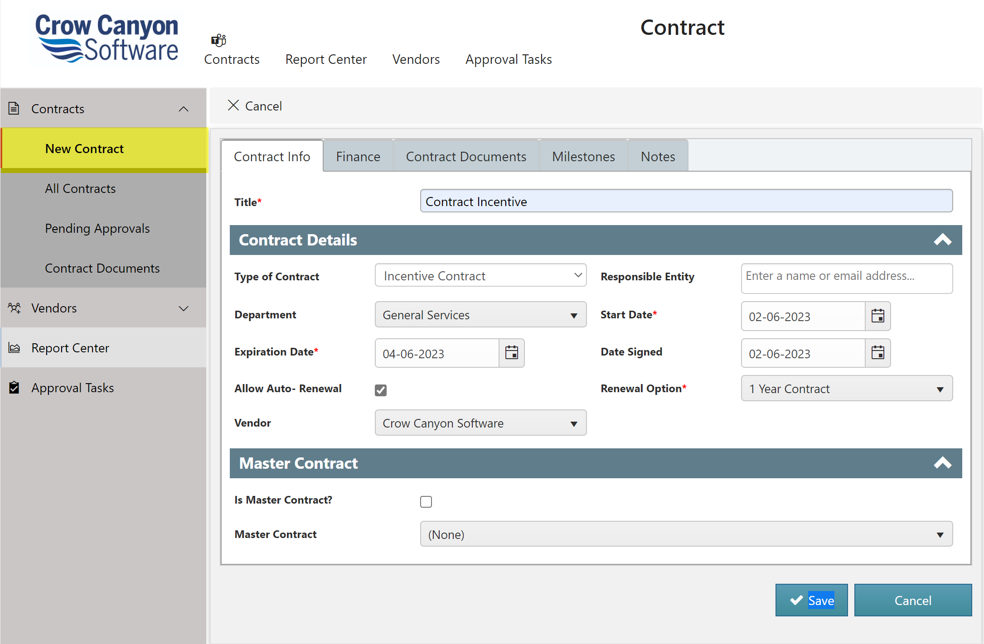

Finance Tab:
Financial information like the value of the Contract can be added in this tab. Value of a contract can be one important factor to decide approval levels for a Contract.
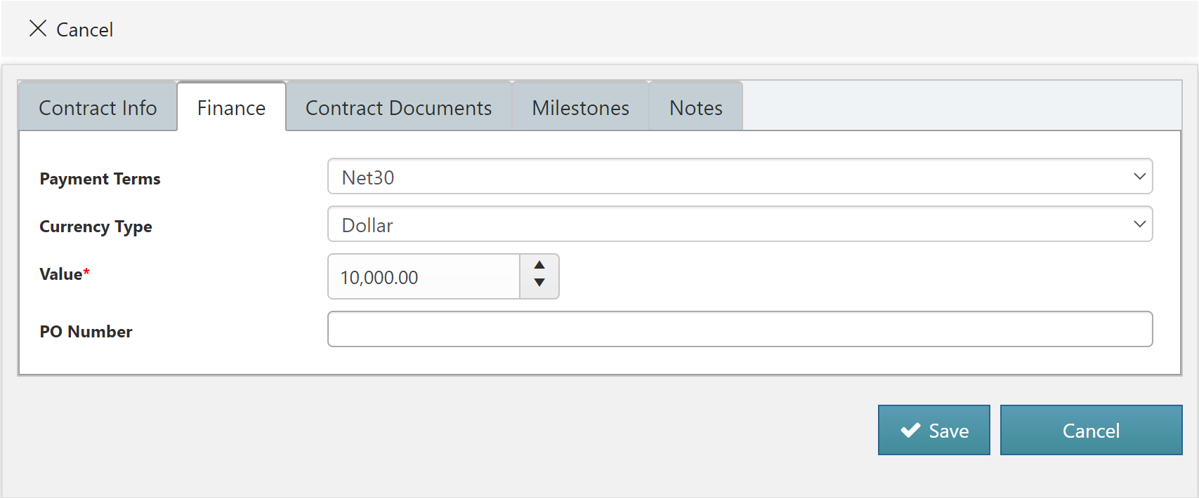

Contract Documents Tab:
To attach Contract documents be it Internal or External, users can navigate to Contract Documents Tab.
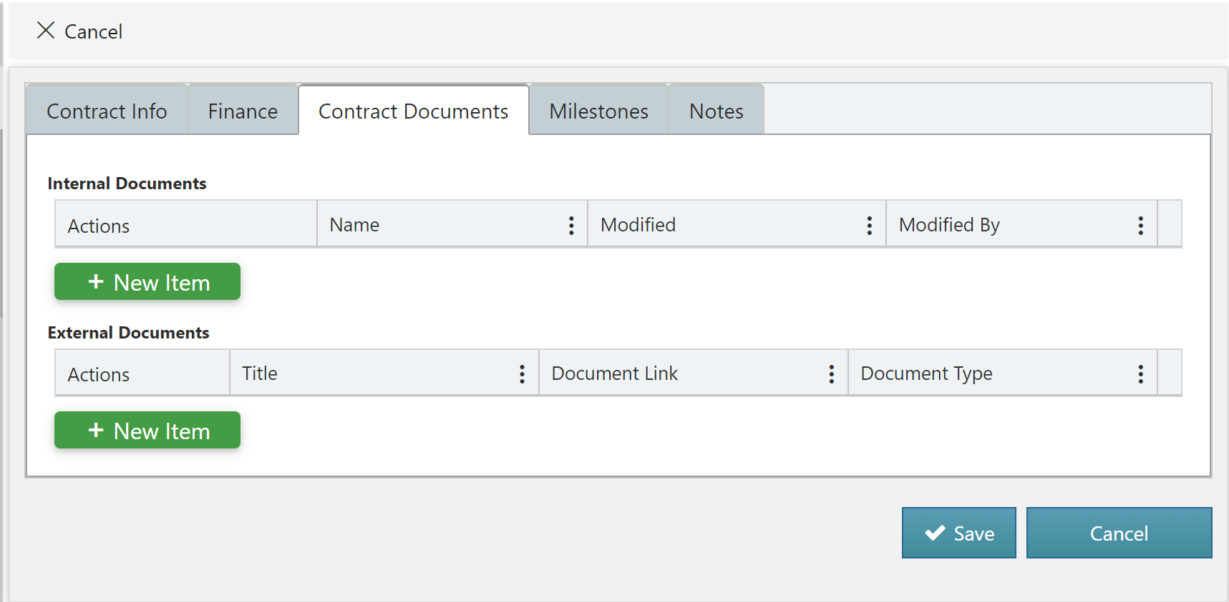

Milestones Tab:
Navigate to this tab to create Contract milestones.
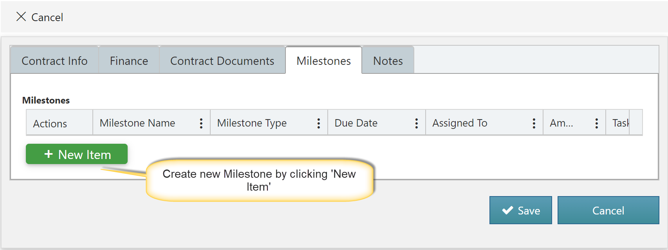
Milestone Form will open. Fill all the details in the form to create new milestone as shown below:
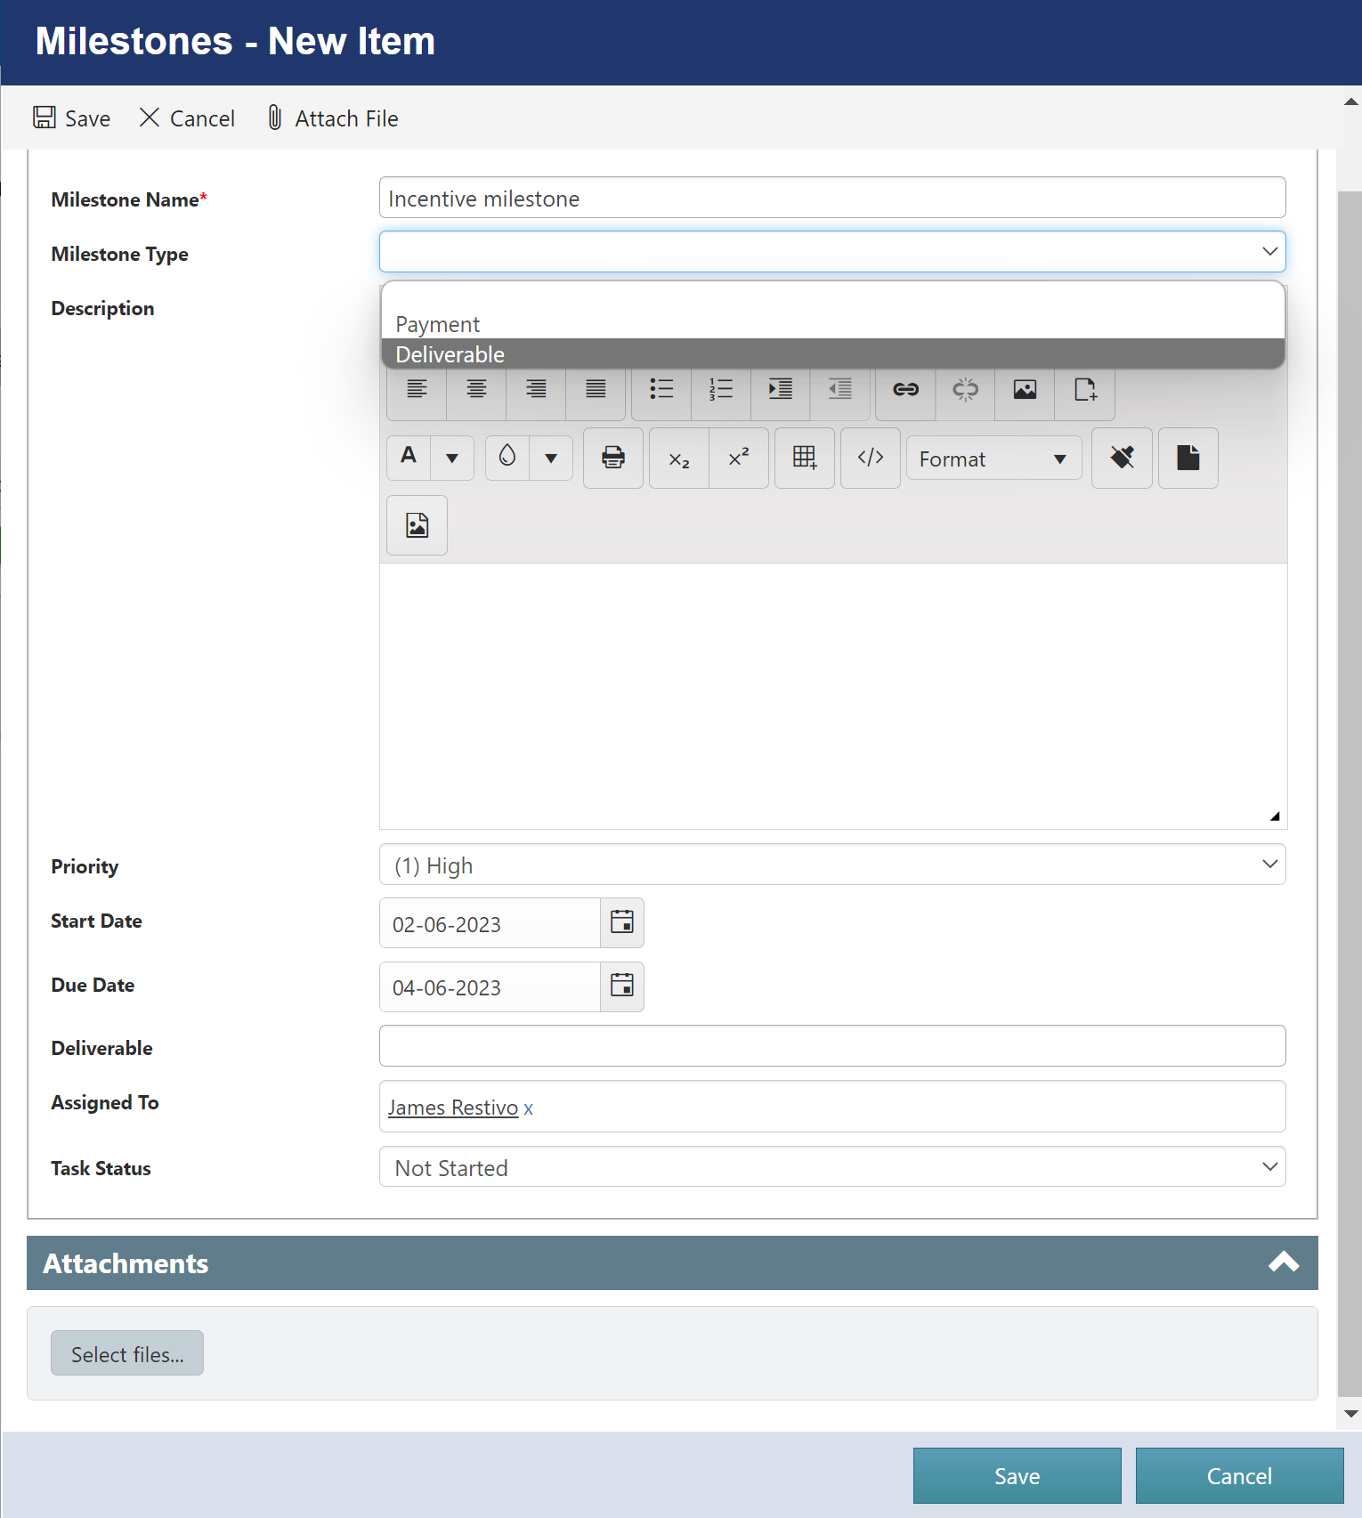

Notes Tab:
Notes in the free form text can be added in this page.
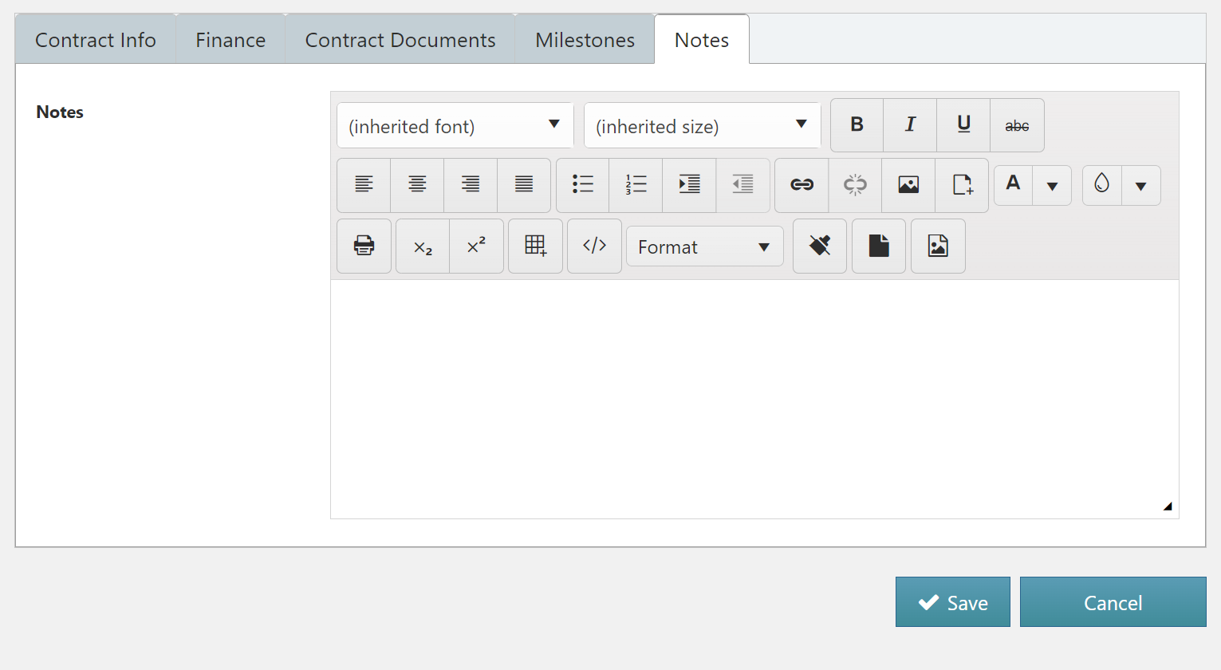

In display form of contract, ‘Submit for renewal’ button will appear (if Allow auto renewal is not enabled in contract). User can submit contract for renewal by click ‘Submit for Renewal’ button as shown below
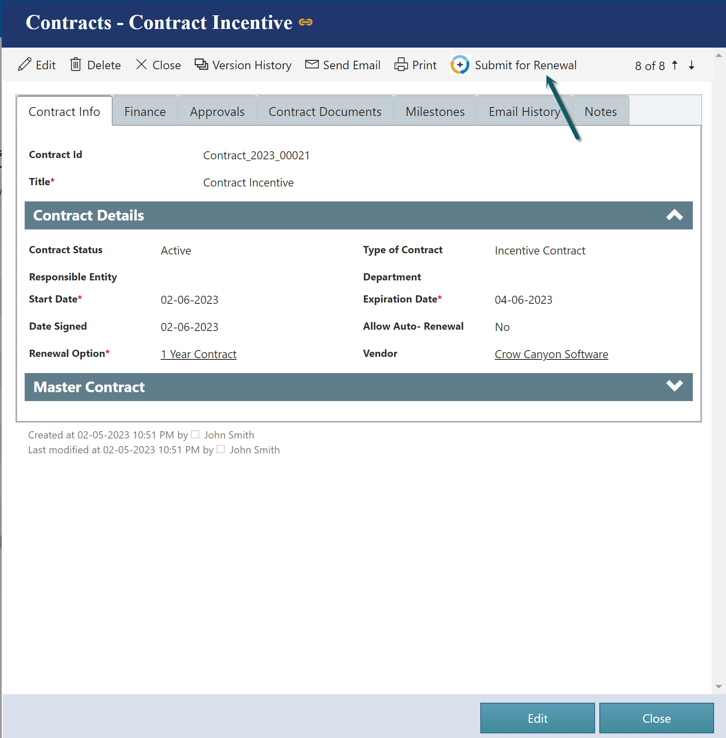
After clicking ‘Submit for Renewal’ Contract undergoes Approval process. If assigned approver(s) approves the contract, Contract is Renewed else not. Contract is terminated if not renewed by the expiration date.

All Contracts
This page has several tabs to show Contracts with different stages. Also, users can see Contracts created by themselves.
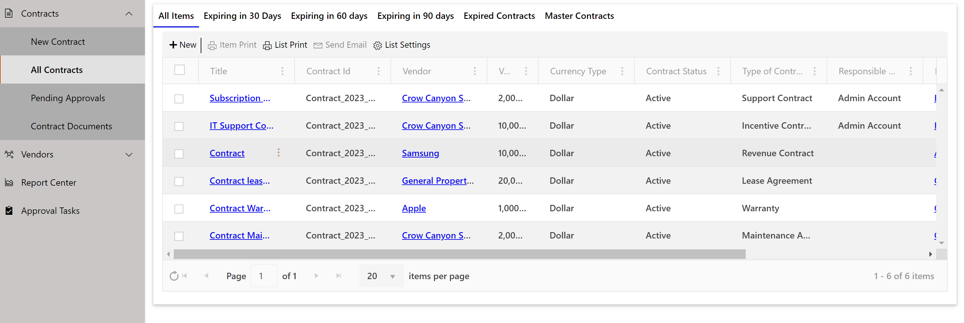

Pending Approvals
Users can see all the Contracts that are awaiting approvals using this link
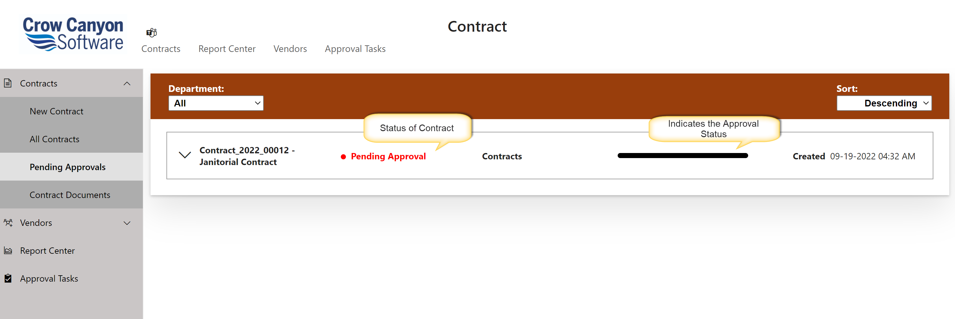
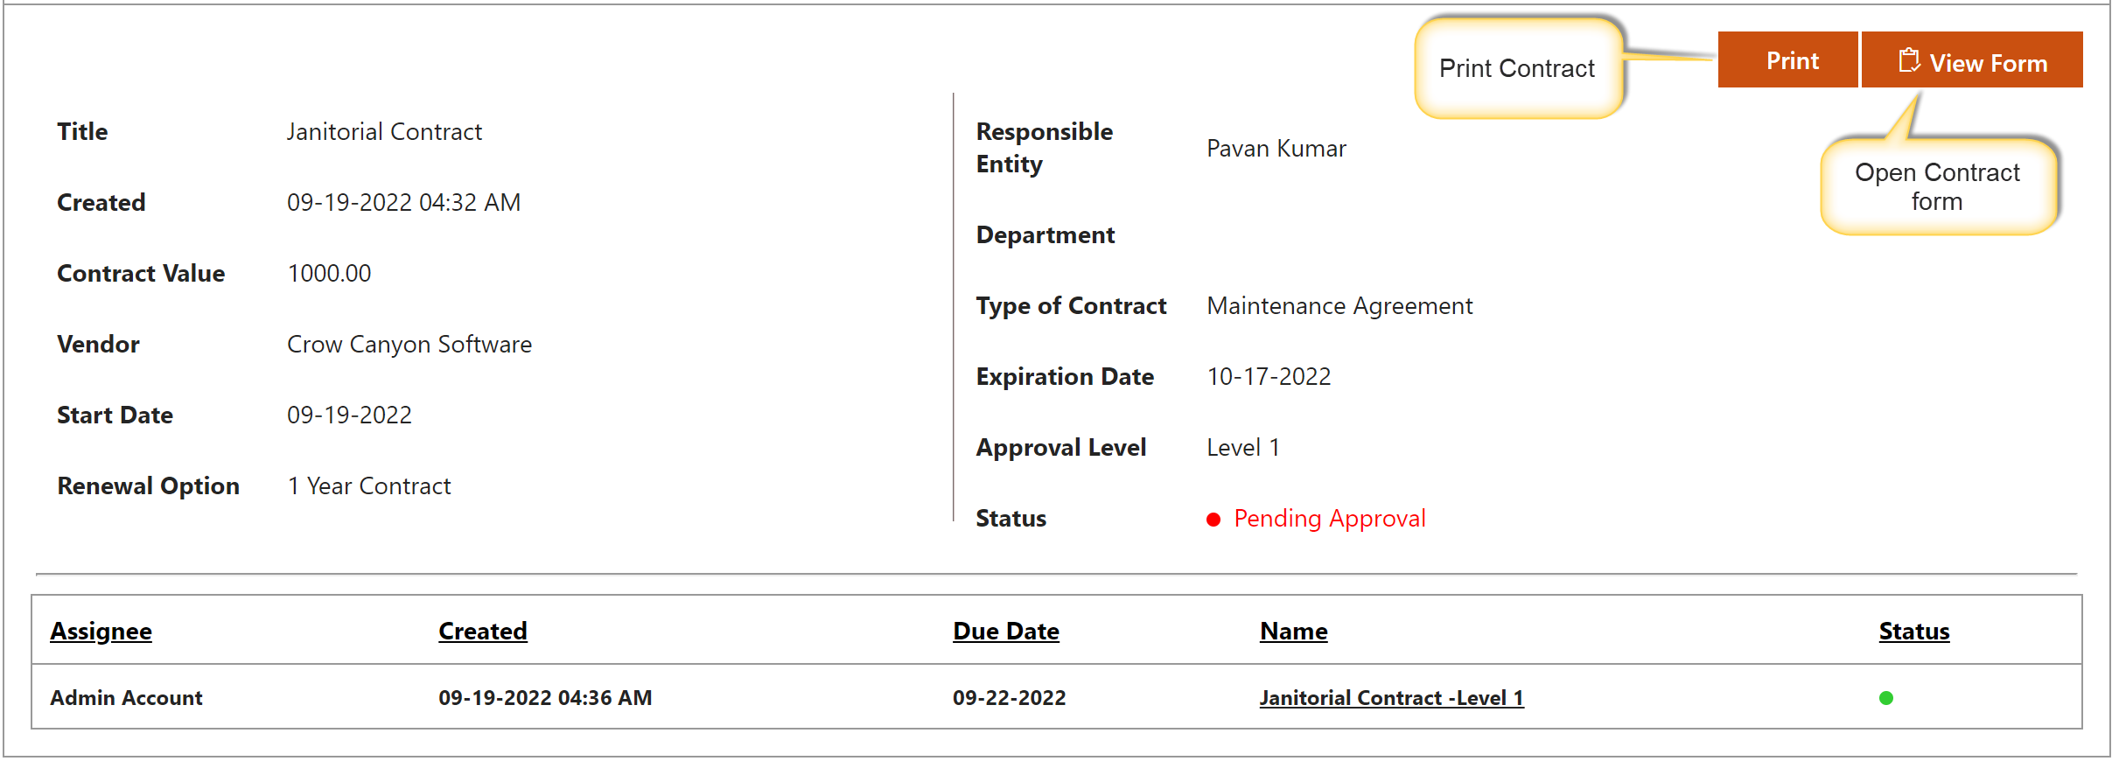

Contract Documents
Users can see all Internal and External Documents that are attached to the contract using this link. These Documents can also be created by clicking ‘New’ in upper left side of page.
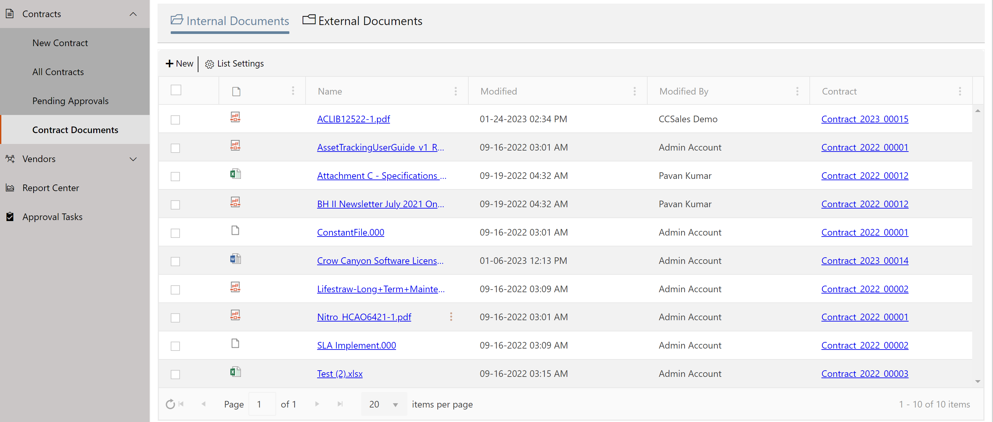

Vendors
Navigates to the “Vendors” page to view and update vendors.

New Vendor
User can click this link to create a new vendor
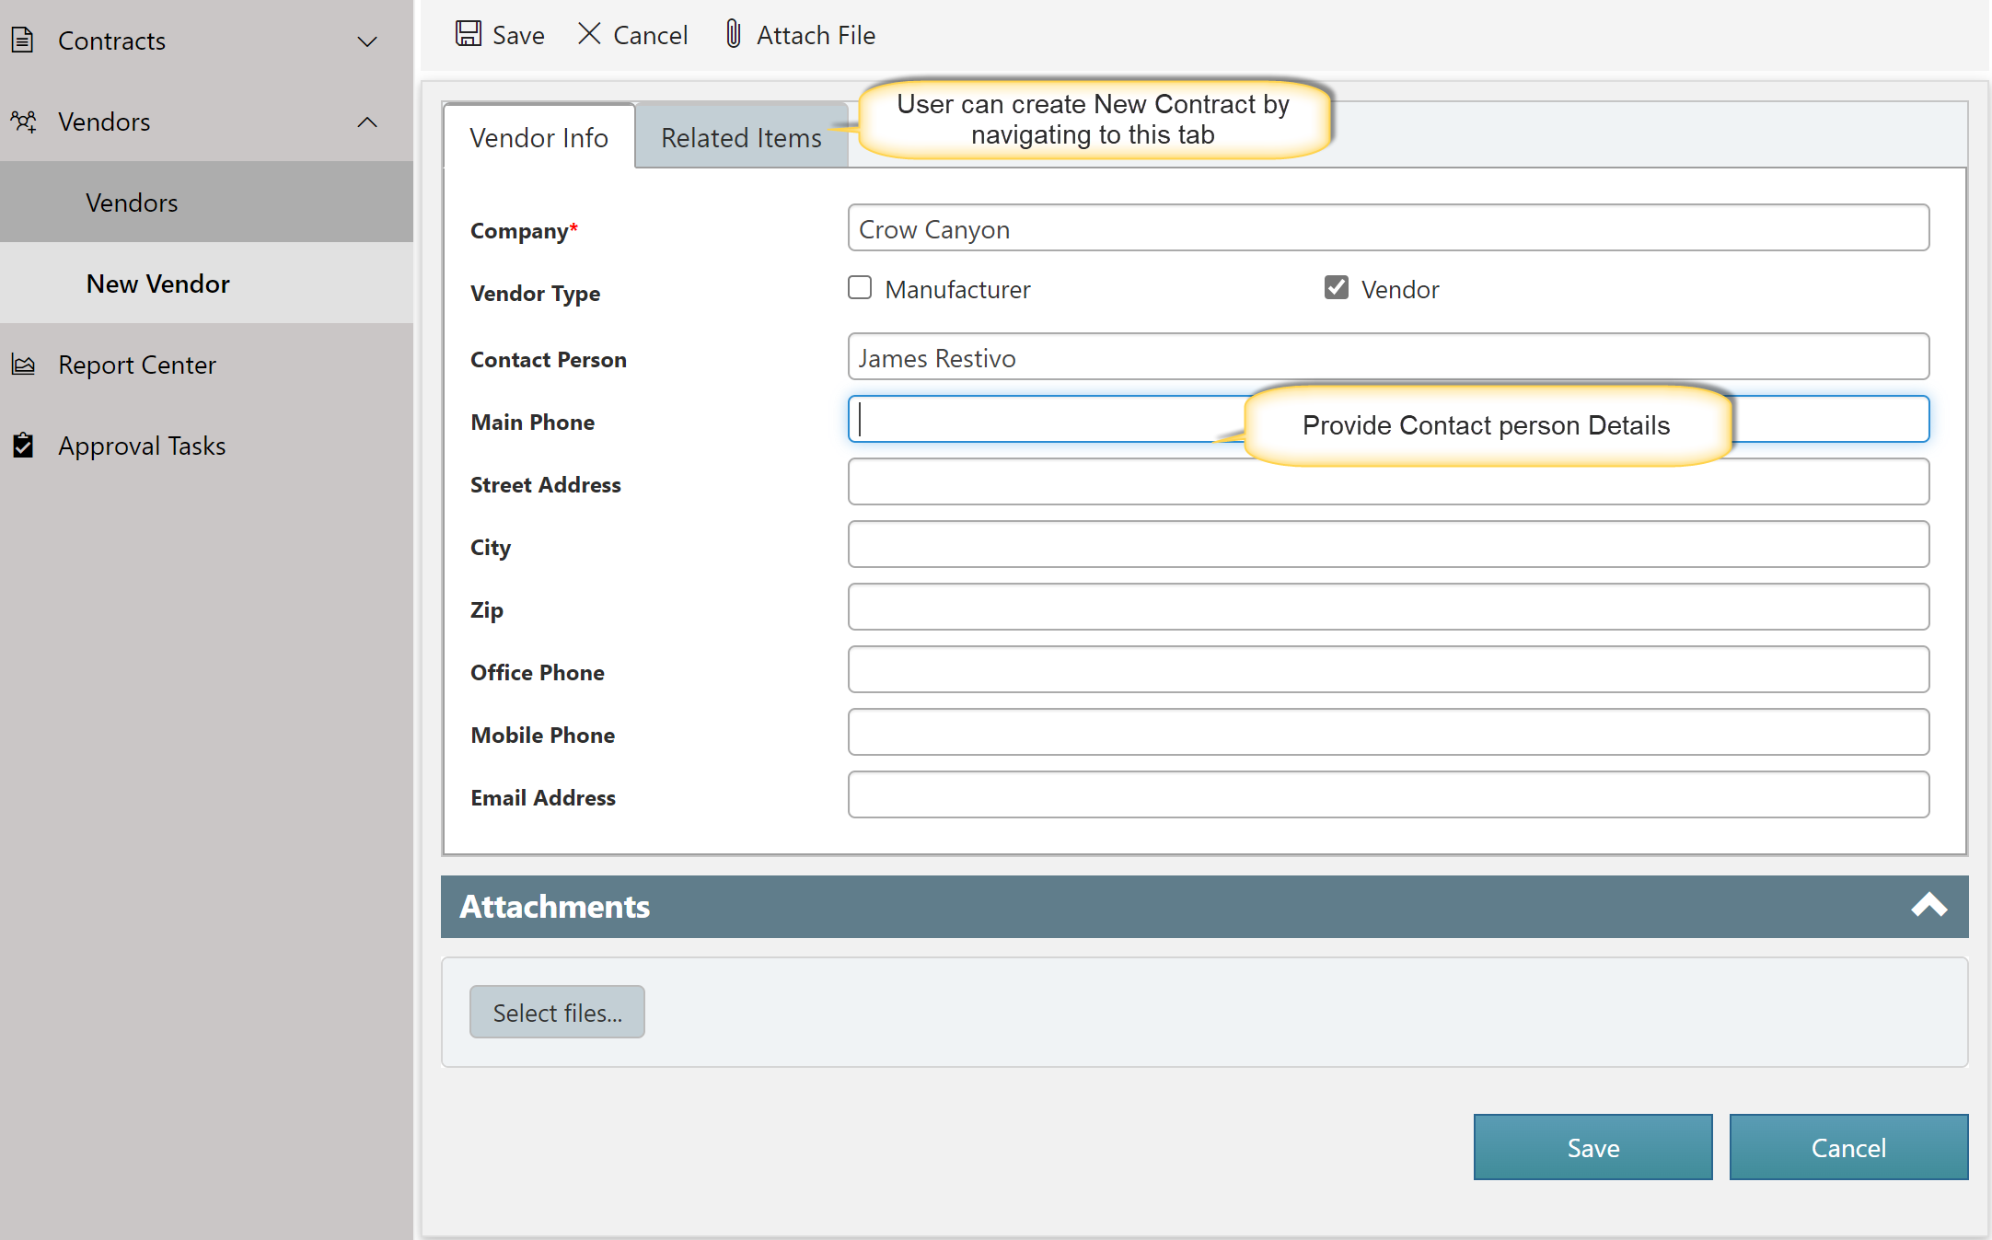

Report Center
Navigates to the Report Center page to view various reports configured in the system.

Approver Tasks
Users can see their pending approval tasks and open them to approve/deny. They can also see tasks for other users; however, they can’t update the approval decision for tasks not assigned to them.

Application Administration
Application Administration workspace provides easy access to configure the Contract Management Application.
Accessing the Application Administration workspace page
Application Administration page is accessed by clicking the settings icon on the top right side of the page. Users need to have at least “Manage Web” permissions on the site to see this icon and navigate to the page.
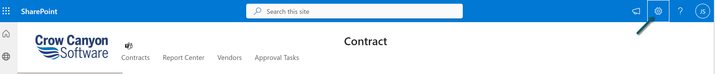
To grant “Manage Web” permission level, go to root site collection Site Settings Site Permissions Click Permission Level’s in the ribbon Edit the required permission level Select “Manage web Site” permission under Site Permissions section and save the permission level.
For more details regarding permissions levels, please refer this article.
Application Administration page
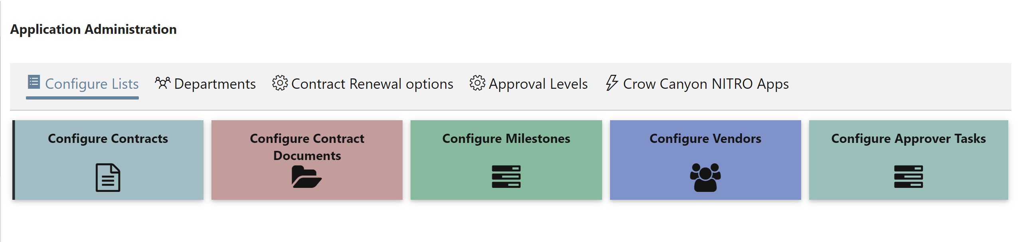
This workspace page allows Administrators to configure the following:
- Configure Lists
- Departments
- Contract Renewal Options
- Approval Levels
- Crow Canyon NITRO Apps

Configure Lists
Administrators can add/update the columns, Forms, Custom Actions etc. for Contracts List, Contract Documents, Milestones, Vendors and Approver Tasks.
These are the core lists that compose the Contract Management application.

Departments
This list is used to specify the departments available in the system. Based on department approval levels can be specified. Custom permissions can also be configured based on department using Crow Canyon NITRO Workflows.

Contract Renewal Options
This List is used to specify the Contract Renewal options available in the system.

Approval Levels
Administrators can define multiple approval levels in this list. Here one Approval Level can be linked to multiple “Renewal Option”. This list will take “Renewal Option”, “Contract Value”, “Amount”, “Approvers”, “Level” and “Due Hours” as input for the Approval Levels.
Approval Tasks will be created for the approval levels based on the “Renewal Option”, “Type of Contract” and the “Value” of the Contract.
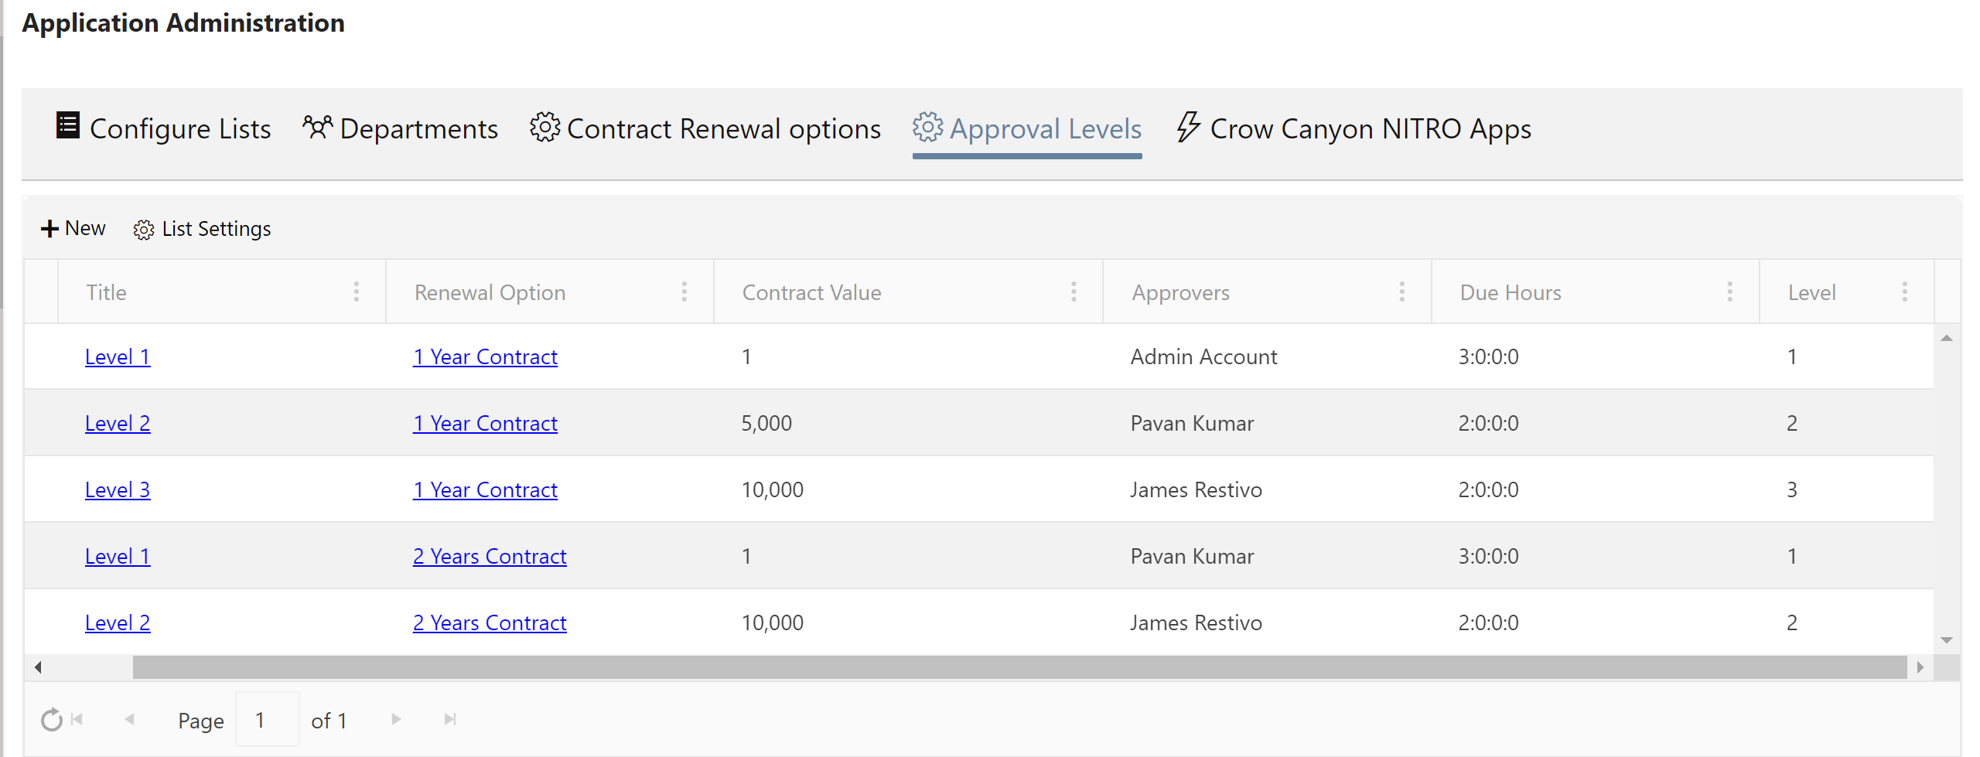
Approval Level Form
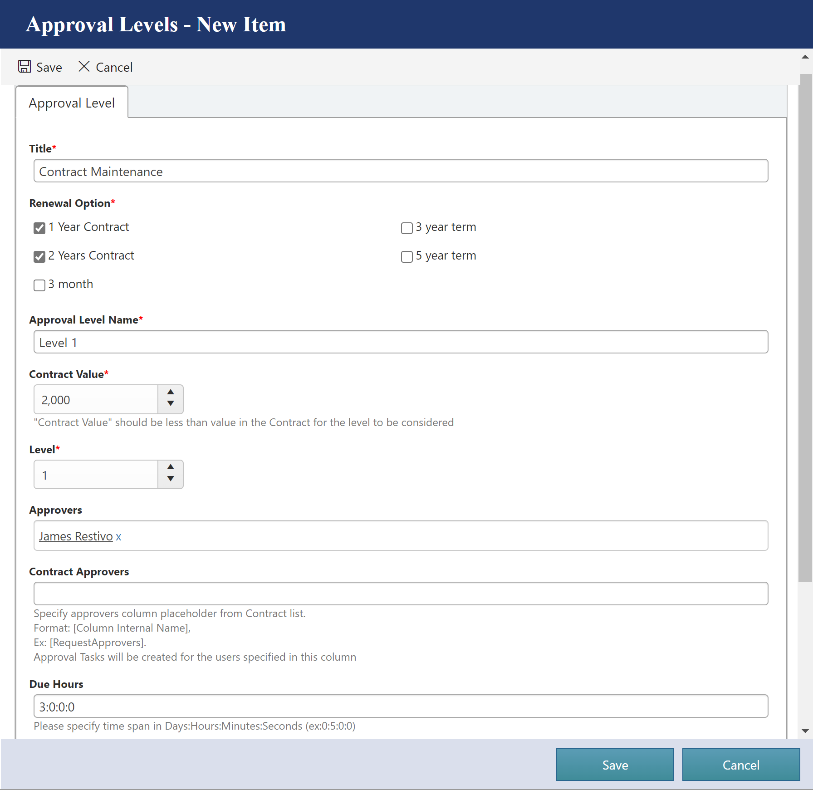

Crow Canyon NITRO Apps
We can navigate to configuration pages of various NITRO components from this tab. We can then configure Forms, Workflows and other features to customize the application. For more details about the NITRO features, refer this article.
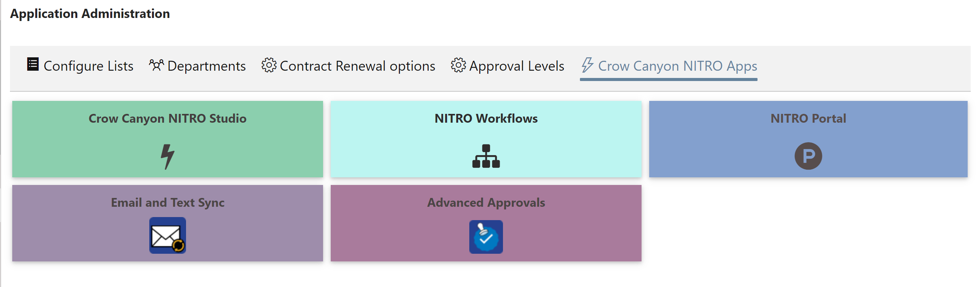

Contract Renewal Approval process
Approval process works based on the approval levels defined in the system. These can be defined based on the Renewal Option, Value and type of Contract etc. One or more levels can be defined for different combinations of these parameters. Administrators need to setup the Approval Levels before Contract renewal can be submitted.

Approval flow
Crow Canyon Contract Management application has a flexible approval process to define any number of approval levels based on the renewal option, value and other parameters.
Contract goes for renewal to the next level approver once it is approved by the previous level. If denied then Contract renewal is marked as denied and it will get terminated on the expiration date. Once all the approvals are given then Contract is automatically renewed.

Submit for Approval
Requester initiates the approval process for the Contract renewal by clicking the “Submit for Renewal” button (available in New, Edit and Display forms).
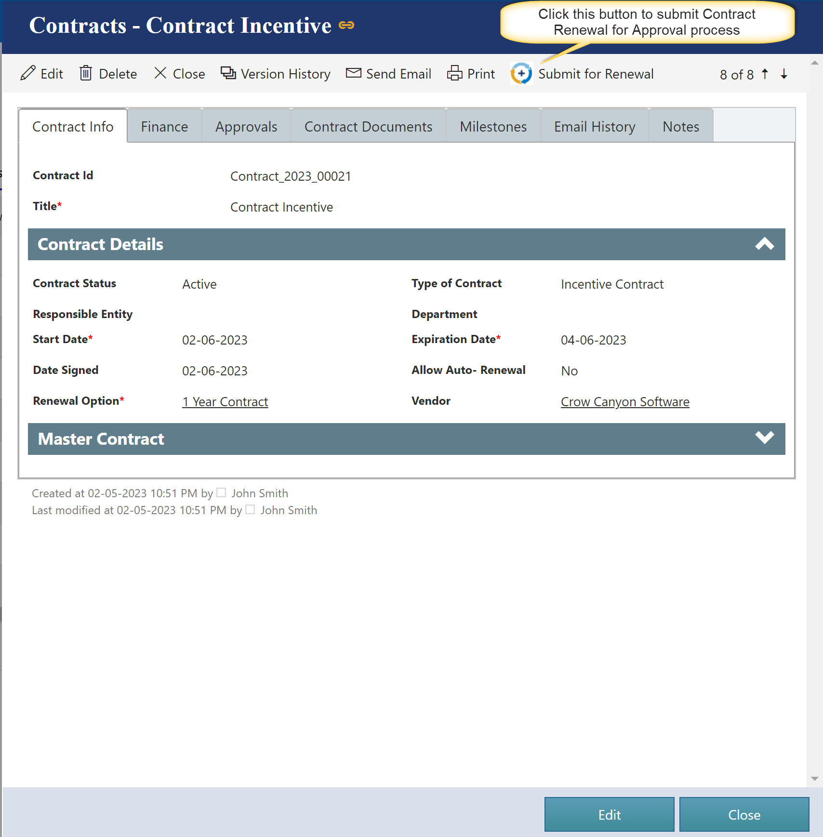
Once the Request is submitted for approval:

- Based on the “Renewal Option”, “Value” of the Contract, approval tasks will be created for applicable approval levels. If none of the approval level is applicable based on the renewal parameters, then contract will be renewed with Approval worklog showing message as ‘contract renewal does not require approval’

- When an approval task is created, approver will receive email notification with links to the Renewal Contract and the approval task.
Note: Notifications are configured using Crow Canyon NITRO Workflows and these notifications are configurable. To modify the notification templates, go to Application Administration NITRO Workflows Edit “Notify Approver on task submission” workflow Edit “Send mail to Approver on task creation” send mail action and “Send approver card to task assignee” post an adaptive card and modify the mail templates as required.
Approver can “Approve”, “Deny” or “Reassign” the Contract using action button in the approval task form
- Based on the approval decision, Contract renewal will go for the next level in the process (Approved/Denied/Next level approval task)
Approvers can take the decision in two ways:
- Using Custom Actions
- Using Lazy approval process

Using Custom Actions

Approve
- This action will be visible only to the user to whom task is assigned.
- This action will set the approver task decision to “Approved.”
- It will create the next level approver task or approve the contract renewal based on the applicable approval levels for the request
- When Contract Renewal is approved, Requester and Responsible entity will receive email notifications.
Note: To modify the Approval notification mail template, go to Application Administration Crow Canyon NITRO Apps NITRO Workflows Edit “Notify Responsible Person on Contract Renewal Terminate” workflow Edit “Mail on Contract Renewal” send mail action and modify the mail template as required.

Deny
- This action will be visible only to the user to whom task is assigned.
- This action will set the approver task decision to “Denied” and update the Contract Renewal Status to “Denied”
- An email will be sent to Requester and the Responsible Entity
Note: To modify the Approval notification mail template, go to Application Administration Crow Canyon NITRO Apps NITRO Workflows Edit “Notify Responsible Person on Contract Renewal Terminate” workflow Edit “Mail on Contract Renewal “send mail action and modify the mail template as required.
Once the Contract renewal is denied, it cannot be resubmitted.

Contracts Form
Contracts form is configured using Crow Canyon NITRO forms as shown below. Form can be changed from the NITRO Forms designer. Adding new columns to the list and to the form can be done from the designer and form layout can be changed as well. Below columns are used in the Contracts approval and other processes, these columns shouldn’t be updated/removed without consulting Crow Canyon.
Columns:
- Title
- Type of Contract
- Responsible Entity
- Department
- Payment Terms
- Currency Type
- Value
- Internal Documents
- External Documents
- Milestones
- Approval Tasks
- Renewal Option
- Master Contract
- PO Number
Refer NITRO forms section in this article for instructions to configure NITRO forms.
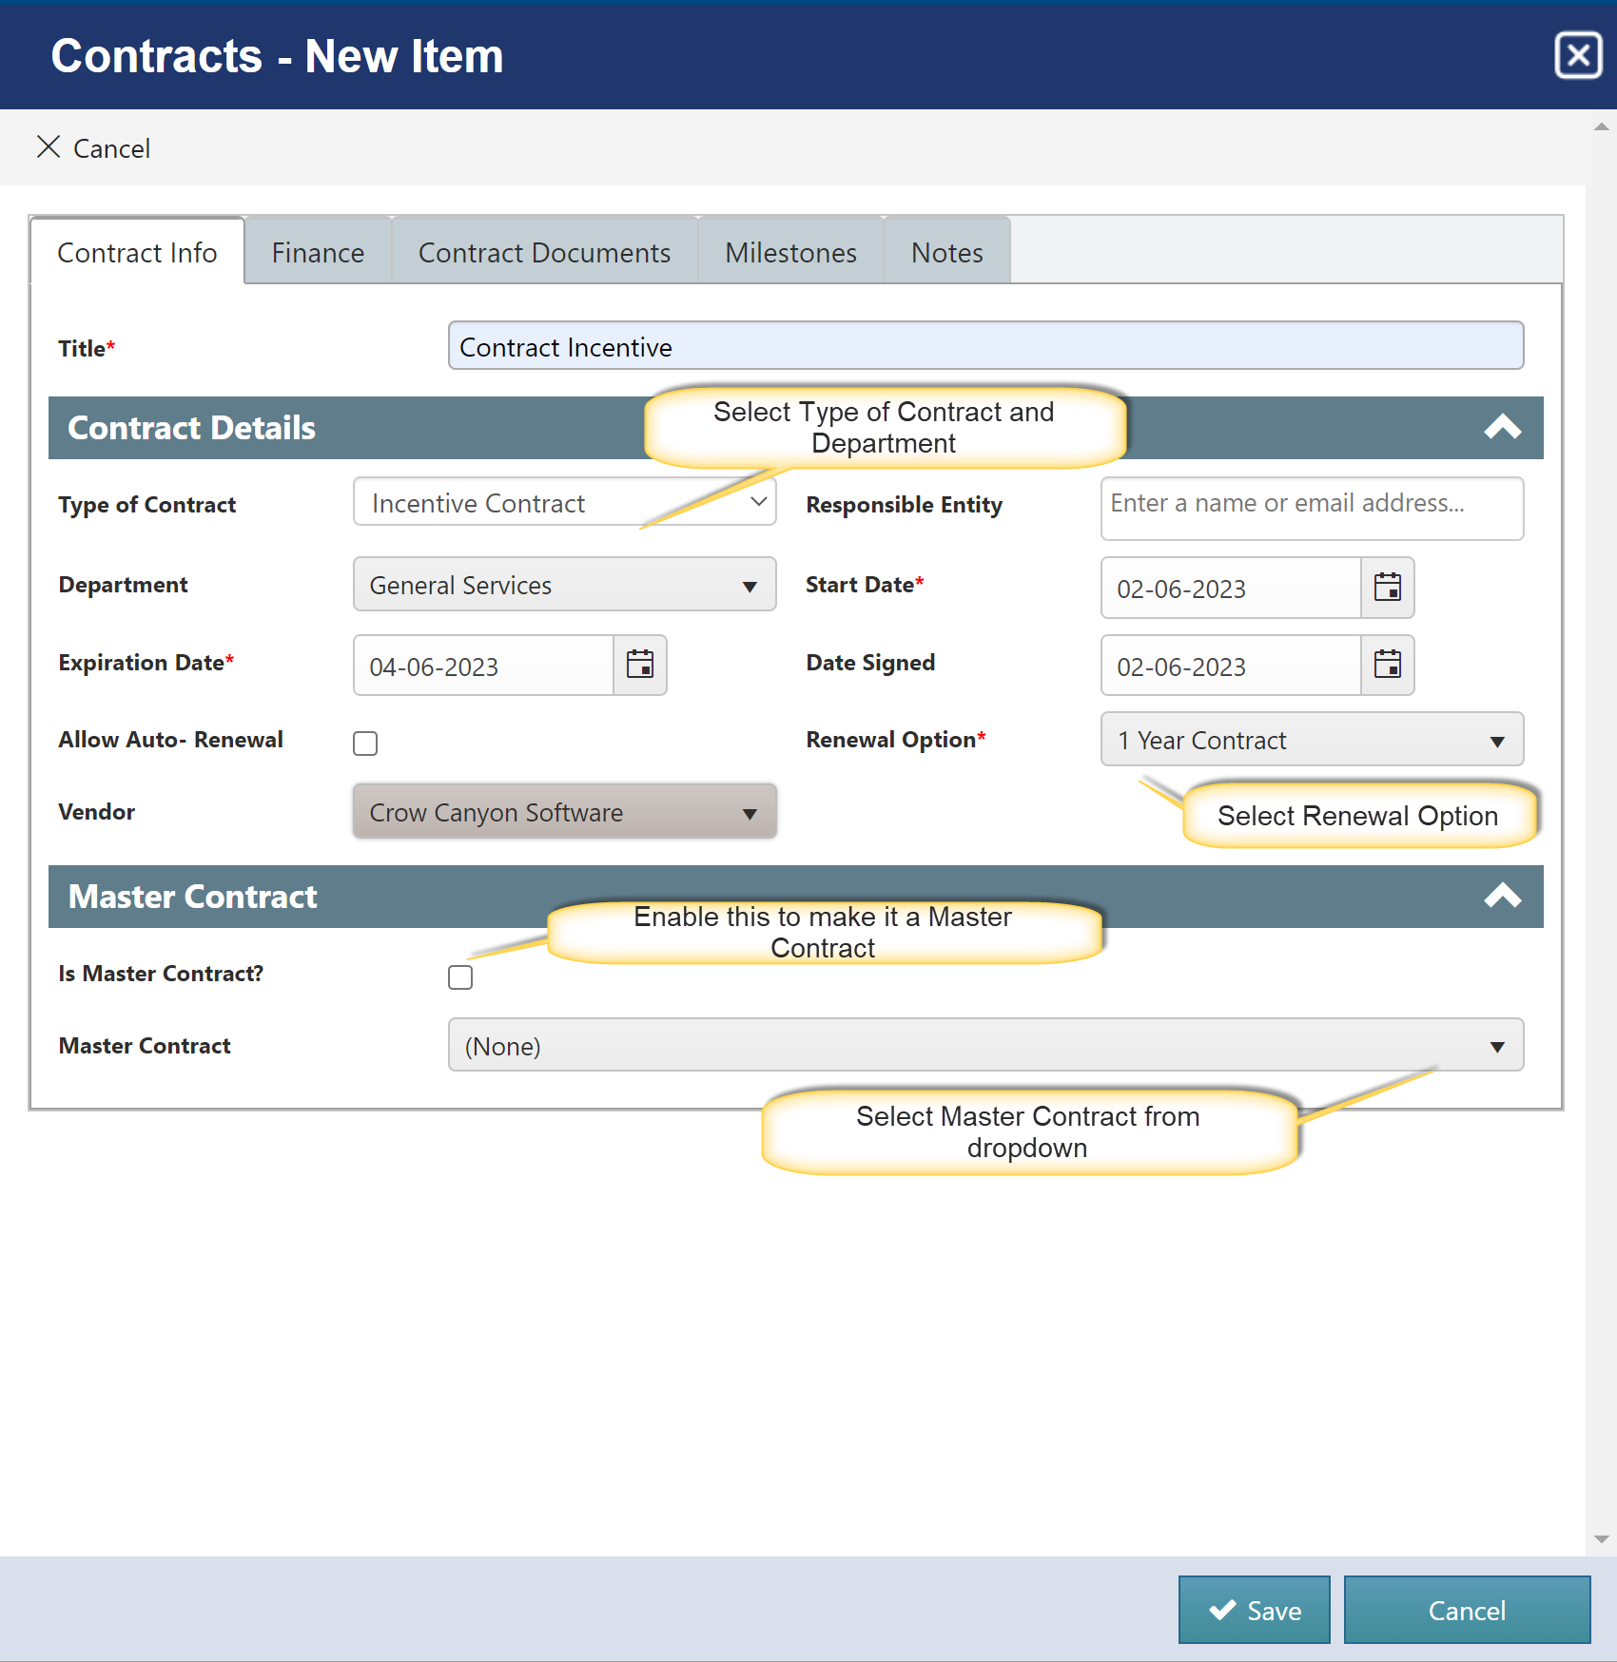

Title: Provide Title for the Contract
Type of Contract: Specify the Type of Contract
Department: Specify department For Contract
Expiration Date: Specify Expiry date of Contract
Vendor: Specify vendor For Contract
Responsible Entity: Specify Responsible Person for Contract
Start Date: Specify Start Date for Contract
Date Signed: Specify Signed Date For Contract
Renewal Option: Specify Renewal Option For Contract
Master Contract: Select Master Contract for this Contract

